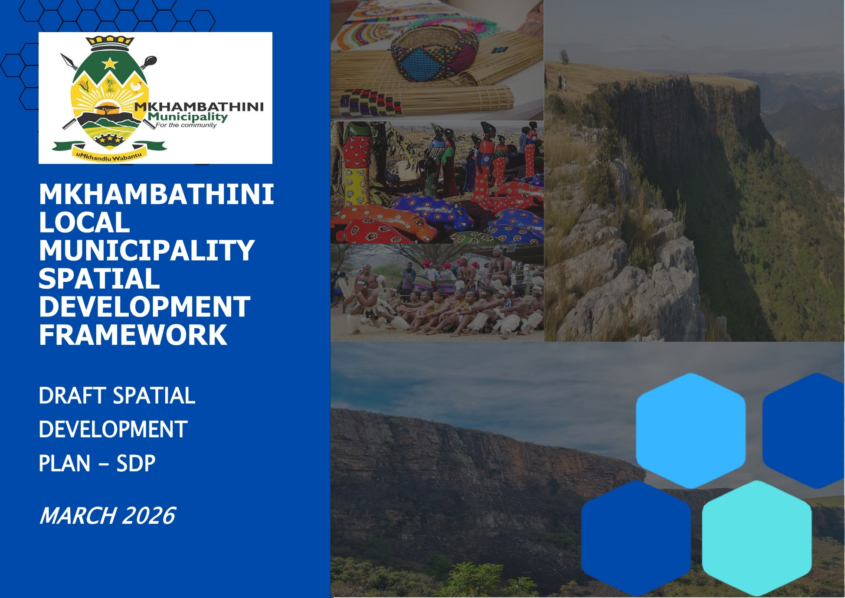
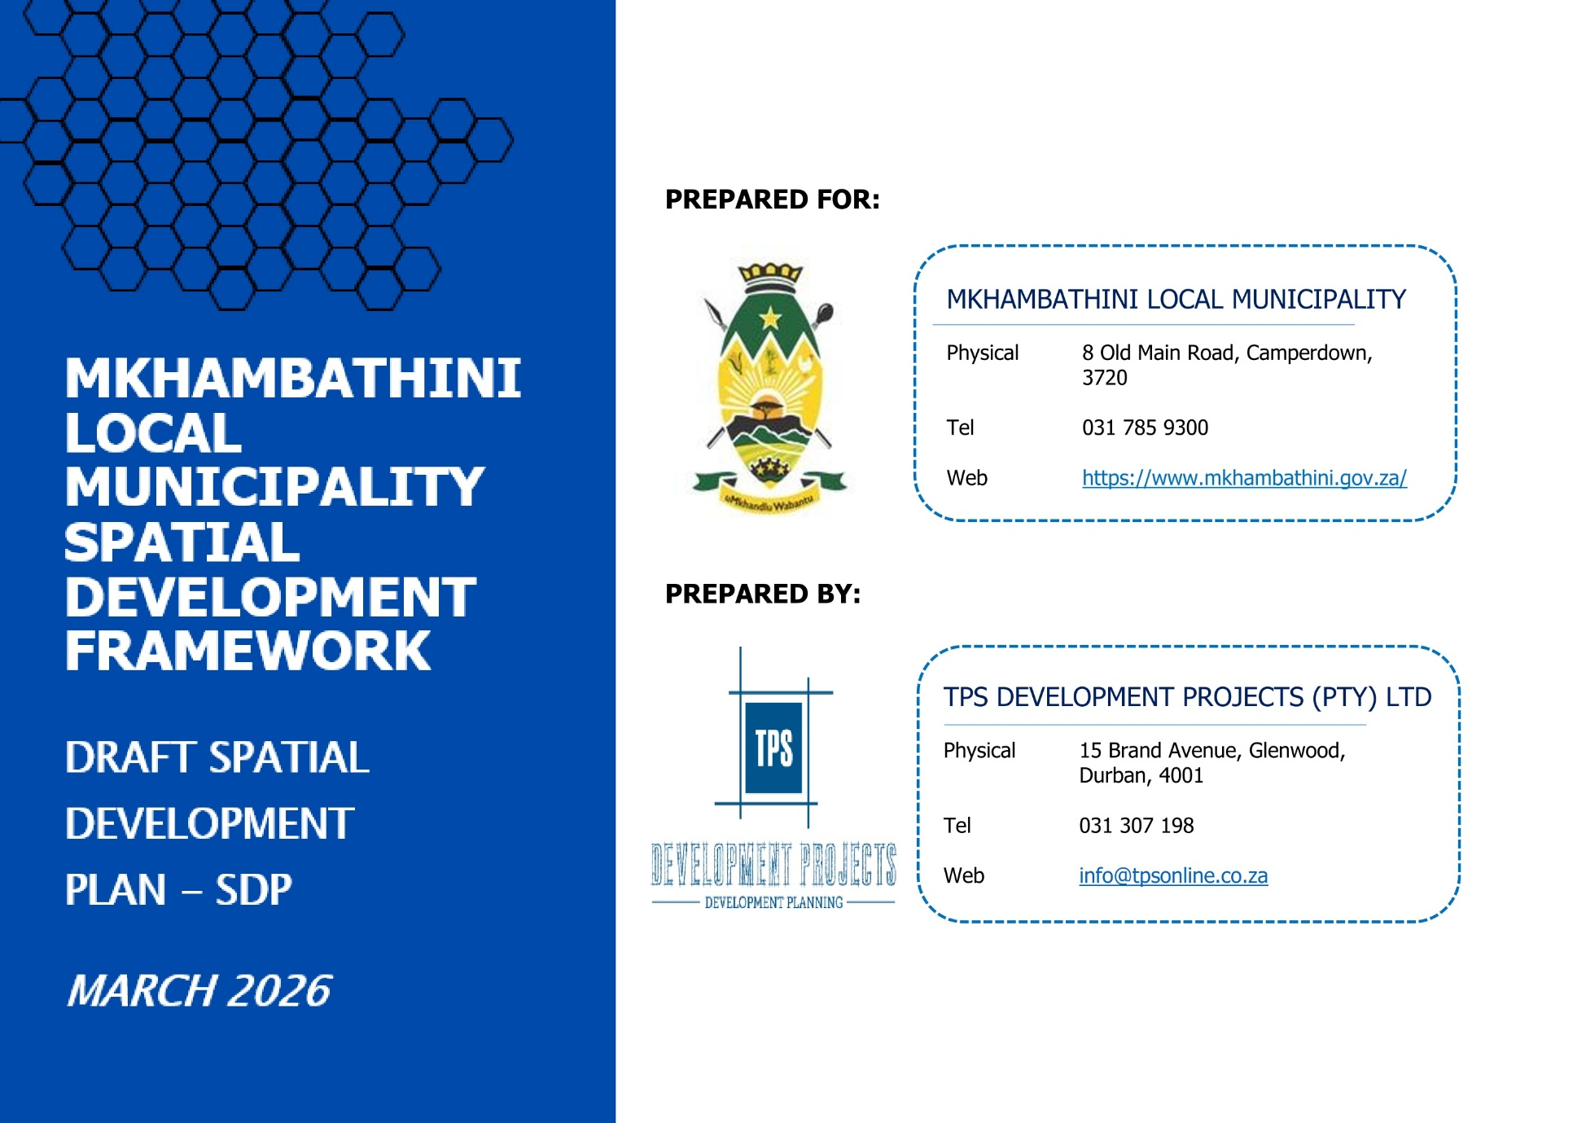

Table of Contents
TABLE OF CONTENTS iii
LIST OF MAPS v
LIST OF TABLES viii
1. INTRODUCTION 9
1.3. PROJECT LOCALITY 9
1.4. LEGISLATION AND POLICY INFORMANTS 11
1.4.1. CONSTITUTION OF THE REPUBLIC OF SOUTH AFRICA, ACT NO. 108 OF 1996 11
1.4.2. MUNICIPAL SYSTEMS ACT, 2000 (ACT NO. 32 OF 2000) 11
1.4.3. MUNICIPAL SYSTEMS ACT, 2000 (ACT NO. 32 OF 2000): 11
1.4.4. SPATIAL PLANNING AND LAND USE MANAGEMENT ACT, 2013 (ACT NO. 16 OF 2013): 11
1.4.5. TRADITIONAL AND KHOI-SAN LEADERSHIP ACT 3 OF 2019 11
1.4.6. NATIONAL ENVIRONMENTAL MANAGEMENT ACT, 1998 (ACT NO. 107 OF 1998) (NEMA) 12
1.4.5. NATIONAL SPATIAL DEVELOPMENT FRAMEWORK, (NSDF), 2022 12
1.4.6. KZN PROVINCIAL GROWTH AND DEVELOPMENT STRATEGY, VISION 2035 13
1.4.7. KZN MEDIUM-TERM DEVELOPMENT PLAN, 2024-2029, (MTDP) 13
1.4.8. KZN PROVINCIAL SPATIAL DEVELOPMENT FRAMEWORK, 2022 13
1.4.9. KZN GREATER REGIONAL SPATIAL DEVELOPMENT FRAMEWORK, 2025 14
1.4.10. UMGUNGUNDLOVU DISTRICT MUNICIPALITY SPATIAL DEVELOPMENT FRAMEWORK, 2022 14
1.4.11. UMGUNGUNDLOVU DISTRICT GROWTH AND DEVELOPMENT PLAN 15
1.4.12. MKHAMBATHINI LOCAL MUNICIPALITY SPATIAL DEVELOPMENT FRAMEWORK, 2026 15
2. SUMMARY OF CHALLENGES AND OPPORTUNITIES 16
3. MKHAMBATHINI MUNICIPALITY 20-YEAR LONG TERM SPATIAL DEVELOPMENT VISION 20
4. MKHAMBATHINI MUNICIPAL FIVE (5) YEAR SPATIAL DEVELOPMENT PLAN 23
4.1. VISION STATEMENT AND OBJECTIVES 23
4.2. GUIDING STRATEGIES 24
4.3. STRATEGY 1: SUSTAINABLE URBAN DEVELOPMENT 25
4.3.1. COMPACT DEVELOPMENT AND INFILL DEVELOPMENT 25
4.3.2. DEVELOPMENT PRIORITY AREAS FOR INTERVENTION AND INVESTMENT (URBAN ACCELERATION ZONES) 25
4.3.3. REVITALISATION OF KEY ECONOMIC NODES 25
4.4. STRATEGY 2: SUSTAINABLE RURAL DEVELOPMENT 33
4.4.5. AGRARIAN TRANSFORMATION 33
4.4.6. SOCIAL DEVELOPMENT IN THE RURAL CONTEXT 33
4.4.7. RURAL AGRO-PROCESSING CLUSTERS 34
4.4.8. RURAL ACCESS, BASIC INFRASTRUCTURE AND DIGITAL INCLUSION 34
4.4.9. RURAL LIVELIHOODS, SMMES AND THE INFORMAL ECONOMY 35
4.4.10. INCREMENTAL SETTLEMENT UPGRADING AND INCLUSION ZONES 35
4.5. STRATEGY 3: REGIONAL INTEGRATION AND CONNECTIVITY 36
4.5.5. ENHANCED CONNECTIVITY: TELECOMMUNICATIONS AND ICT DEVELOPMENT 36
4.5.6. N3 NATIONAL AND PROVINCIAL CORRIDOR DEVELOPMENT 36
4.5.7. PRIMARY CORRIDOR DEVELOPMENT: R603 AND P338 37
4.5.8. SECONDARY CORRIDOR DEVELOPMENT: P477, P566 AND R624 37
4.5.9. PROPOSED TOURISM ROUTES 37
4.6. STRATEGY 4: COMPETITIVE INFRASTRUCTURE LED-GROWTH 38
4.6.5. ELECTRICITY INFRASTRUCTURE 38
4.6.6. SANITATION INFRASTRUCTURE 38
4.6.7. WATER INFRASTRUCTURE 38
4.6.8. SOCIAL FACILITIES 39
4.7. STRATEGY 5: SUSTAINABLE USE AND PRESERVATION OF THE NATURAL ENVIRONMENT 39
4.7.5. HYDROLOGY PROPOSALS (NFEPA RIVERS) 39
4.7.6. HOUSEHOLDS IN HYDROLOGICAL FEATURES 39
4.7.7. TOPOGRAPHY & HOUSEHOLDS ON STEEP SLOPES 39
4.7.8. CLIMATE CHANGE 40
4.7.9. AGRICULTURE & FARMER SUPPORT 40
4.7.10. DISASTER MANAGEMENT & RISK REDUCTION 40
5. CAPITAL INVESTMENT FRAMEWORK 42
5.1. MONITORING AND EVALUATION PLAN 86
6. CONCLUSION 91

LIST OF MAPS
MAP 1: WARD DEMARCATION 10
MAP 2: TRADITIONAL AUTHORITY AREAS 10
MAP 3: REGIONAL LOCALITY 10
MAP 4: PROVINCIAL LOCALITY 10
MAP 5: MKHAMBATHINI SDF COMPOSITE 22
MAP 6: CAMPERDOWN URBAN-EDGE 27
MAP 7: ESTON URBAN EDGE 28
MAP 8: OPHOKWENI A SETTLEMENT EDGE 29
MAP 9: OPHOKWENI B SETTLEMENT EDGE 30
MAP 10: NGILANYONI SETTLEMENT EDGE 31
MAP 11: MAQONGQO SETTLEMENT EDGE 32
MAP 12: CIF SOCIAL FACILITIES 47
MAP 13: CIF SOCIAL FACILITIES WARD 1 48
MAP 14: CIF SOCIAL FACILITIES WARD 2 49
MAP 15: CIF SOCIAL FACILITIES WARD 3 50
MAP 16: CIF SOCIAL FACILITIES WARD 4 51
MAP 17: CIF SOCIAL FACILITIES WARD 5 52
MAP 18: CIF SOCIAL FACILITIES WARD 6 53
MAP 19: CIF SOCIAL FACILITIES WARD 7 54
MAP 20: CIF LED WARD 4 55
MAP 21: CIF INFRASTRUCTURE 56
MAP 22: CIF INFRASTRUCTURE WARD 1 57
MAP 23: CIF INFRASTRUCTURE WARD 2 58
MAP 24: CIF INFRASTRUCTURE WARD 3 59
MAP 25: CIF INFRASTRUCTURE WARD 4 60
MAP 26: CIF INFRASTRUCTURE WARD 5 61
MAP 27: CIF INFRASTRUCTURE WARD 4 62
MAP 28: CIF HUMAN SETTLEMENTS 63
MAP 29: CIF HUMAN SETTLEMENTS WARD 2 64
MAP 30: CIF HUMAN SETTLEMENTS WARD 3 65
MAP 31: CIF HUMAN SETTLEMENTS WARD 4 66
MAP 32: CIF HUMAN SETTLEMENTS WARD 5 67
MAP 33: CIF HUMAN SETTLEMENTS WARD 6 68
MAP 34: CIF HUMAN SETTLEMENTS WARD 7 69
MAP 35: CIF DISASTER RISK MANAGEMENT 70
MAP 36: CIF DISASTER RISK MANAGEMENT WARD 1 71
MAP 37: CIF DISASTER RISK MANAGEMENT WARD 1 72
MAP 38: CIF DISASTER RISK MANAGEMENT WARD 2 73
MAP 39: CIF DISASTER RISK MANAGEMENT WARD 3 74
MAP 40: CIF DISASTER RISK MANAGEMENT WARD 4 75
MAP 41: CIF DISASTER RISK MANAGEMENT WARD 5 76
MAP 42: CIF DISASTER RISK MANAGEMENT WARD 6 77
MAP 43: CIF DISASTER RISK MANAGEMENT WARD 7 78
MAP 44: CIF ENVIRONMENTAL MANAGEMENT WARD 1 79
MAP 45: CIF ENVIRONMENTAL MANAGEMENT WARD 2 80
MAP 46: CIF ENVIRONMENTAL MANAGEMENT WARD 3 81
MAP 47: CIF ENVIRONMENTAL MANAGEMENT WARD 4 82
MAP 48: CIF ENVIRONMENTAL MANAGEMENT WARD 5 83
MAP 49: CIF ENVIRONMENTAL MANAGEMENT WARD 6 84
MAP 50: CIF ENVIRONMENTAL MANAGEMENT WARD 1 85

LIST OF TABLES
TABLE 1: SUMMARY OF CHALLENGES AND OPPORTUNITIES 16
TABLE 2: OBJECTIVES AND IMPLEMENTATION VISION 23
TABLE 3: MKHAMBATHINI LM 5-YEAR DEVELOPMENT PLAN 43
TABLE 4: MONITORING AND EVALUATION FRAMEWORK 86

INTRODUCTION

The Municipal Systems Act, 2000 (Act 32 of 2000) (herein referred to as “MSA”), requires that each Municipality prepares an Integrated Development Plan (herein referred to as “IDP”) and a Spatial Development Framework (herein referred to as “SDF”) as a core component of the IDP to realize the spatial vision of the Municipality. Section 26e of the MSA states that the Municipality must prepare “a spatial development framework which must include the provision of basic guidelines for a land use management system for the municipality”.
The Spatial Development Plan (SDP) for Mkhambathini has been prepared as a short- to medium-term implementation framework that translates the long-term spatial vision and strategies contained in the municipal SDF into prioritised development interventions for the next five-year period. The SDP serves as a practical planning and implementation tool that identifies key spatial projects, programmes, and investment priorities required to guide sustainable development and spatial transformation within the municipality.
In alignment with the guidelines provided by the Department of Cooperative Governance and Traditional Affairs (CoGTA), the SDP plays an important role in monitoring and facilitating the implementation of the SDF by linking spatial strategies with municipal planning, budgeting, and performance management processes. The plan therefore assists the municipality in coordinating spatial development initiatives, aligning infrastructure investment with spatial priorities, and ensuring that development interventions support the municipality’s Integrated IDP, municipal budget, and sector plans.
Within the context of Mkhambathini, the SDP focuses on identifying strategic development projects that support spatial restructuring, improved service delivery, sustainable rural and agricultural development, environmental management, and local economic development. By prioritising key spatial investments and guiding the implementation of catalytic projects, the SDP ensures that development within the municipality occurs in a coordinated, efficient, and sustainable manner, ultimately contributing to improved livelihoods and balanced spatial development across the municipal area.

project locality
Mkhambathini Local Municipality is a predominantly rural municipality in the south-west of KwaZulu-Natal, located between Pietermaritzburg and Durban within the uMgungundlovu District. It is strategically positioned along the N3 corridor and adjacent to Cato Ridge, with strong regional connectivity via provincial routes linking it to surrounding municipalities, including eThekwini, Msunduzi, uMshwathi, Richmond, and Ugu. The municipality comprises seven wards largely under traditional authority, including Mapumulo, MaNyavu, Macala-Gwala, Embo-Thimuni, and Isimahla reinforcing its dispersed rural settlement pattern. Its landscape is characterised by the Valley of a Thousand Hills and Midlands Mist Belt, supporting agricultural production and ecotourism potential. This spatial positioning establishes Mkhambathini as a corridor-linked rural municipality with strong agricultural and environmental assets, but with limited urban development, requiring a focus on nodal consolidation, corridor-based access, and coordinated rural service delivery.
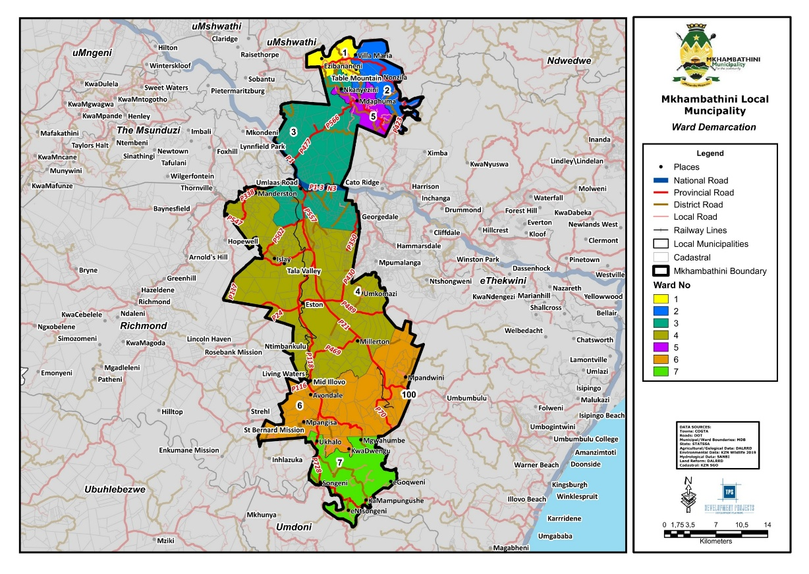
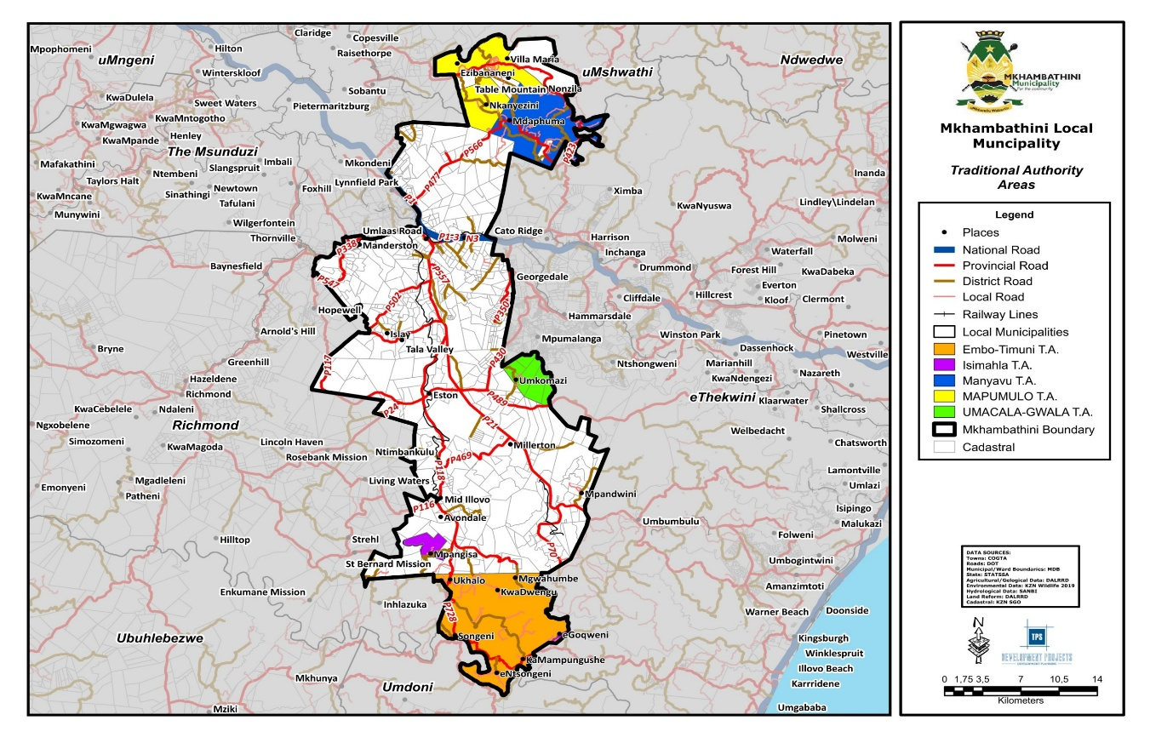
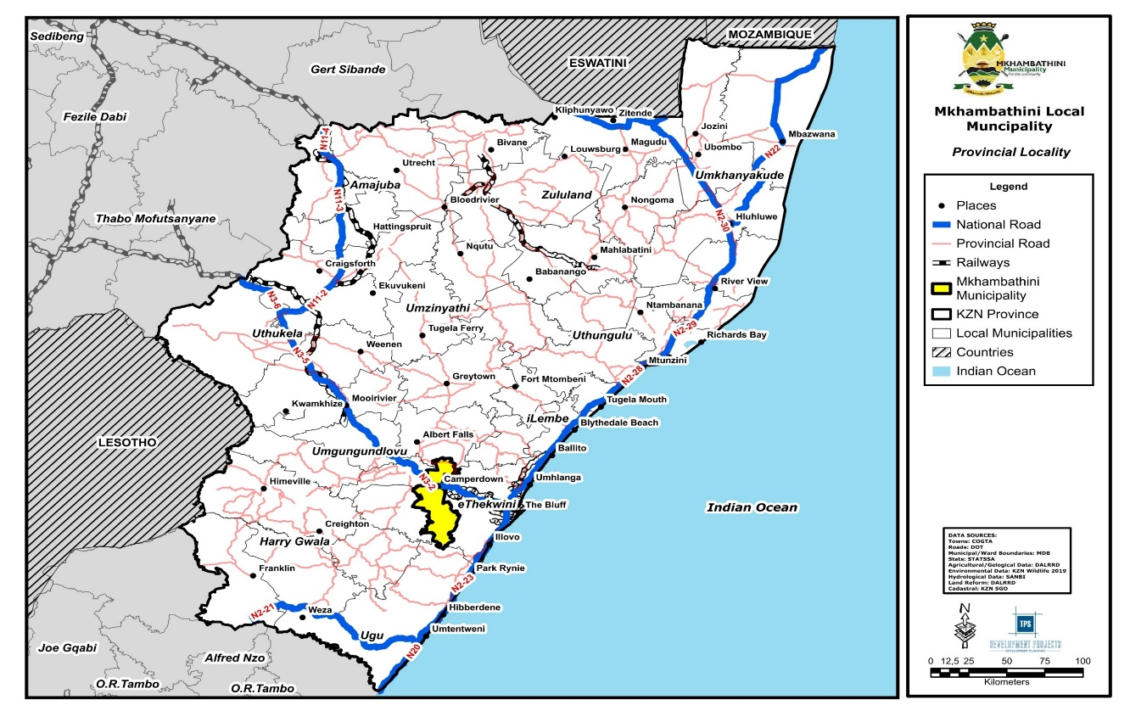
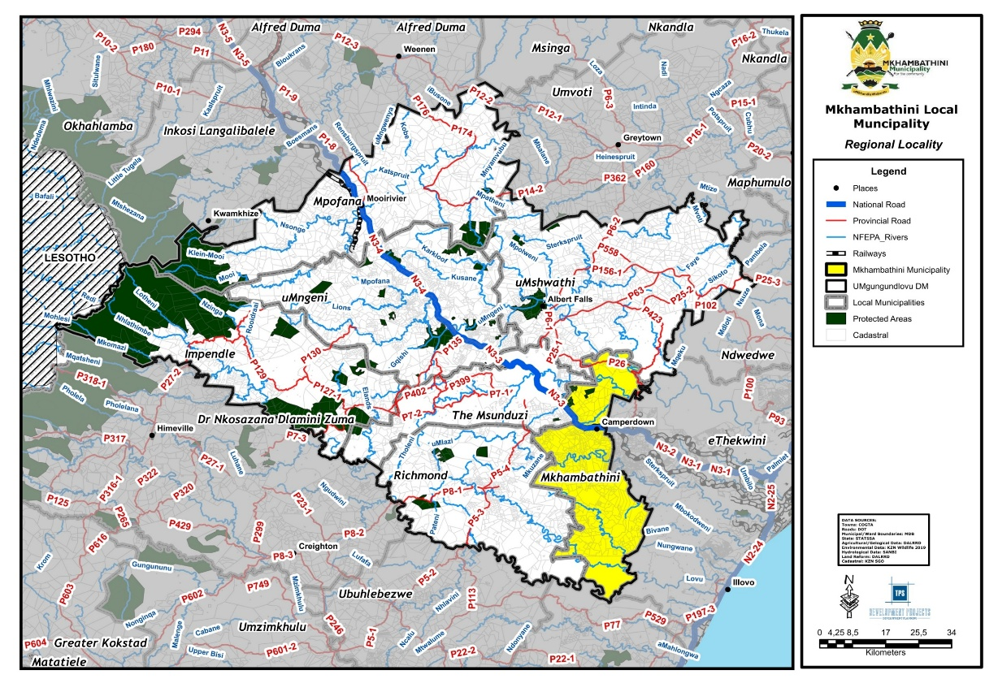
Map 1: Ward Demarcation
Map 2: Traditional Authority Areas
Map 3: Regional Locality
Map 4: Provincial Locality

LEGISLATION AND POLICY INFORMANTS

CONSTITUTION OF THE REPUBLIC OF SOUTH AFRICA, ACT NO. 108 OF 1996

The Constitution establishes the framework for democratic local governance (Section 152) and directs spatial planning toward integrated development, spatial transformation, and the progressive realisation of access to land, housing, basic services, and a sustainable environment.
SPATIAL DIRECTIVES: Ensure equitable access to land, housing, and infrastructure in both the urban, and rural areas. Strengthen public participation in planning decisions, particularly in traditional authority areas. Avoid development that compromises environmental rights, especially along estuaries, floodplains and wetlands.

MUNICIPAL SYSTEMS ACT, 2000 (ACT NO. 32 OF 2000)
The Municipal Systems Act provides the framework for IDP’s, SDF’s, and subsequently the SDP’s. Accordingly, SDP’s must reflect the desired spatial form, address land use patterns, guide development, and align with neighboring municipalities.

MUNICIPAL SYSTEMS ACT, 2000 (ACT NO. 32 OF 2000):
The Municipal Systems Act provides the framework for IDP’s, SDF’s, and subsequently the SDP’s. Accordingly, SDP’s must reflect the desired spatial form, address land use patterns, guide development, and align with neighboring municipalities.
SPATIAL DIRECTIVES: Mkhambathini SDP must prioritize environmental assessments, and basic land use management guidelines in consideration to cross border analysis outlined in the SDF

SPATIAL PLANNING AND LAND USE MANAGEMENT ACT, 2013 (ACT NO. 16 OF 2013):
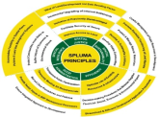
The Spatial Planning and Land Use Management Act establishes norms and standards for spatial planning and land use management. Ensures consistency, equity, and efficiency across all government spheres.
SPATIAL DIRECTIVES: Mkhambathini must prepare its SDP according to SPLUMA principles: Spatial Justice, Sustainability, Efficiency, Resilience, and Good Governance. As an extension of the SDF, the Municipal SDP must include short-term spatial development visions, population and housing demand estimates, infrastructure requirements, environmental assessments, and implementation plans


TRADITIONAL AND KHOI-SAN LEADERSHIP ACT 3 OF 2019
The Traditional and Khoi-San Leadership Act, 3 of 2019, establishes the legal framework for recognised traditional leadership, positioning Traditional Councils as statutory bodies responsible for land administration, customary governance, and development coordination. In KZN, these structures operate within provincial systems coordinated through COGTA and aligned with the Intergovernmental Relations Framework Act, 2005.
SPATIAL DIRECTIVES: Large portions of municipal land fall under the ITB jurisdiction, where most rural settlements are located. Spatial planning and service delivery must therefore be coordinated with Traditional Councils to manage land allocation, support structured upgrading and consolidation, and prevent unplanned expansion, infrastructure inefficiencies, and development in high-risk areas.

NATIONAL ENVIRONMENTAL MANAGEMENT ACT, 1998 (ACT NO. 107 OF 1998) (NEMA)
The objective of the statute is to provide for co-operative, environmental governance by establishing principles for decision-making on matters affecting the environment.
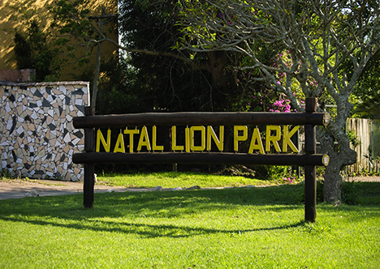
SPATIAL DIRECTIVES: Priority conservation areas within the municipality, including Ezemvelo KZN Wildlife–identified CBA Irreplaceable zones along the northern and southern extents, require protection and sustainable management in line with NEMA. Spatial planning must support appropriate land uses, compatible economic activities, and eco-tourism, while safeguarding these areas through community and regulatory stewardship.

NATIONAL SPATIAL DEVELOPMENT FRAMEWORK, (nsdf), 2022
Approved in March 2022, the NSDF provides a national spatial framework to address apartheid spatial imbalances by promoting equitable development, economic growth, and employment.
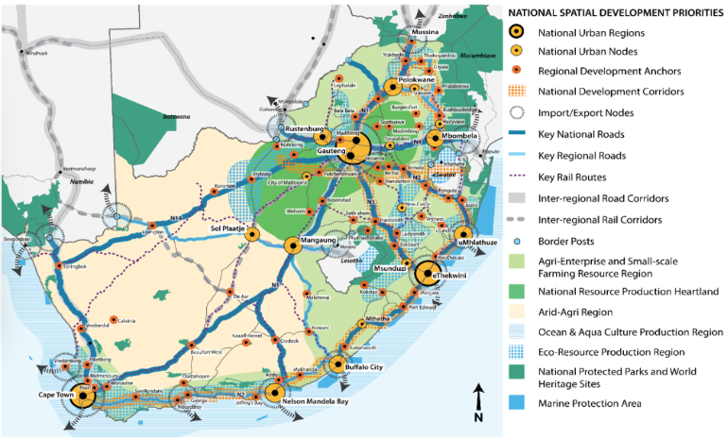
SPATIAL DIRECTIVES: Although the municipality is not specifically mentioned in the National SDF, it is identified as an Agri-Enterprise and Small-Scale Farming Region to which the following is proposed:
- Productive use of high value agricultural land to support national food security.
- Enhance connectivity through well-planned infrastructure investment and settlement consolidation in well-connected regional anchor towns.
- Enhance and extend the role of small-and-medium scale farming through rural land reform, to alleviate unemployment and poverty, and contribute to national food security.
- Rehabilitation of degraded land
- Effective land-use management
- Improve rural-to-rural connections, market accessibility and necessary agricultural production infrastructure
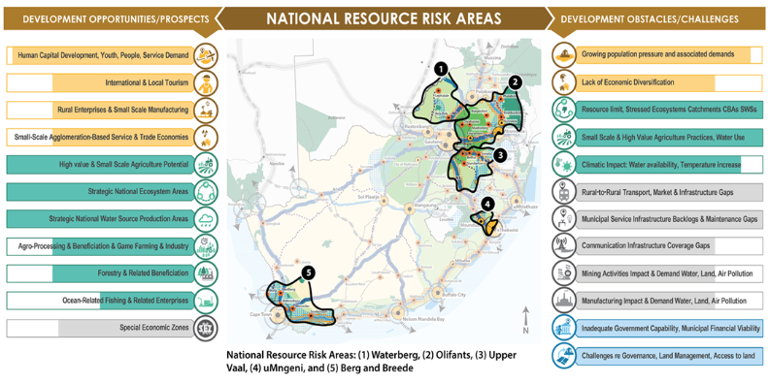
In line with the NSDF, Mkhambathini’s development must reinforce its role along the N3 corridor through compact, nodal growth focused on Camperdown and Umlaas Road, prioritising logistics, agro-processing, and service-industrial activities while preventing linear sprawl. This must be supported by water-sensitive planning and the protection of ecological infrastructure within the uMngeni catchment.

Kzn provincial growth and development strategy, VISION 2035
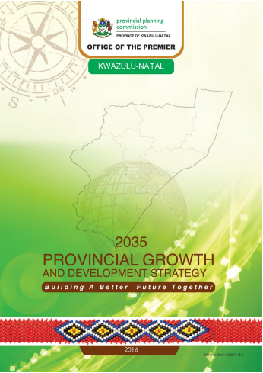
The KZN PGDS is a long-term strategy guiding provincial economic and social development toward sustainable growth, job creation, poverty reduction, and inclusive access to opportunities and services.
SPATIAL DIRECTIVES: The PGDS positions the N3 as KZN’s primary economic spine, requiring Mkhambathini to concentrate logistics and employment-generating activities within Camperdown and Umlaas Road while preventing ribbon development and unmanaged access. It further prioritises Midlands urban–rural integration and agro-processing, necessitating strengthened linkages between traditional authority areas and the primary node via the R603, P338, and P477 corridors.

KZN MEDIUM-TERM DEVELOPMENT PLAN, 2024-2029, (MTDP)
The MTDP is KZN’s five-year implementation framework that translates the PGDS and MTSF into prioritised programmes, projects, budgets, and responsibilities, guiding infrastructure investment, service delivery, economic development, and spatial transformation.
SPATIAL DIRECTIVES: Although not explicitly referenced, the PGDS/MTDP positions Mkhambathini within the N3 freight corridor and Midlands agro-economic zone, requiring protection of the N3 function, consolidation of economic and infrastructure investment in Camperdown and Umlaas Road, strengthened rural–urban linkages along routes such as the R603, and safeguarding of high-value agricultural land and water catchments.

Kzn provincial spatial development framework, 2022
The KZN PSDF is the statutory spatial framework guiding provincial development by identifying corridors, nodes, investment areas, and environmentally sensitive zones, and directing where growth should be promoted, managed, or restricted.
SPATIAL DIRECTIVES: According to the PSDF, Camperdown is identified as a Small Town, which is a centre that provides services to the local economy. The PSDF proposes the following interventions for small towns:
- Secondary economic growth areas.
- Promote as secondary node in support of corridor development.
- Promote compact urban development & combat urban sprawl.
- Promote focused investment & managed growth.
- Promote densification (brown agenda) & infill development.
- Provide economies of scale for effective & affordable service delivery.
- Infill where high levels of services are available
- Increased residential density (number of dwellings).
- Promote socio-economic upliftment.
- Promote provision of sufficient bulk infrastructure services (demand & supply).
- Priority spending on infrastructural upgrading needs (new & maintain)

kzn greater regional spatial development framework, 2025
The KZN Greater RSDF is a SPLUMA-aligned regional framework that guides cross-boundary spatial transformation, economic transition, and infrastructure coordination by integrating national, provincial, and municipal priorities into a long-term spatial logic of corridors, multi-nodal development, protection areas, and priority investment zones.
SPATIAL DIRECTIVES: Spatial development in Mkhambathini should reinforce its role within the Greater KZN multi-nodal region by structuring movement and investment along the N3, R603, R624, P338, and P477 corridors, while consolidating growth within key service centres and settlement clusters (Eston–Maqongqo, Mid-Illovo–Manderston, Ophokweni, and Ngilanyoni–Tilongo) to improve access and efficiency. Development within the uMngeni catchment must be strictly managed to protect water security and ecological systems, with tourism directed along established routes to assets such as Nagle Dam and controlled through measures that prevent ribbon development.
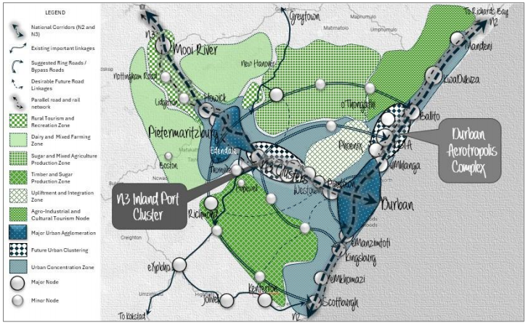

umgungundlovu district municipality spatial development framework, 2022
The UMDM SDF is the district’s SPLUMA-aligned statutory framework that guides long-term spatial development by defining corridors, settlement hierarchies, protection areas, and priority investment zones to inform coordinated land use, infrastructure planning, and decision-making.
SPATIAL DIRECTIVES: The UMDM SDF directs development in Mkhambathini around a defined settlement hierarchy, with Camperdown as the primary town, supported by Eston and Mid-Illovo as rural service centres, and a dispersed rural settlement network. Growth and investment are to be consolidated within these centres and along the R603 and R624 corridors, while expansion beyond them remains low-intensity and rural in character. This positions Mkhambathini as an agricultural support municipality focused on corridor access and rural service delivery rather than urban-scale growth.
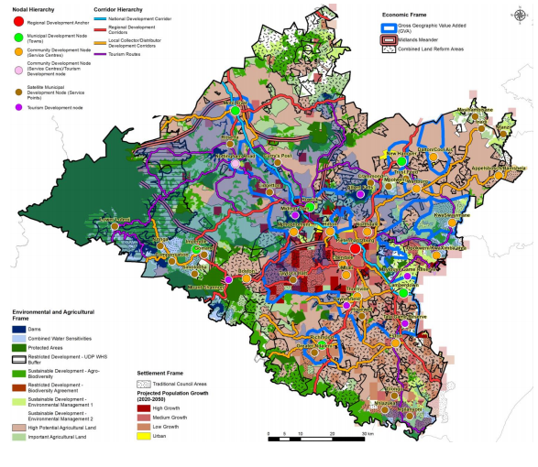

umgungundlovu district growth and development plan
The UMDM DGDP establishes a long-term development vision for the district, providing a coordinated framework for planning across municipalities and a spatial rationale for priority interventions.
SPATIAL DIRECTIVES: The UMDM DGDP positions Mkhambathini as a corridor-linked, agriculture-driven municipality along the N3, anchored in crop production and intensive livestock, including a significant poultry sector. Eston is identified as a priority agro-processing hub with value-chain linkages to the corridor, while manufacturing focuses on value addition to agricultural and timber resources, and tourism leverages assets such as Tala Game Reserve and Nagle Dam. This reinforces Mkhambathini’s role as a rural production support area rather than a primary urban growth centre.

MKHAMBATHINI LOCAL MUNICIPALITY SPATIAL DEVELOPMENT FRAMEWORK, 2026
The municipality has developed a Municipal SDF with the following long-term vision statement:
“By 2045, Mkhambathini will be a prosperous municipality where industry, tourism, and agriculture drive sustainable livelihoods, regional integration, and inclusive human development along the N3 Corridor, supported by the protection and restoration of its natural systems that underpin long-term resilience”
SPATIAL DIRECTIVES: The following spatial concepts have been outlined in the SDF that are to be realised in the SDP:
- Spatial Priority Investment Areas
- Sustainable Urban Development
- Sustainable Rural Development
- Nodal Development
- Corridor Development
- Sustainable Use And Preservation Of The Natural Environment
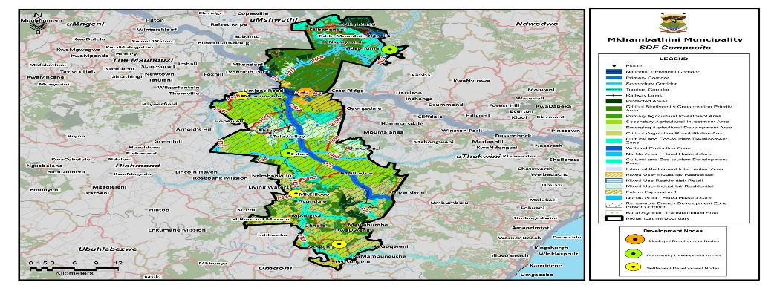

summary of challenges and opportunities
Table 1: Summary of challenges and opportunities
STRENGTHS | WEAKNESSES | OPPORTUNITIES | THREATS
One of Mkhambathini LM's key strengths is its growing working-age population which constitutes 64.6% of the total population. | A weakness is its high dependency ratio, which at 48.9% places a significant economic strain on the working-age population. | The demographic advantage presents an opportunity for economic growth, as a larger portion of the population is capable of contributing to the labour market and fostering economic activity. | The aging population will require increased healthcare and social services.
Increasing matric and higher education attainment indicate a more skilled workforce that could potentially drive economic diversification and improved employment prospects. | The municipality has a significant indigent population, with 78% of households earning less than R38 400 per year. | Encouraging public-private partnerships to develop technical and vocational education and training (TVET) institutions can help bridge the skills gap and improve employability. | High levels of poverty and inequality pose challenges for social stability and can lead to increased reliance on government grants.
The municipality’s poverty rate is declining over time. | Income disparities and poverty remain major challenges, with 69.9% of the population living below the upper-bound poverty line. Additionally, 12.6% of residents live below the food poverty line, meaning they struggle to afford even basic nutrition. | In relation to the other municipalities in the District, Mkhambathini has the highest socio-economic vulnerability in Umgungundlovu. It is also one of the most socio-economically vulnerable municipalities, ranking 43rd out of 44 in KZN with a SEVI of 9.4 | Income inequality remain persistent threats to social stability. If job creation does not keep pace with population growth, there could be increased levels of poverty, crime, and social unrest. The lack of sufficient job opportunities could lead to higher rates of youth unemployment.
The high unemployment (25.4%) and low labour absorption (32.7%) poses challenges for the municipality. | The low-skilled workforce has grown at a 2.1% CAGR indicating that new entrants into the labour market are also low skilled workers | In relative terms Mkhambathini has a lower unemployment rate of 25.4% in comparison to provincial and national levels. | Lack of basic services and infrastructure to support job growth in key sectors.
The agriculture sector provides significant employment and contributes substantially to the local economy. | Impact of climate change on the agricultural sector. | Mkhambathini has prime agricultural land with large areas with good agricultural potential. | While agriculture is a key strength, over-reliance on this sector makes the municipality vulnerable to economic shocks such as climate change, market fluctuations, and external trade disruptions.
Agriculture, particularly in the form of agro-processing, poultry, sugarcane, and maize farming, plays a vital role in the local economy. The agricultural sector continues to generate employment for approximately 47.5% of the workforce in Mkhambathini, underscoring its importance to the local economy. | The secondary and tertiary sectors remain underdeveloped, with manufacturing employing only 9.5% of the workforce and trade-related activities accounting for 12%. | By investing in agro-industrial parks, small-scale manufacturing, and food processing, Mkhambathini can reduce its dependence on raw agricultural production and create higher-value job opportunities. | Climate change, which poses a serious risk to the municipality’s agricultural sector. Droughts, unpredictable weather patterns, and natural disasters could severely impact crop yields, food security, and employment in agriculture.
Increased industrial investment along Umlaas Road towards Msunduzi. | Marginalization of communities from key economic opportunities exacerbated by poorly structured routes (predominantly north and south). | Relatively good agricultural land and opportunities exist to develop this sector even further | The wrong type of development on prime land.
Fairly diverse tourism sector due to the scenic beauty (Table Mountain), adventure activities, accommodation, cultural activities, nature, major events and rural activities found in the area. | No signage to tourism related routes and insufficient marketing of tourism in the Municipality | Further development of tourism opportunities, integration and collective promotion of tourism attractions | Poor infrastructure in rural areas including lack of proper road infrastructure.
Mkhambathini is strategically located near key transport routes such as the N3, connecting it to important industrial and logistics hubs. | Spatial isolation and underdeveloped infrastructure in some parts of the municipality hinder access to services, education, and economic opportunities. | This positioning offers significant opportunities for developing the logistics and manufacturing sectors, particularly in agricultural-related industries like food processing and transport equipment. | It is a largely rural municipality with limited private development taking place within it.
Established agricultural and manufacturing sectors. | While agriculture remains the backbone of the economy, the secondary and tertiary sectors, such as manufacturing, retail, and services, remain underdeveloped | There is significant potential for diversifying into other sectors such as manufacturing, logistics, and tourism. | Mkhambathini's economy has generally become more concentrated over time, increasing its vulnerability to external economic shocks.
There have been notable improvements in electricity access, with 96.3% of households having access to electricity for lighting in 2022. | Sanitation and waste management remain challenging with only 25.3% of households have flush toilets connected to a sewerage system. Weekly refuse removal services are also severely lacking, with only 15.7% of households receiving this service. | Expanding access to piped water, sanitation, and waste management services will improve living conditions and attract more businesses and residents. This can be done through public-private partnerships for service delivery improvements. | If access to water, sanitation, and waste management is not significantly improved, there could be negative consequences for public health and environmental sustainability.
The town of Camperdown is the most urban area of the municipality and the municipality’s primary node appropriately positioned in proximity to the N3. | Concentration of amenities and infrastructure in Camperdown | Potential exists to develop and intensify the role of Eston and Ophokweni as secondary nodes. | Anticipated increase in in migration to Camperdown.
The economic vulnerability index has improved over time, declining from 6.9 in 1996 to 4.7 in 2011, suggesting some level of economic stabilization. | Over-reliance on a few sectors, such as agriculture, exposes it to economic shocks if these sectors underperform or face external challenges | Diversification of agricultural production and Agri-processing opportunities around Eston (poultry production and sugarcane). | The municipality faces risks associated with limited industrial diversification.

Mkhambathini MUNICIPALITY 20-YEAR LONG TERM SPATIAL DEVELOPMENT VISION

The vision for a Local Municipality should align with higher-level visions and consider spatial representation tiers. It should guide the growth of the area, leveraging its strengths and addressing its issues.
The strategic development vision for the Mkhambathini SDF was developed in line with the National Spatial Development Framework (NSDF), KwaZuluNatal Provincial Spatial Development Framework, KwaZulu-Natal Growth and Development Strategy, the UMgungundlovu Spatial Development Framework (SDF) and the UMgungundlovu Integrated Development Plan (IDP). The vision statements for these plans, as well as the SDF vision, are highlighted below:
National Spatial Development Framework Vision, 2022
“All Our People Living in Shared and Transformed Places in an Integrated, Inclusive, Sustainable and Competitive National Space Economy.”
Provincial Spatial Development Framework Vision (Towards 2022 - 2027)
“Equitable utilization of physical and environmental resources toward greater spatial integration and sustainability in development”
Provincial Growth and Development Strategy
“By 2035 KZN will be a prosperous Province with a healthy, secure and skilled population, living in dignity and harmony, acting as a gateway to Africa and the World)”
UMgungundlovu District Municipality Integrated Development Plan Vision
“UMDM is geared towards creating an economically vibrant, socially inclusive, environmentally resilient district with thriving communities and universal infrastructure for all by 2027 and beyond”
UMgungundlovu District Municipality District Development Model
“By 2052, UMDM shall be a viable, innovative and resilient region that is built on sustainable economic growth and accountability”
Mkhambathini Local Municipality Integrated Development Plan
“By 2030 Mkhambathini Municipality will be KwaZulu-Natal’s mega-hub for industries, tourism and agriculture along the N3 Corridor which provides a socially cohesive environment”

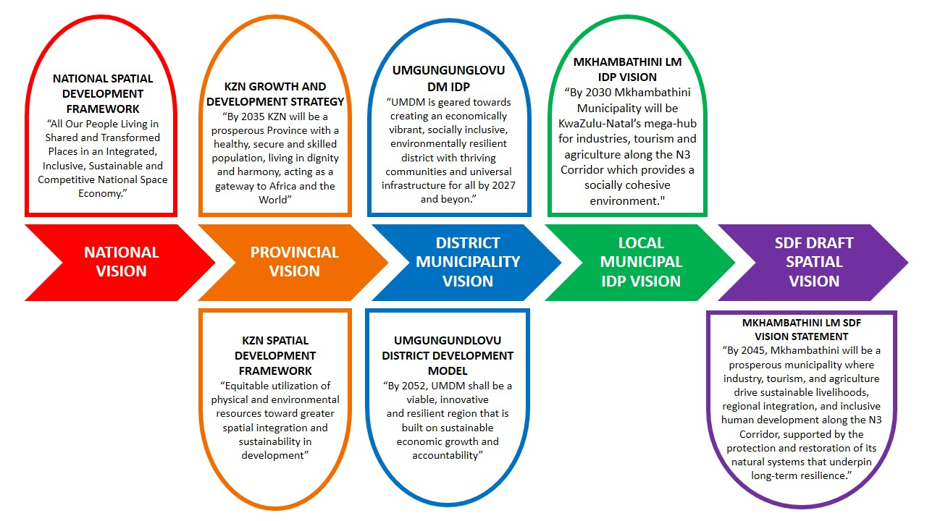


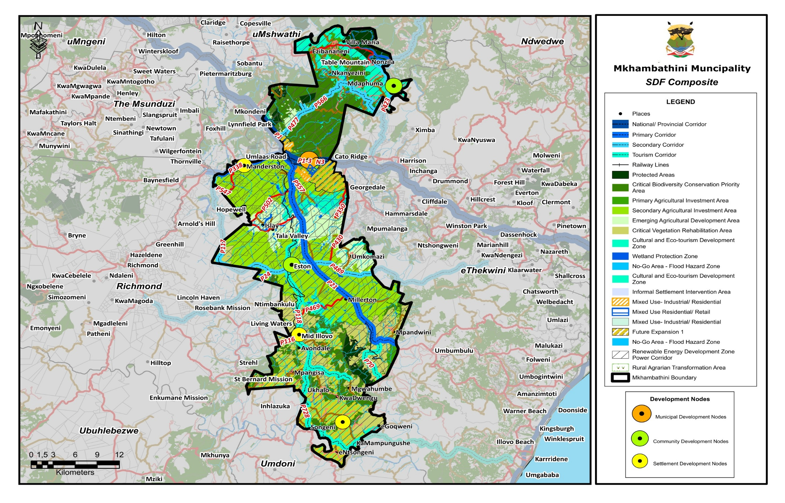
Map 5: Mkhambathini SDF Composite

mkhambathini municipal five (5) year spatial development plan
Over the next five years, Mkhambathini Local Municipality aims to establish a well-structured, inclusive, and economically productive rural municipality that promotes sustainable agricultural development, improved connectivity, and environmentally responsible land management. The municipality will focus on strengthening key service nodes such as Camperdown and strategically located rural settlements, improving access to infrastructure and services, and leveraging its strategic location along the N3 corridor to stimulate local economic development.
The Spatial Development Plan seeks to guide spatial growth by consolidating settlements, protecting high-value agricultural land and biodiversity resources, and directing investment towards strategic development corridors and nodes. Through coordinated planning and targeted infrastructure investment, the municipality will work toward creating sustainable human settlements, resilient rural economies, and improved quality of life for communities across the municipal area.

vision statement and objectives
The Municipal 5-Year Development Vision is as follows:
“By 2031, Mkhambathini will exhibit improved spatial functionality along the N3 corridor and key settlements, supported by enhanced infrastructure and services, enabling emerging economic activity in agriculture, tourism, and industry while safeguarding critical environmental systems.”
NCRAGE NODAL DEVELOPMENT
Table 2: Objectives and Implementation Vision
SPATIAL DEVELOPMENT OBJECTIVE | IMPLEMENTATION VISION (2026–2031)
STRENGTHEN NODAL DEVELOPMENT | - Strengthen Camperdown as the primary service and economic node within the municipality.  - Promote the development of secondary rural service nodes to improve access to social facilities, municipal services, and economic opportunities for rural communities
IMPROVE MOVEMENT SYSTEMS AND CONNECTIVITY | - Enhance connectivity between settlements, economic areas, and service centres through improved road infrastructure.  - Capitalise on the N3 corridor and regional road networks to improve access to markets, employment opportunities, and regional economic hubs.
PROTECT ENVIRONMENTAL AND BIODIVERSITY ASSETS | - Protect environmentally sensitive areas including rivers, wetlands, biodiversity areas, and ecological corridors.  - Promote sustainable land use practices that balance development with environmental conservation and climate resilience.
PROMOTE AGRICULTURAL DEVELOPMENT AND THE RURAL ECONOMY | - Safeguard high-value agricultural land and support agrarian reform and emerging farmers.  - Promote agricultural value chains, agri-processing opportunities, and rural-based economic activities.
DEVELOP SUSTAINABLE HUMAN SETTLEMENTS | - Encourage compact and well-located settlement development near service nodes and economic opportunities.  - Improve access to basic services, housing, and social infrastructure within existing settlements.
STIMULATE LOCAL ECONOMIC DEVELOPMENT | - Identify and promote opportunities in agriculture, tourism, logistics, and rural enterprise development.  - Encourage investment along strategic transport corridors and within designated economic nodes.

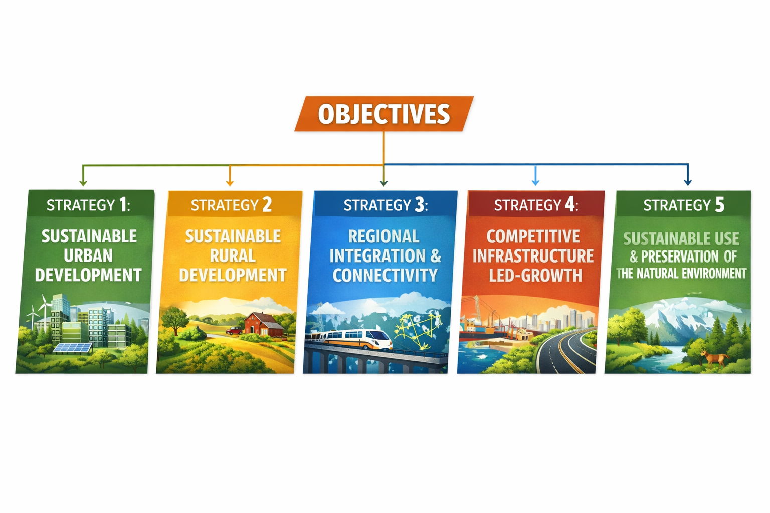
GUIDING STRATEGIES
Figure 1: Development Strategies

Strategy 1: Sustainable Urban Development

Compact Development and Infill Development
The municipality will promote compact and efficient urban growth through targeted infill development and increased residential densities within existing settlement areas. Vacant and underutilised land within Camperdown, particularly between the R103 and N3 corridors, will be prioritised for medium-density mixed-use redevelopment that integrates residential, commercial and community uses. The R103 corridor will be transformed from a low-density transport route into an active mixed-use service boulevard characterised by improved pedestrian infrastructure, non-motorised transport facilities and higher-density shopfront housing developments.
To improve land-use efficiency and infrastructure sustainability, the municipality will introduce minimum residential density thresholds and promote diverse housing typologies such as walk-up flats, duplex units and densified serviced layouts near transport corridors and economic nodes. Within defined village growth boundaries, infill sites will be allocated for mixed-income housing, small business parks and community facilities. The redevelopment of underutilised land, including old industrial sites, will also be encouraged to stimulate economic activity and support sustainable urban form.

Development Priority Areas for Intervention and Investment (Urban Acceleration Zones)
Urban Acceleration Zones will be established in areas with strong economic potential and existing infrastructure capacity to fast-track development and investment. These zones are primarily located along the N3 Strategic Corridor and the R103 corridor, where logistics, industrial and commercial activities are already emerging. Key priority areas include the Camperdown–Umlaas Road precinct, which will be developed as a logistics and agri-industrial hub through precinct planning and land development facilitation mechanisms.
The Eston node will be strengthened through the diversification of the Eston Mill precinct into an agro-processing and renewable energy hub, supported by public–private partnerships for infrastructure investment. Along the R103 corridor between Camperdown and Lynnfield Park, development will be guided through improved access management, road beautification and mixed-use frontage zoning to support compact economic growth. These acceleration zones will be supported by precinct plans, local area plans and prioritised bulk infrastructure investment through municipal and provincial funding programmes.

Revitalisation of Key Economic Nodes
The sustainable urban development strategy also focuses on revitalising key economic nodes within the municipality to improve economic activity, service delivery and settlement integration.

Camperdown–Umlaas Node
This primary municipal development node will be strengthened as a regional logistics and service gateway along the N3 corridor. Development interventions include the establishment of a unified regional gateway node, development of logistics estates near the Umlaas interchange, and the introduction of transit-oriented housing around the Camperdown CBD. Infrastructure upgrades such as a new wastewater treatment works, improved water storage capacity and internal connector roads will support higher-density development and economic expansion. Green infrastructure corridors along the Mshwathi River will also be developed to improve environmental resilience and recreational opportunities.

Eston Node
Eston will be developed as a rural service centre supporting surrounding farming communities and agricultural industries. Proposed interventions include agro-industrial development linked to the sugar mill, revitalisation of railway infrastructure for freight logistics, and the development of tourism opportunities linked to Tala Game Reserve and Nagle Dam. Infrastructure improvements will include the formalisation of the taxi rank, improved road safety measures, expanded community services and the development of a red meat agricultural hub.

Ophokweni Node
Development in Ophokweni will focus on improving access to basic infrastructure and strengthening its role as a rural service centre. Key interventions include the development of a comprehensive water supply system, sanitation upgrades, improved access roads and the formalisation of local trading areas and transport facilities. Additional measures such as solar street lighting and lightning protection systems will enhance community safety and resilience.

Ngilanyoni Node
Ngilanyoni will be developed as a satellite service node supporting surrounding rural settlements. Priority interventions include water supply improvements, sanitation upgrades, road infrastructure development and the establishment of a local market and agricultural support facilities. Tourism opportunities linked to the uMkomaas Valley adventure routes will also be explored to stimulate local economic activity.

Maqonqo Node
Maqonqo will be strengthened as a tertiary rural service centre through improved infrastructure, settlement restructuring and support for local economic activities. Planned interventions include the formalisation of public transport facilities, development of community markets, livestock support infrastructure and the expansion of education and healthcare facilities.

Mid-Illovo Node
Mid-Illovo will be developed as an agricultural service hub supporting surrounding commercial farms and rural settlements. Development initiatives include the activation of rail freight infrastructure, establishment of agro-processing and light industrial activities, and the development of formal trading areas and transport facilities. Infrastructure upgrades such as stormwater management, water supply improvements and solid waste management will support the sustainable growth of the node.

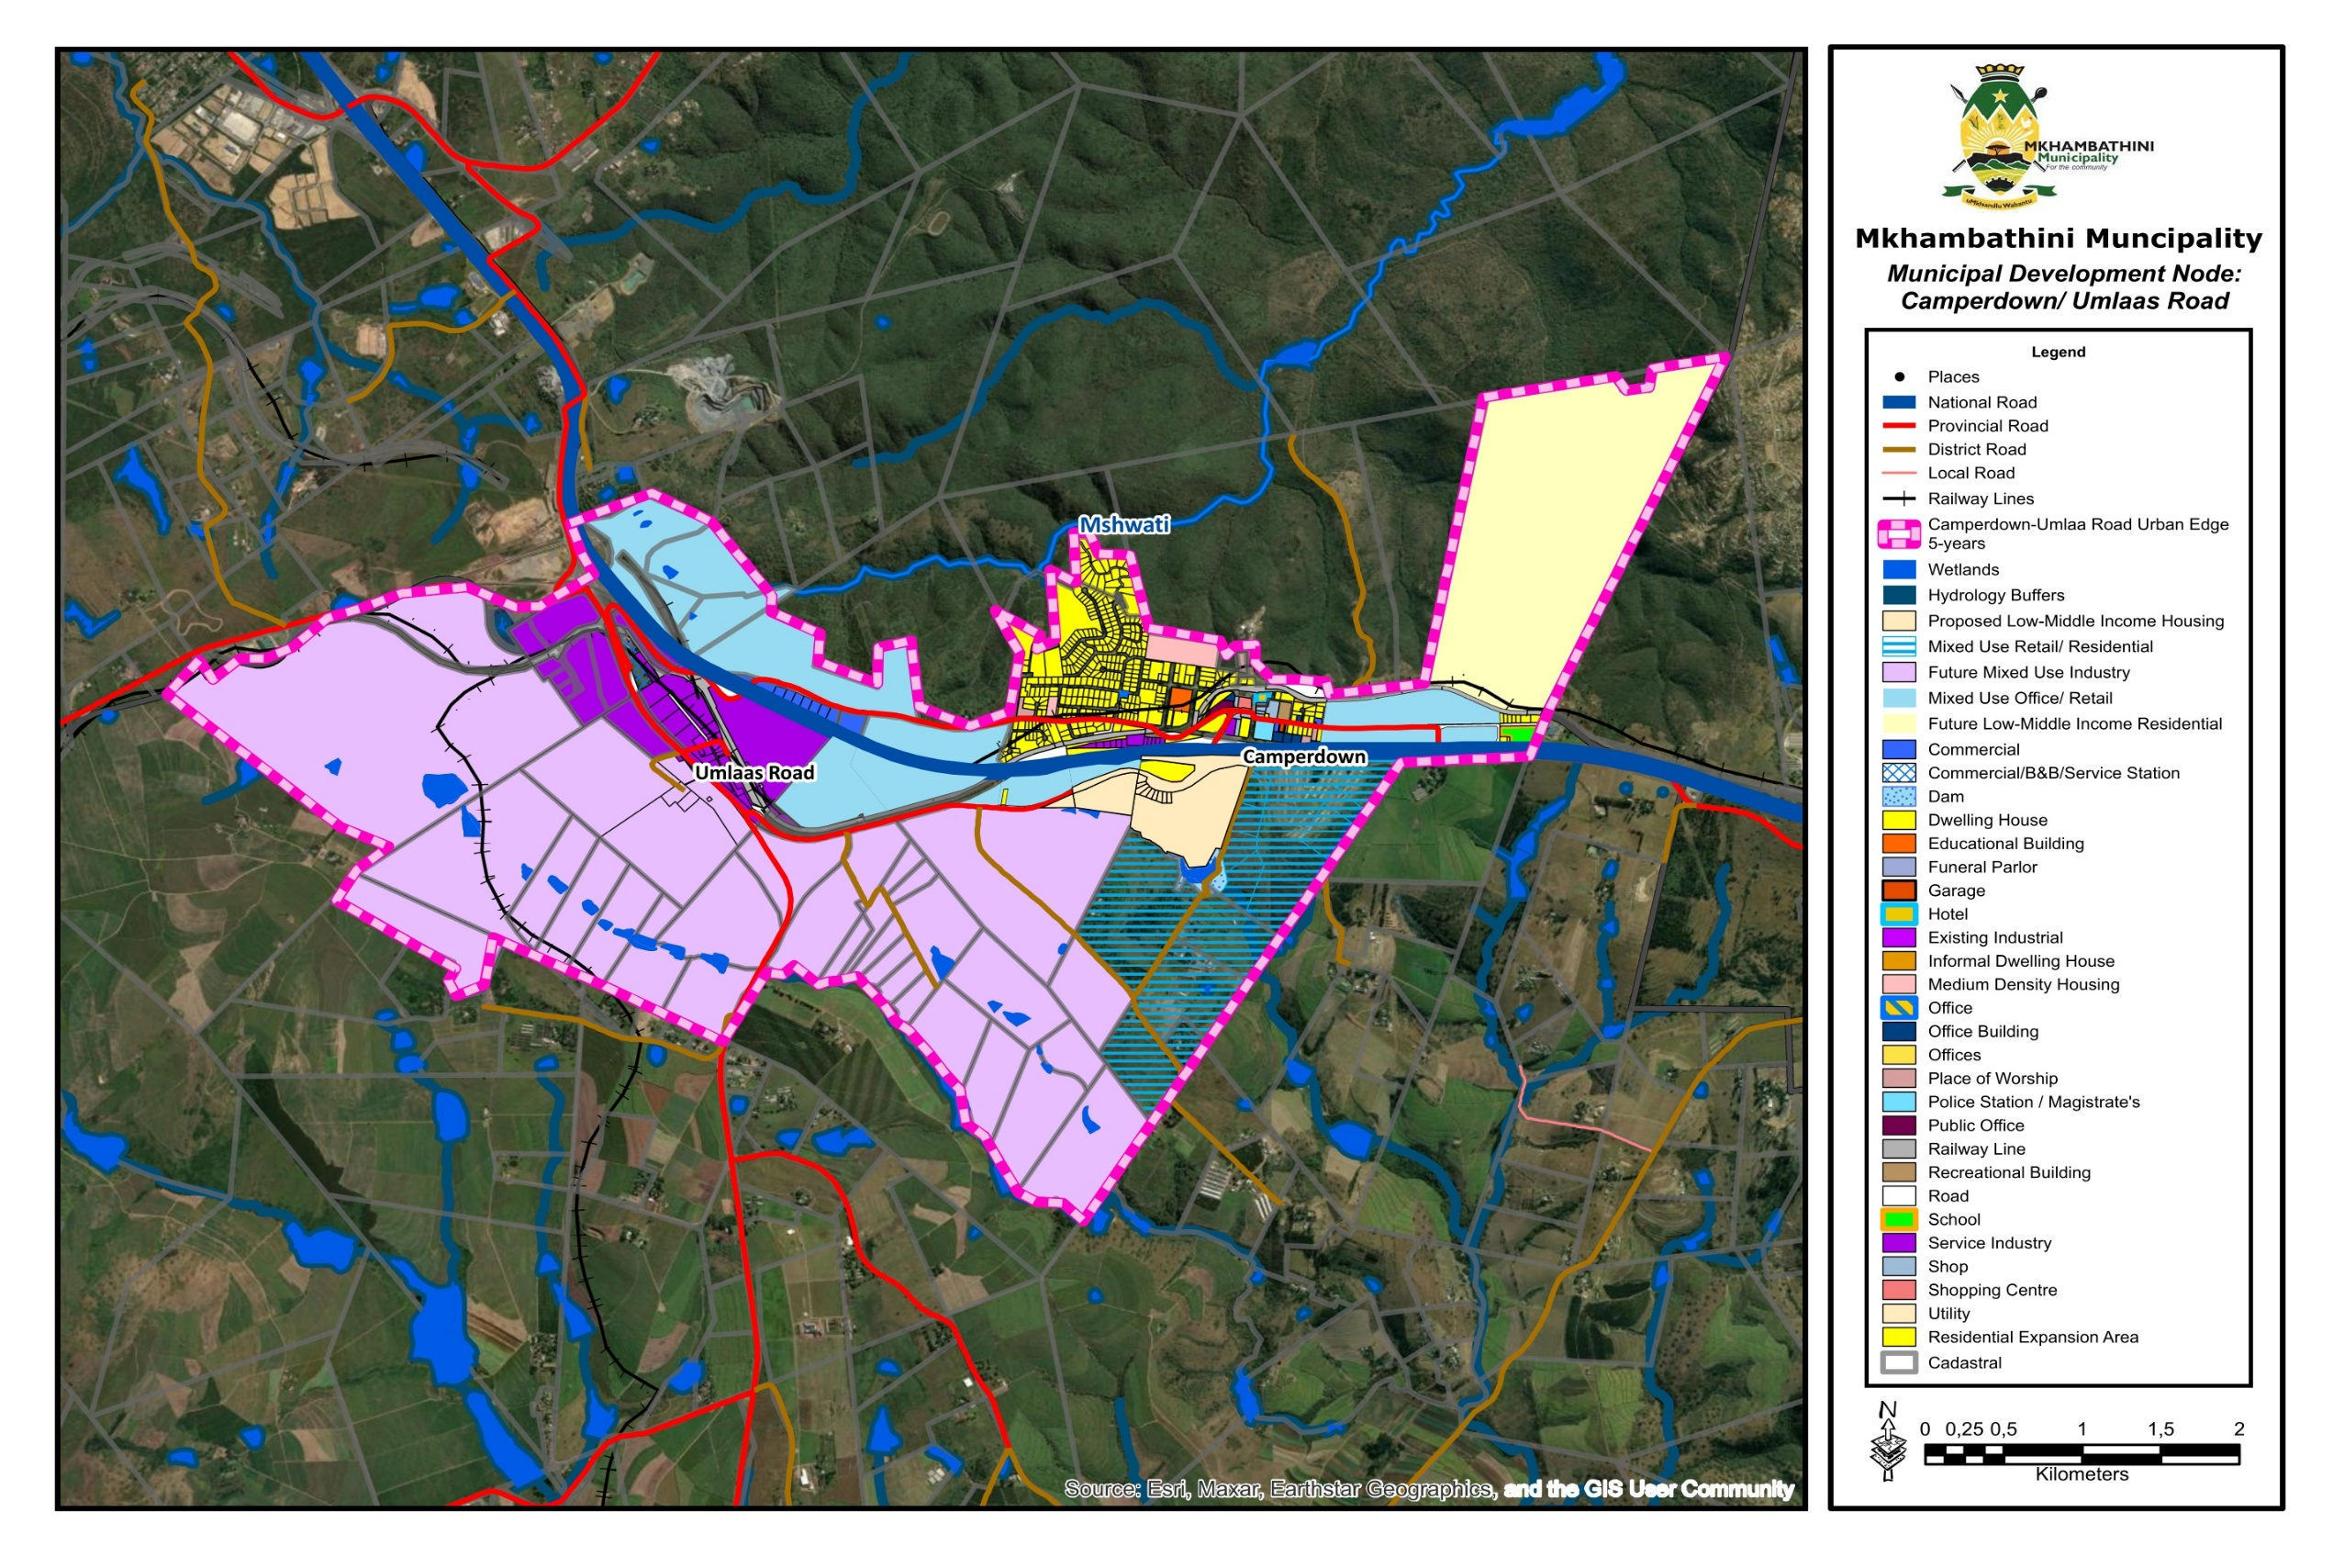
Map 6: Camperdown Urban-Edge
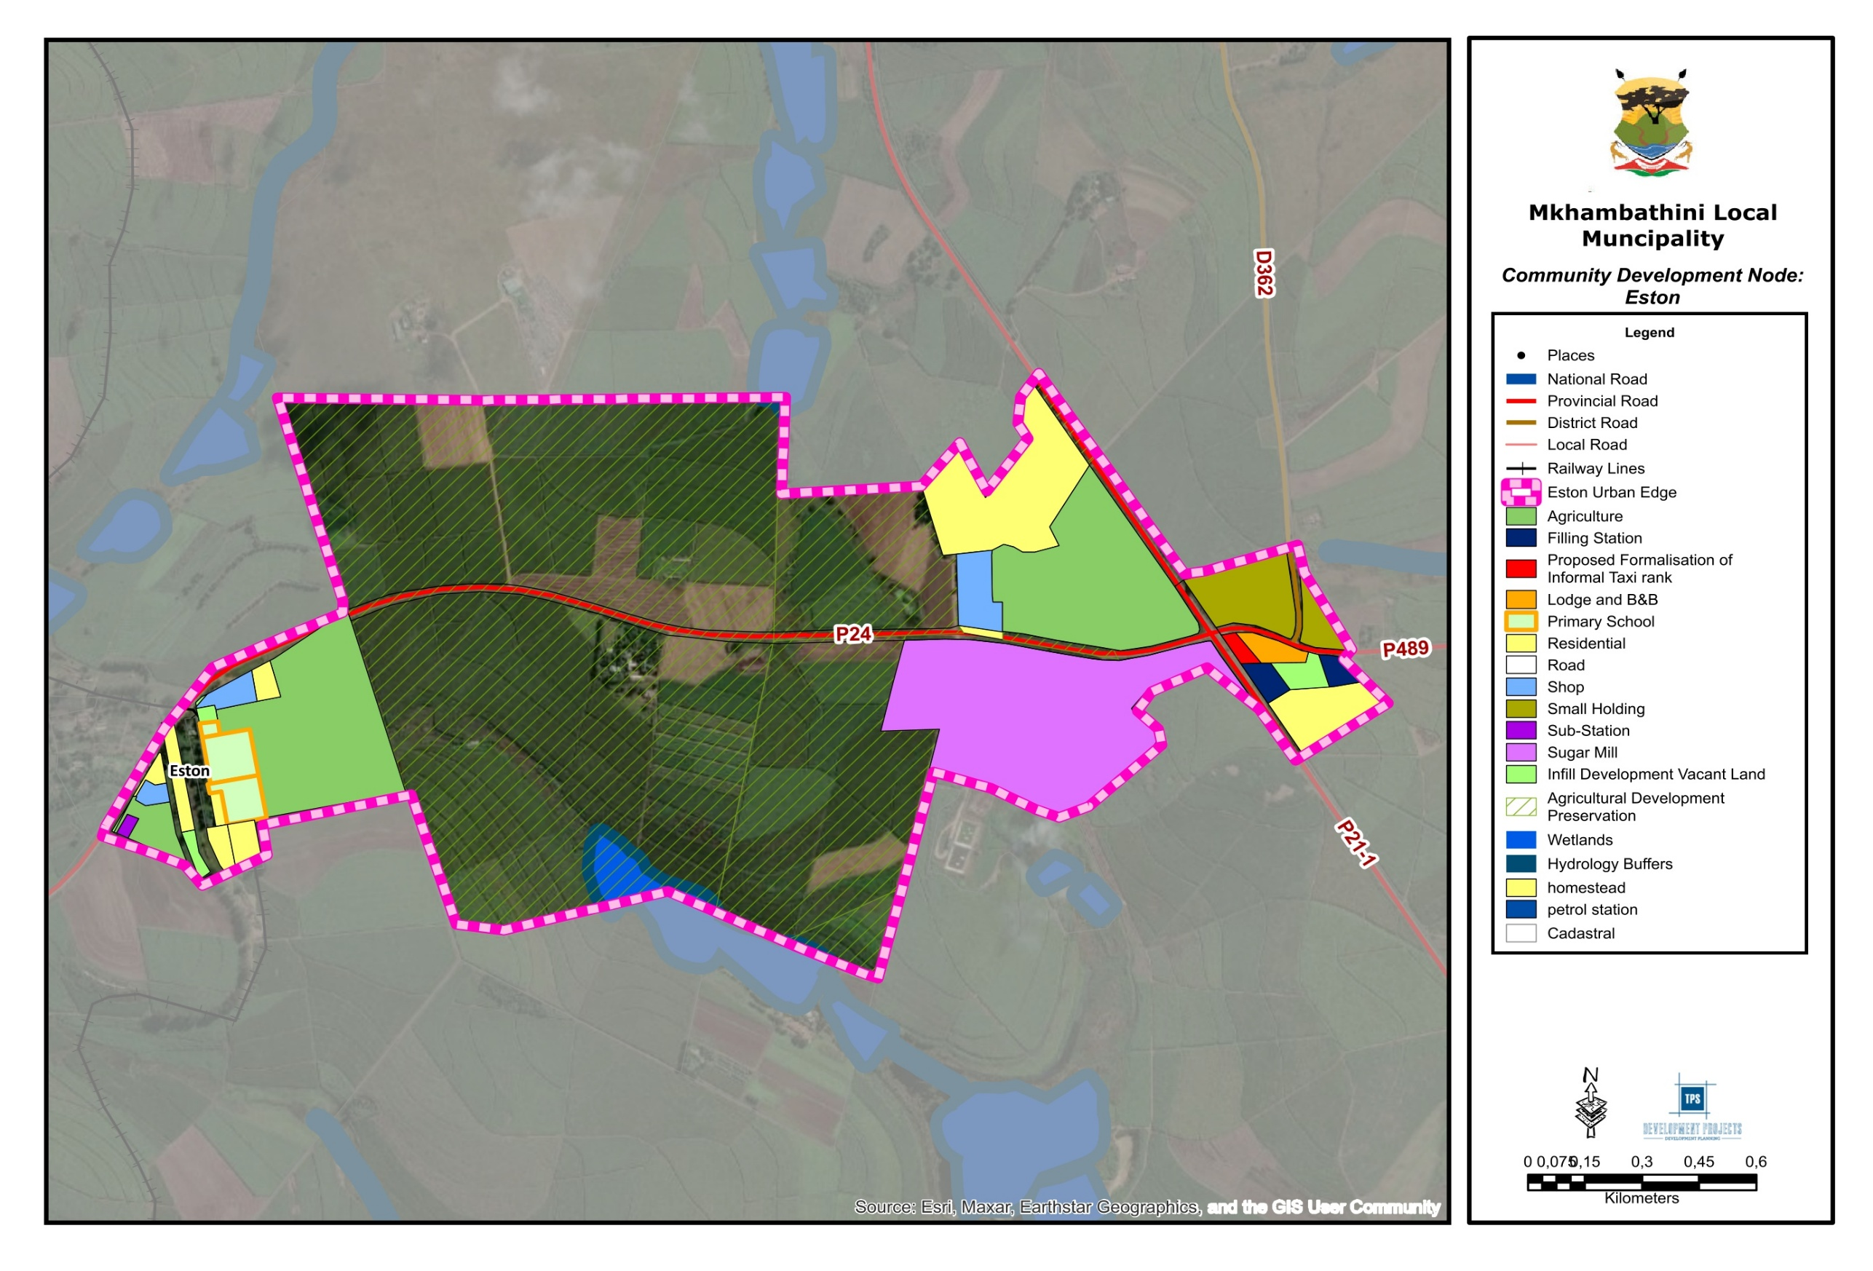
Map 7: Eston Urban Edge
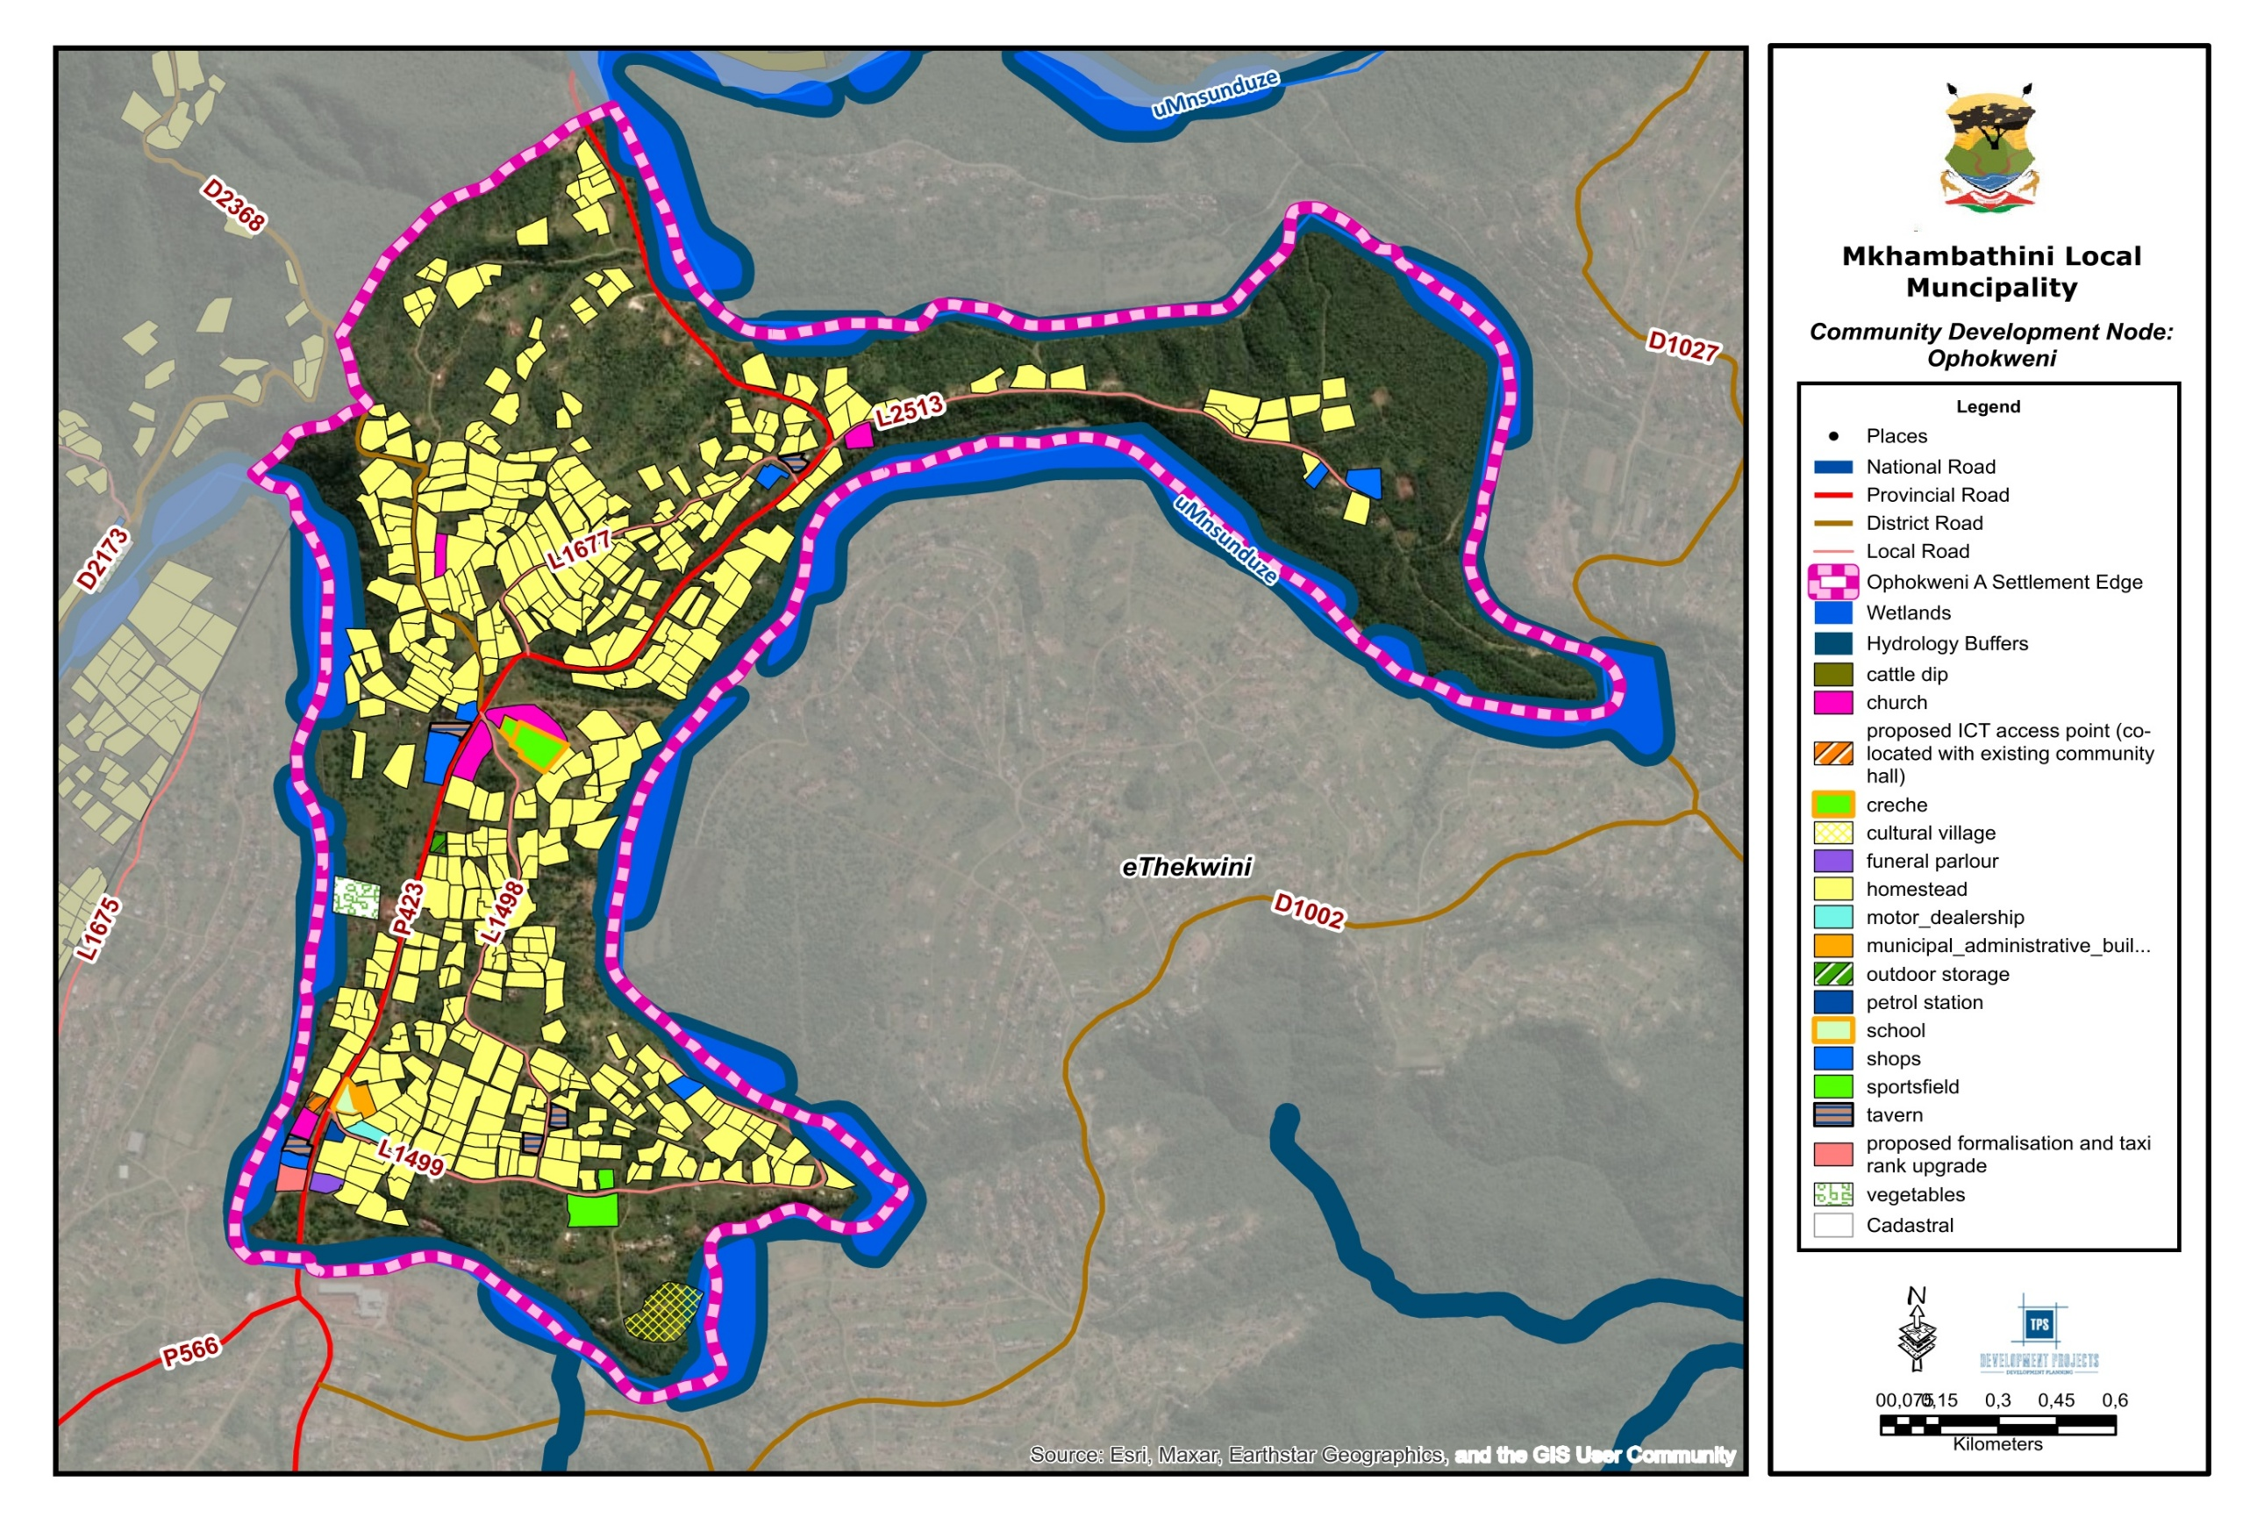
Map 8: Ophokweni A Settlement Edge
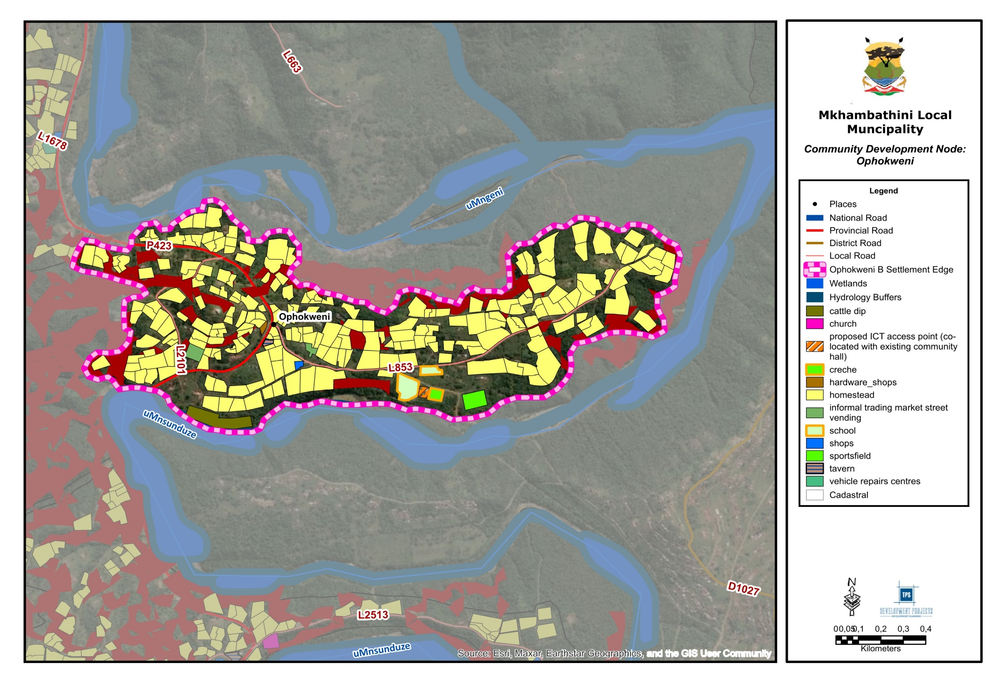
Map 9: Ophokweni B Settlement Edge
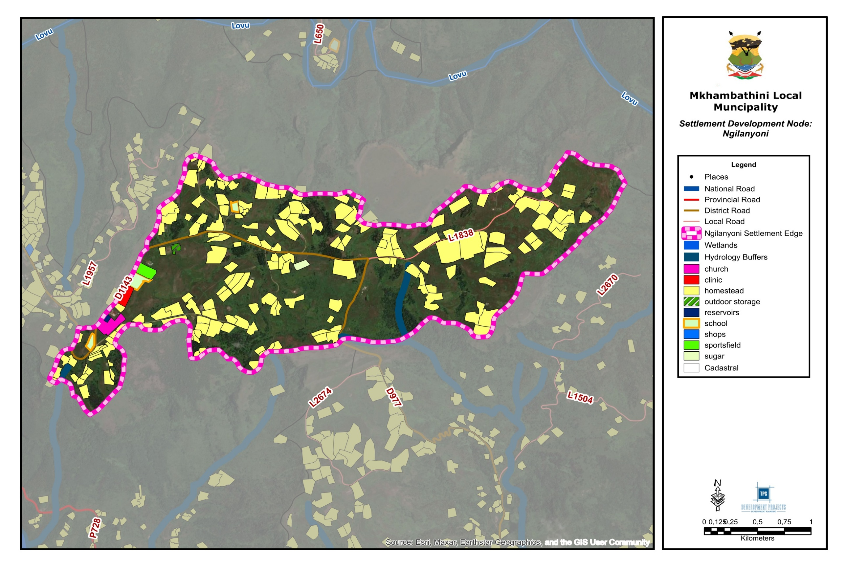
Map 10: Ngilanyoni Settlement Edge
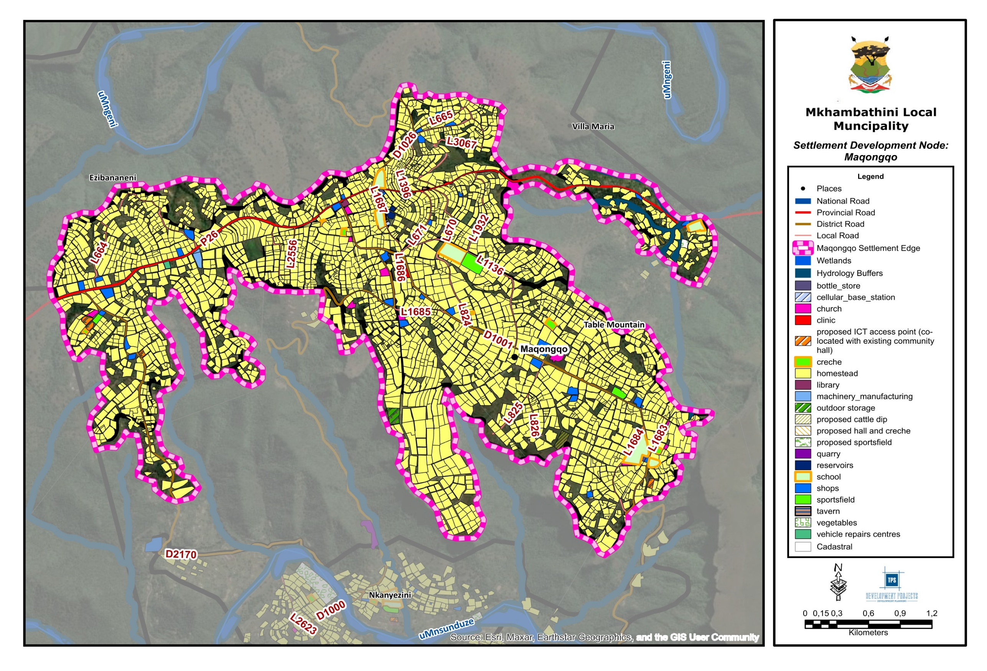
Map 11: Maqongqo Settlement Edge

Strategy 2: Sustainable Rural Development
The Sustainable Rural Development Strategy aims to strengthen rural livelihoods, enhance agricultural productivity, improve service access, and support diversified rural economies across the Mkhambathini Municipality. Given the municipality’s predominantly rural settlement structure and strong agricultural base, this strategy focuses on agrarian transformation, improved rural infrastructure, agro-processing development, social service provision, and inclusive economic participation.
Through targeted investments and coordinated planning, the municipality seeks to transform rural settlements into productive and resilient communities that support both subsistence and commercial economic activities.

Agrarian Transformation
Agrarian transformation focuses on improving the productivity, sustainability, and economic viability of land reform farms and agricultural projects within the municipality. Several land reform projects have been identified across Mkhambathini that require targeted support to strengthen agricultural production and market access.
Key interventions include:
- Upgrading agricultural infrastructure such as livestock kraals, pigsties, poultry housing, irrigation systems, farm access roads, and perimeter fencing.
- Provision of mechanisation support, including tractors, planters, sprayers, and harvesting equipment through programmes such as the Comprehensive Agricultural Support Programme (CASP).
- Improved water supply systems through boreholes, reservoirs, and reticulated irrigation networks.
- Veterinary and extension support to improve livestock health and agricultural productivity.
- Market access support, including linking farmers to fresh produce markets, supermarkets, and institutional procurement programmes.
- Farmer training programmes focusing on crop production, livestock management, sustainable land practices, and farm business management.
These interventions aim to improve productivity and strengthen the participation of emerging farmers in agricultural value chains.

Social Development in the Rural Context
Social development initiatives aim to improve access to essential services and community facilities across the municipality’s Traditional Authority areas. The proposed facilities respond directly to service backlogs, settlement growth patterns, and the spatial distribution of rural populations.
In Manyavu and Mapumulo Traditional Authority areas, proposed clinics, secondary schools, and community halls will be located within densely populated settlement clusters where residents currently travel long distances to access services. Additional facilities such as sports fields, cattle dips, and small trading facilities will support youth development, agricultural activity, and the formalisation of local economic activities.

In Embo-Timuni and Isimahla Traditional Authority areas, facilities will support growing rural settlements such as Ngilanyoni, Thembasethu, and Ophokweni. Proposed interventions include the establishment of community halls, crèches, sports facilities, and agricultural support infrastructure. These facilities will create accessible service centres that strengthen social cohesion while improving access to public services.
Overall, the proposed social infrastructure will support the development of functional rural service nodes and improve living conditions within rural communities.

Rural Agro-Processing Clusters
The municipality’s agricultural landscape consists of diverse production zones including sugarcane and dairy farming in the south, mixed livestock farming in central areas, and horticultural production in the north. To strengthen agricultural value chains, the municipality proposes the development of decentralised rural agro-processing clusters that align with these production zones.
Key clusters include:
- ESTON–MID ILLOVO CLUSTER (SOUTHERN REGION)
This cluster will focus on sugarcane, dairy, and emerging macadamia production. Proposed projects include smallholder sugarcane support programmes linked to the Eston Mill, the development of an agricultural hub, and the establishment of a dairy chilling and packaging facility to support milk producers.

- MANDERSTON–UMKHOMAZI CLUSTER (CENTRAL REGION)
This cluster will support livestock farming, poultry production, and subsistence crop farming. Proposed projects include a livestock feed-mixing facility, a small abattoir, and cooperative wool and hide processing initiatives to support local livestock farmers.
- MANYAVU–MAPUMULO CLUSTER (NORTHERN REGION)
This cluster will focus on vegetable production, horticulture, and small-scale fruit farming. Proposed initiatives include a vegetable drying and cold-chain facility as well as community orchard and seedling nursery projects to support local markets and agro-processing activities.
These agro-processing clusters will strengthen agricultural value chains, create rural employment opportunities, and improve market access for smallholder farmers.

Rural Access, Basic Infrastructure and Digital Inclusion
Limited accessibility and infrastructure remain significant constraints to rural development within the municipality. Many rural settlements are connected by gravel roads that deteriorate during rainy seasons, restricting access to schools, clinics, and markets.
To address these challenges, several provincial road upgrades have been proposed to improve connectivity between rural settlements, agricultural production areas, and major transport corridors such as the N3 and R103.
In addition to physical infrastructure improvements, the municipality proposes the implementation of a Rural Broadband Roll-Out Programme aligned with Strategic Infrastructure Project (SIP) 15. This programme will introduce fibre infrastructure and establish approximately twelve ICT access points across rural wards.
Existing public facilities such as schools, libraries, and community halls will function as digital hubs offering free Wi-Fi, computer access, digital training, and access to e-government services. These interventions will reduce the digital divide and support education, entrepreneurship, and access to markets.

Rural Livelihoods, SMMEs and the Informal Economy
The municipality aims to strengthen rural livelihoods by supporting small enterprises, cultural industries, eco-tourism, and the informal economy.
Key initiatives include:
- Establishment of community arts and craft centres to support local cultural industries such as beadwork, weaving, woodcraft, and traditional performances.
- Development of eco-tourism corridors linking natural attractions, cultural heritage sites, and rural communities.
- Establishment of recycling cooperatives and buy-back centres linked to waste-to-craft and upcycling initiatives.
- Development of community composting projects that support local agriculture while addressing waste management challenges.
- Creation of rural micro-markets and trading stalls along key transport corridors such as P118, P566, and D1143 to formalise informal trading activities.

Incremental Settlement Upgrading and Inclusion Zones
Several rural settlements within the municipality are experiencing rapid population growth and informal expansion, resulting in service backlogs and land-use conflicts. To address these challenges, the municipality proposes the implementation of incremental settlement upgrading programmes in priority areas.
Priority settlements include:
- KwaDwengu
- Maqonqo
- Ngilanyoni
- Mpandwini
- Mpangisa
- Nkanyezo
- Ezimwini
- Ophokweni
These settlements will adopt Incremental Upgrading Frameworks in accordance with the Spatial Planning and Land Use Management Act (SPLUMA) and the National Upgrading Support Programme (NUSP) guidelines.
The approach focuses on improving basic services, upgrading internal road networks, supporting community facilities, and enabling small businesses through simplified land-use approvals.

Strategy 3: Regional Integration and Connectivity
The Regional Integration and Connectivity Strategy seeks to strengthen Mkhambathini Municipality’s spatial linkages with surrounding economic centres while improving internal accessibility between rural settlements, economic nodes, and strategic transport corridors.
Given the municipality’s strategic location along the N3 national logistics corridor, the strategy focuses on enhancing digital connectivity, strengthening transportation corridors, improving mobility networks, and unlocking tourism and economic opportunities through corridor-based development. These interventions aim to integrate rural communities into the broader regional economy while improving access to services, employment opportunities, and markets.

Enhanced Connectivity: Telecommunications and ICT Development
Digital connectivity remains uneven across the municipality, with reliable telecommunications infrastructure concentrated around Camperdown, Eston, and the N3 corridor, while rural Traditional Authority areas such as Manyavu, Mapumulo and Embo-Timuni experience limited connectivity. This digital divide constrains access to education, economic participation and municipal services.
To address this challenge, the municipality proposes the following interventions:
- Establishment of an ICT Innovation Hub in Camperdown, which will function as a digital incubator supporting youth entrepreneurs, start-ups and SMMEs through access to high-speed broadband, training programmes and co-working facilities.
- Expansion of broadband infrastructure through the rollout of Points of Presence (POPs) and community Wi-Fi zones in rural service centres such as Ngilanyoni, Ophokweni and Mapumulo.
- Conversion of existing public facilities such as community halls, libraries and multi-purpose centres into digital access hubs providing free Wi-Fi, e-learning platforms and access to e-government services.
- Development of solar-powered ICT towers in off-grid rural settlements to ensure reliable connectivity while supporting renewable energy solutions.
- Implementation of digital skills and e-enterprise training programmes targeting youth, cooperatives and small businesses through partnerships with institutions such as SEDA and relevant provincial departments.

N3 National and Provincial Corridor Development
The N3 corridor is one of South Africa’s most important national logistics routes, linking the Durban Port to the economic centres of Gauteng and the interior of the country. Within Mkhambathini Municipality, the corridor presents significant opportunities for logistics, agro-processing and industrial development.
The spatial vision for the N3 is to transform it from a simple transit route into a Green Logistics and Innovation Corridor that supports economic development while promoting environmental sustainability.
Key interventions include:
- Development of logistics, agro-processing and light industrial nodes at strategically located interchanges.
- Establishment of truck staging areas and logistics support facilities to improve freight management and safety.
- Safeguarding land for future intermodal transport infrastructure linked to potential rail freight developments in the broader region.
- Promoting low-carbon freight initiatives and renewable energy infrastructure to support sustainable logistics operations.
- Strengthening linkages between the corridor and surrounding rural production areas such as Manyavu, Mapumulo, Eston and Mid-Illovo.

Primary Corridor Development: R603 and P338
The R603 and P338 corridors serve as critical regional routes connecting Mkhambathini with neighbouring municipalities and economic centres.
The R603 corridor connects Camperdown to the South Coast and supports commercial agriculture, tourism and rural settlements. The municipality proposes to develop this corridor as a “Farm-to-Coast Experience Route”, integrating agricultural production, rural tourism, craft markets and eco-adventure destinations. Infrastructure upgrades, including road improvements, cycling lanes and tourism signage, will support this initiative while preserving the scenic landscape character of the corridor.
The P338 corridor, located along the boundary with Msunduzi Municipality, will be positioned as a cross-boundary agri-business and mobility corridor linking rural agricultural areas to regional markets. Development opportunities include rural logistics depots, light agro-industrial activities and farm-based tourism initiatives. Land will also be safeguarded for potential intermodal logistics infrastructure to support long-term freight diversification.

Secondary Corridor Development: P477, P566 and R624
Secondary corridors such as the P477, P566 and R624 play an important role in linking rural settlements to primary economic corridors and service centres.
These corridors will be upgraded to improve accessibility and mobility through:
- Road surface improvements and shoulder widening.
- Installation of bus and taxi pull-off points and improved road safety infrastructure.
- Integration of non-motorised transport infrastructure and solar-powered lighting.
- Development of small trading areas and tourism stopovers along key scenic points.
- Introduction of green infrastructure measures such as improved drainage systems and erosion control.
These improvements will enhance connectivity between rural communities and economic nodes while improving safety and transport efficiency.

Proposed Tourism Routes
The municipality also proposes the development of a Heritage–Eco–Scenic Tourism Circuit linking key environmental and cultural attractions across the municipality. This route will connect areas such as Table Mountain, Nagle Dam, Maqonqo, the uMngeni Valley and surrounding conservation landscapes.
Key tourism development initiatives include:
- Development of trailheads, signage, parking facilities and visitor amenities at key attraction sites.
- Establishment of rural craft markets and cultural heritage centres, particularly in settlements such as Maqonqo.
- Promotion of eco-adventure activities including hiking, cycling and nature tourism.
- Development of community-based tourism initiatives, including homestays and guided cultural experiences.
- Implementation of route branding, tourism marketing and digital mapping to promote the tourism circuit.
These tourism routes will strengthen rural economic opportunities while showcasing the municipality’s natural and cultural heritage assets.

STRATEGY 4: competitive infrastructure led-growth

Electricity Infrastructure
- Electrification of backlog households: Connect 3,641 un-electrified homes (≈43% of households), prioritizing high-backlog areas such as Camperdown (Ward 3) and Wards 4, 6, 7. Estimated cost: ~R55 million (INEP funding possible).
- Off-grid solar for remote settlements: Deploy solar kits/micro-grids in sparsely populated areas (e.g., Nagle, Mahlabathini) to provide lighting and phone charging, with potential future grid upgrades.
- Substation upgrades: Strengthen existing Eskom substations (Eston, Umlaas Road 88 kV & 132 kV) to meet growing demand.
- Public lighting and safety: Expand solar streetlights to rural villages, taxi ranks, and community hubs to enhance safety and economic activity.
- Renewable Energy Development Zone (REDZ): Leverage Mkhambathini’s position in the Eastern Corridor for solar PV, hybrid micro-grids, battery storage, and green job creation.

Sanitation Infrastructure
- New Camperdown WWTW (2 ML/day): Replace outdated 0.5 ML/day plant; expand sewer networks to Camperdown, Umlaas Road, and growth zones along N3 corridor.
- Rural sanitation backlog eradication: Provide 3,000–4,000 Ventilated Improved Pit (VIP) latrines, convert 300 bucket toilets, prioritizing dense villages and environmentally sensitive areas.

Water Infrastructure
- Camperdown/Umlaas Road bulk supply upgrade: Increase water capacity, storage, and distribution for growth areas.
- Network regularization and NRW reduction: Address illegal connections, leaks, and unmetered water use in peri-urban settlements.
- High-level reservoirs & booster pumps: Serve elevated communities like Manyavu, Nkanyezini, and Shayamoya.
- Eston–Mid Illovo bulk pipeline extension: Expand water supply to southern rural settlements and install storage reservoirs at strategic points.

Social Facilities
- Health: One additional hospital (L1) and seven new clinics to meet population thresholds.
- Safety & Security: Current police and fire stations sufficient; recommend investment in fire trucks, rescue, and dedicated ambulances.
- Education: Address shortages in secondary schools (2), ECD centers (17), and maintain/improve existing primary schools.
- Other civic facilities: Maintain/upscale community halls, sports grounds, libraries, taxi rank formalization, and acquire land for cemeteries. Major backlog exists in ICT infrastructure (12 access points needed).

STRATEGY 5: SUSTAINABLE USE AND PRESERVATION OF THE NATURAL ENVIRONMENT
Mkhambathini Municipality contains important natural resources, including rivers, biodiversity areas, and environmentally sensitive landscapes that must be protected to ensure long-term sustainability. This strategy promotes responsible land use management that balances development with environmental conservation. Development should avoid environmentally sensitive areas such as wetlands, river corridors, and critical biodiversity areas. Environmental management practices should also support climate resilience, sustainable agricultural practices, and the protection of ecological systems that provide essential ecosystem services to local communities.

Hydrology Proposals (NFEPA Rivers)
- Class B – Largely Natural (Lovu, Mbokodweni, Mgwahumbe, Nungwane): Establish 30m vegetated buffers, rehabilitate banks, alien species removal, clean-ups.
- Class C – Moderately Modified (Mkabela, Mkomazi, Umlazi, Umngeni): Remove alien species, plant indigenous vegetation, promote cross-boundary coordination.
- Class D – Largely Modified (Mpushini, Mshwati, Umsunduze): River clean-up, riparian corridor restoration.

Households in Hydrological Features
There are 205 households located within 32m buffers that require relocation in order to mitigate environmental and safety risks associated with their current siting. Appropriate interventions should include the identification of suitable and safe relocation sites that provide access to basic services and livelihoods, coupled with incentives to encourage voluntary relocation and reduce resistance. Furthermore, strict land-use regulations must be enforced to prevent future encroachment into buffer zones, and zoning measures should be established to designate areas for protected or restricted use in order to safeguard environmentally sensitive spaces and promote sustainable spatial planning.

Topography & Households on Steep Slopes
There are 1 162 households situated on steep slopes that present significant risks related to accessibility, erosion, and structural instability. Proposed interventions should focus on identifying safe relocation sites, offering incentives to affected households, enforcing strict land-use regulations, and implementing zoning restrictions to prevent further residential development in high-risk areas. Key priority areas requiring attention include Ukhalo, Mpangisa, Kwadwengu, Mgwahumbe, and other similarly vulnerable settlements where steep terrain compromises long-term habitation and environmental sustainability. These measures will support risk reduction, improved spatial planning, and safer human settlements.

Climate Change
Agriculture and environmental sustainability should promote green agriculture practices, rainwater harvesting, and agroforestry to enhance food security and ecosystem resilience. Economic growth and energy transition can be supported through green economy initiatives, eco-tourism, and the adoption of renewable energy technologies, which contribute to sustainable development and job creation. Infrastructure and hydrological resilience should prioritise climate-resilient roads, green infrastructure solutions, and effective watershed management to reduce environmental degradation and improve service delivery. In the health and tourism sectors, interventions must strengthen local health systems, improve water and sanitation services, and develop eco-tourism and cultural heritage routes to diversify economic opportunities while preserving natural and cultural assets.
Climate change challenges require both mitigation and adaptation strategies, including energy efficiency measures, afforestation, resilient settlements, and the conservation of wetlands and sustainable agricultural systems. High-risk households in adverse locations should be mapped and provided with guidance on risk reduction and emergency preparedness to minimise vulnerability. Flood risk management must incorporate early warning systems, regular maintenance of drainage infrastructure, and the rehabilitation of riverine ecosystems to enhance flood control and environmental stability. These integrated interventions will support climate resilience, sustainable land use, and long-term socio-economic development.

Agriculture & Farmer Support
The proposed agricultural development programme includes establishing an agri-park and agro-processing facility as a centralised agricultural hub in Mpandwini, with feasibility assessments based on economic viability, social benefits, and environmental sustainability. Sustainable irrigation infrastructure should be developed in priority agricultural zones including Camperdown, Mpangisa, Mid Ilovo, Ntimbankulu, Eston, and the Tala Valley to enhance agricultural productivity and water efficiency. Extension offices should be established in both Tala Valley and Mpandwini to provide technical support, training, and advisory services to farmers, strengthening agricultural capacity and innovation. Community gardens are also proposed in Mpandwini and Ezibananeni to improve food security, generate livelihoods, and enhance skills development at household and community levels. These integrated initiatives will support sustainable agricultural growth, economic development, and improved rural resilience.

Disaster Management & Risk Reduction
Institutional capacity within disaster management should be strengthened through the development of a fully equipped disaster management centre and a functional Fire and Rescue Department, supported by improved resources, operational vehicles, and regular staff training. Disaster risk management strategies must address hazards such as fires, lightning, drought, floods, hailstorms, strong winds, civil unrest, illegal electricity connections, and road accidents through public awareness campaigns, infrastructure upgrades, and early warning systems that enhance community preparedness and risk reduction. Informal settlements remain highly vulnerable to environmental and safety risks, requiring targeted interventions such as relocation or hazard mitigation in settlements including Mavalindlela, Mandalay, Emabhodini, Railway, Mandela Park, and Vans. These areas face risks related to fire outbreaks, flooding, slope instability, pollution, and proximity to rail infrastructure, necessitating comprehensive spatial planning, improved service delivery, and risk-sensitive settlement management to enhance safety and resilience.

capital investment framework

The Capital Investment Framework (CIF) translates the long-term spatial vision of the Mkhambathini Spatial Development Framework into a focused five-year implementation programme aligned to the Spatial Development Plan (SDP). The CIF identifies and prioritises catalytic and service-driven capital projects required to address infrastructure backlogs, support settlement consolidation, and improve access to social and economic opportunities within key nodes, corridors, and rural settlements.

The CIF comprises short- to medium-term projects across key sectors, including:
- Bulk and internal infrastructure upgrades (water, sanitation, electricity);
- Social infrastructure provision (clinics, schools, community facilities);
- Human settlements and settlement upgrading initiatives;
- Local economic development and agricultural support projects;
- Environmental management and resilience interventions; and
- Transport and mobility improvements.

Projects included in the CIF are aligned to available funding streams and implementation capacity within Mkhambathini Local Municipality, uMgungundlovu District Municipality, provincial sector departments, and national grant programmes. The CIF therefore serves as a coordinated investment framework to guide budgeting, intergovernmental alignment, and phased implementation over the SDP period.

The purpose of the CIF is to ensure that capital investment is spatially targeted toward priority development nodes, key corridors, and identified restructuring areas, thereby supporting improved spatial functionality, service delivery, and the progressive realisation of the Municipality’s long-term development vision.

[Refer to Annexure B – Detailed Capital Investment Framework]

The table below depicts a 5-year development plan for Mkhambathini Municipality in line with the SDF.
Table 3: Mkhambathini LM 5-year Development Plan
CATEGORY | STATUS QUO KEY FINDINGS | CHALLENGES TO BE ADDRESSED | RECOMMENDATIONS | LONG-TERM SPATIAL OBJECTIVES | PRIORITY PROJECTS  (2026-2031)
Hydrology and Water Resources | - Rivers and wetlands form part of the uMngeni catchment and play a critical role in regional water supply.  - Existing wastewater infrastructure in Camperdown is under pressure due to growing settlement demand.  - Sanitation failures and stormwater runoff contribute to pollution of watercourses. | - Pollution of rivers and wetlands due to inadequate wastewater treatment and stormwater management.  - Limited bulk water and sanitation infrastructure capacity to support growing settlements.  - Inadequate environmental management of river corridors and wetlands. | - Strengthen wastewater treatment capacity.  - Improve stormwater management.  - Protect river corridors and wetland systems. | Strategy 4: Competitive Infrastructure & LED-Growth  Strategy 5: Sustainable Use & Preservation of the Natural Environment | - Expand and upgrade Camperdown Wastewater Treatment Works.  - Construct bulk water storage and pipeline infrastructure for Nkanyezini Rural Settlement Cluster.  - Implement alien invasive plant clearing programmes along river corridors.
Environmental Management and Vegetation | - Natural ecosystems are under pressure due to land degradation, invasive alien vegetation and illegal dumping.  - Public open spaces and ecological corridors are poorly maintained in several settlements. | - Environmental degradation due to illegal dumping, land degradation and invasive species.  - Poor management and maintenance of public open spaces and ecological corridors. | - Strengthen environmental rehabilitation programmes.  - Improve waste management and public open space maintenance.  - Promote community-based environmental initiatives. | Strategy 5: Sustainable Use & Preservation of the Natural Environment | - Implement alien invasive plant removal programme across all wards.  - Implement recycling diversion programme and community waste separation initiatives.  - Implement ward-based litter picking and street cleansing programmes.  - Establish municipal public open space management and greening programme.  - Implement beautification and greening initiative in Ward 3.
Climate Change and Disaster Risk Management | - Climate variability and extreme weather events are increasing.  - Rural communities are vulnerable to lightning strikes and severe storms.  - Disaster response capacity requires strengthening. | - Increasing vulnerability of rural settlements to climate-related disasters.  - Limited disaster preparedness and early warning systems.  - Lack of resilient infrastructure in high-risk areas. | - Strengthen disaster preparedness and climate resilience initiatives.  - Improve early warning systems and emergency response capacity. | Strategy 2: Sustainable Rural Development  Strategy 5: Sustainable Use & Preservation of the Natural Environment | - Provide emergency relief support and disaster response coordination.  - Install lightning protection systems in public facilities.  - Install solar-powered high mast lights across wards.
Human Settlements and Housing | - Significant housing backlog and rural settlement growth.  - Informal settlements and poorly serviced rural settlements exist in several wards.  - Camperdown identified as primary urban growth node. | - Housing backlog and proliferation of informal settlements.  - Unplanned development in high-risk areas such as floodplains and servitudes.  - Limited bulk infrastructure to support housing delivery. | - Implement integrated housing delivery programmes.  - Upgrade informal settlements incrementally.  - Provide serviced land and infrastructure in development nodes. | Strategy 1: Sustainable Urban Development  Strategy 2: Sustainable Rural Development | - Implement IRDP at Camperdown Development Node (±9 000 units).  - Implement Stage 1 ISU for Stockdale Settlement.  - Implement rural housing programme (±2 000 units across Wards 2,3,5).  - Implement UISP in Ward 3 settlements.  - Construct rural housing units across Wards 1,4,5,7.  - Provide Temporary Residential Units in Stockdale.  - Implement disaster housing programmes.  - Conduct beneficiary verification and profiling.
Transport and Mobility Infrastructure | - Municipality located along the N3 corridor linking Durban and Pietermaritzburg.  - Internal rural road infrastructure is largely gravel and inaccessible during heavy rainfall. | - Poor condition of rural access roads and bridges.  - Limited connectivity between rural settlements and economic nodes.  - Insufficient transport infrastructure to support regional economic growth. | - Upgrade rural access roads and bridge infrastructure.  - Strengthen regional transport connectivity along the N3 corridor. | Strategy 3: Regional Integration & Connectivity  Strategy 4: Competitive Infrastructure & LED-Growth | - Upgrade and expand the N3 transport corridor.  - Upgrade rural access roads (Zinenbeni, Estingini, Mantungwini, Mphayeni, Nqgulunga).  - Construct reinforced concrete bridges including Mboyi Bridge.  - Construct Matigulu Access Road.
Economic Development and Agriculture | - Agriculture remains a dominant sector with livestock and crop production.  - Limited agro-processing and market infrastructure. | - Lack of agro-processing facilities and agricultural value chain infrastructure.  - Limited access to markets, training and storage for farmers. | - Promote agro-processing and agricultural value chains.  - Support farmer training and infrastructure development. | Strategy 2: Sustainable Rural Development  Strategy 4: Competitive Infrastructure & LED-Growth | - Establish Farmer Support Unit and aggregation facility in Eston.  - Develop livestock processing and red meat hub in Eston.  - Develop mixed-use logistics and economic precinct near Camperdown CBD.
Social Infrastructure and Community Facilities | - Rural settlements lack libraries, sports facilities and ECD centres.  - Youth population growth increasing demand for recreational facilities. | - Limited access to social and community facilities in rural settlements.  - Insufficient infrastructure to support youth development and community services. | - Expand access to social infrastructure and recreational facilities.  - Promote youth development through sport and cultural infrastructure. | Strategy 1: Sustainable Urban Development  Strategy 2: Sustainable Rural Development | - Construct public library in Camperdown.  - Construct community library in KwaNyavu.  - Develop arts and culture centre in Camperdown/Maqongqo.  - Develop indoor multi-purpose sports centre in KwaNyavu/Banqobile.  - Upgrade sports fields across wards.  - Construct ECD facilities and community halls.  - Construct bus and taxi shelters.  - Develop Eston Taxi Rank with market stalls.

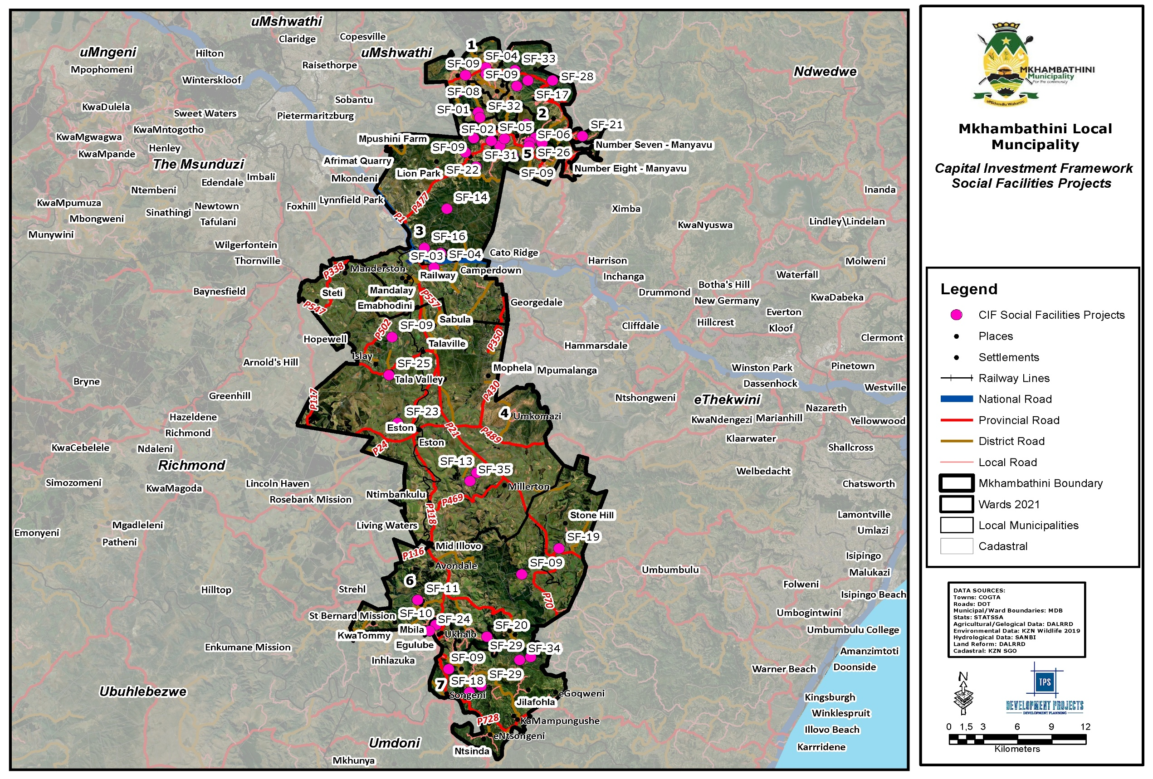
Map 12: CIF Social Facilities
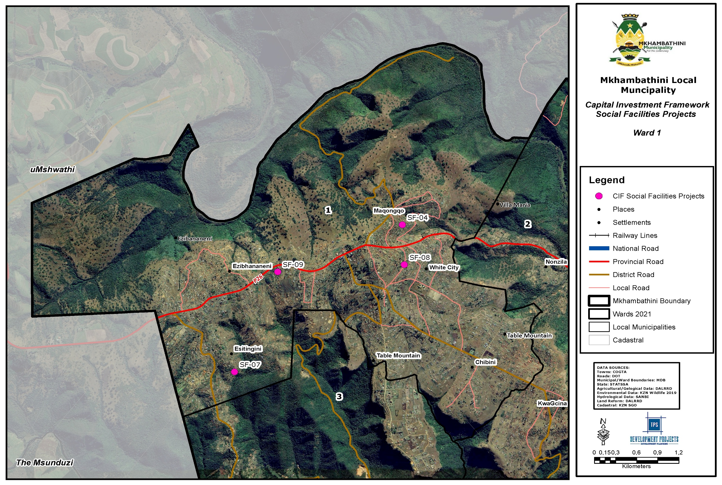
Map 13: CIF Social Facilities Ward 1
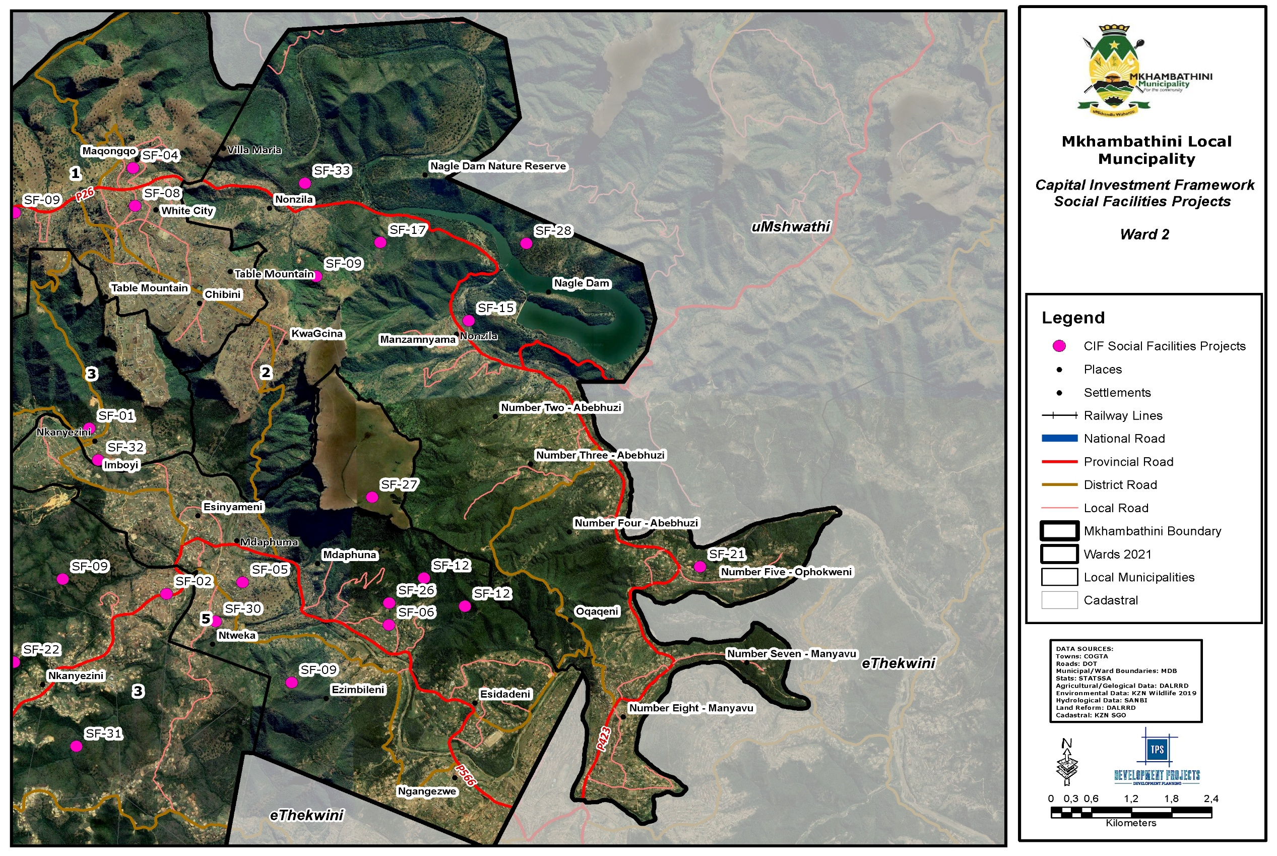
Map 14: CIF Social Facilities Ward 2
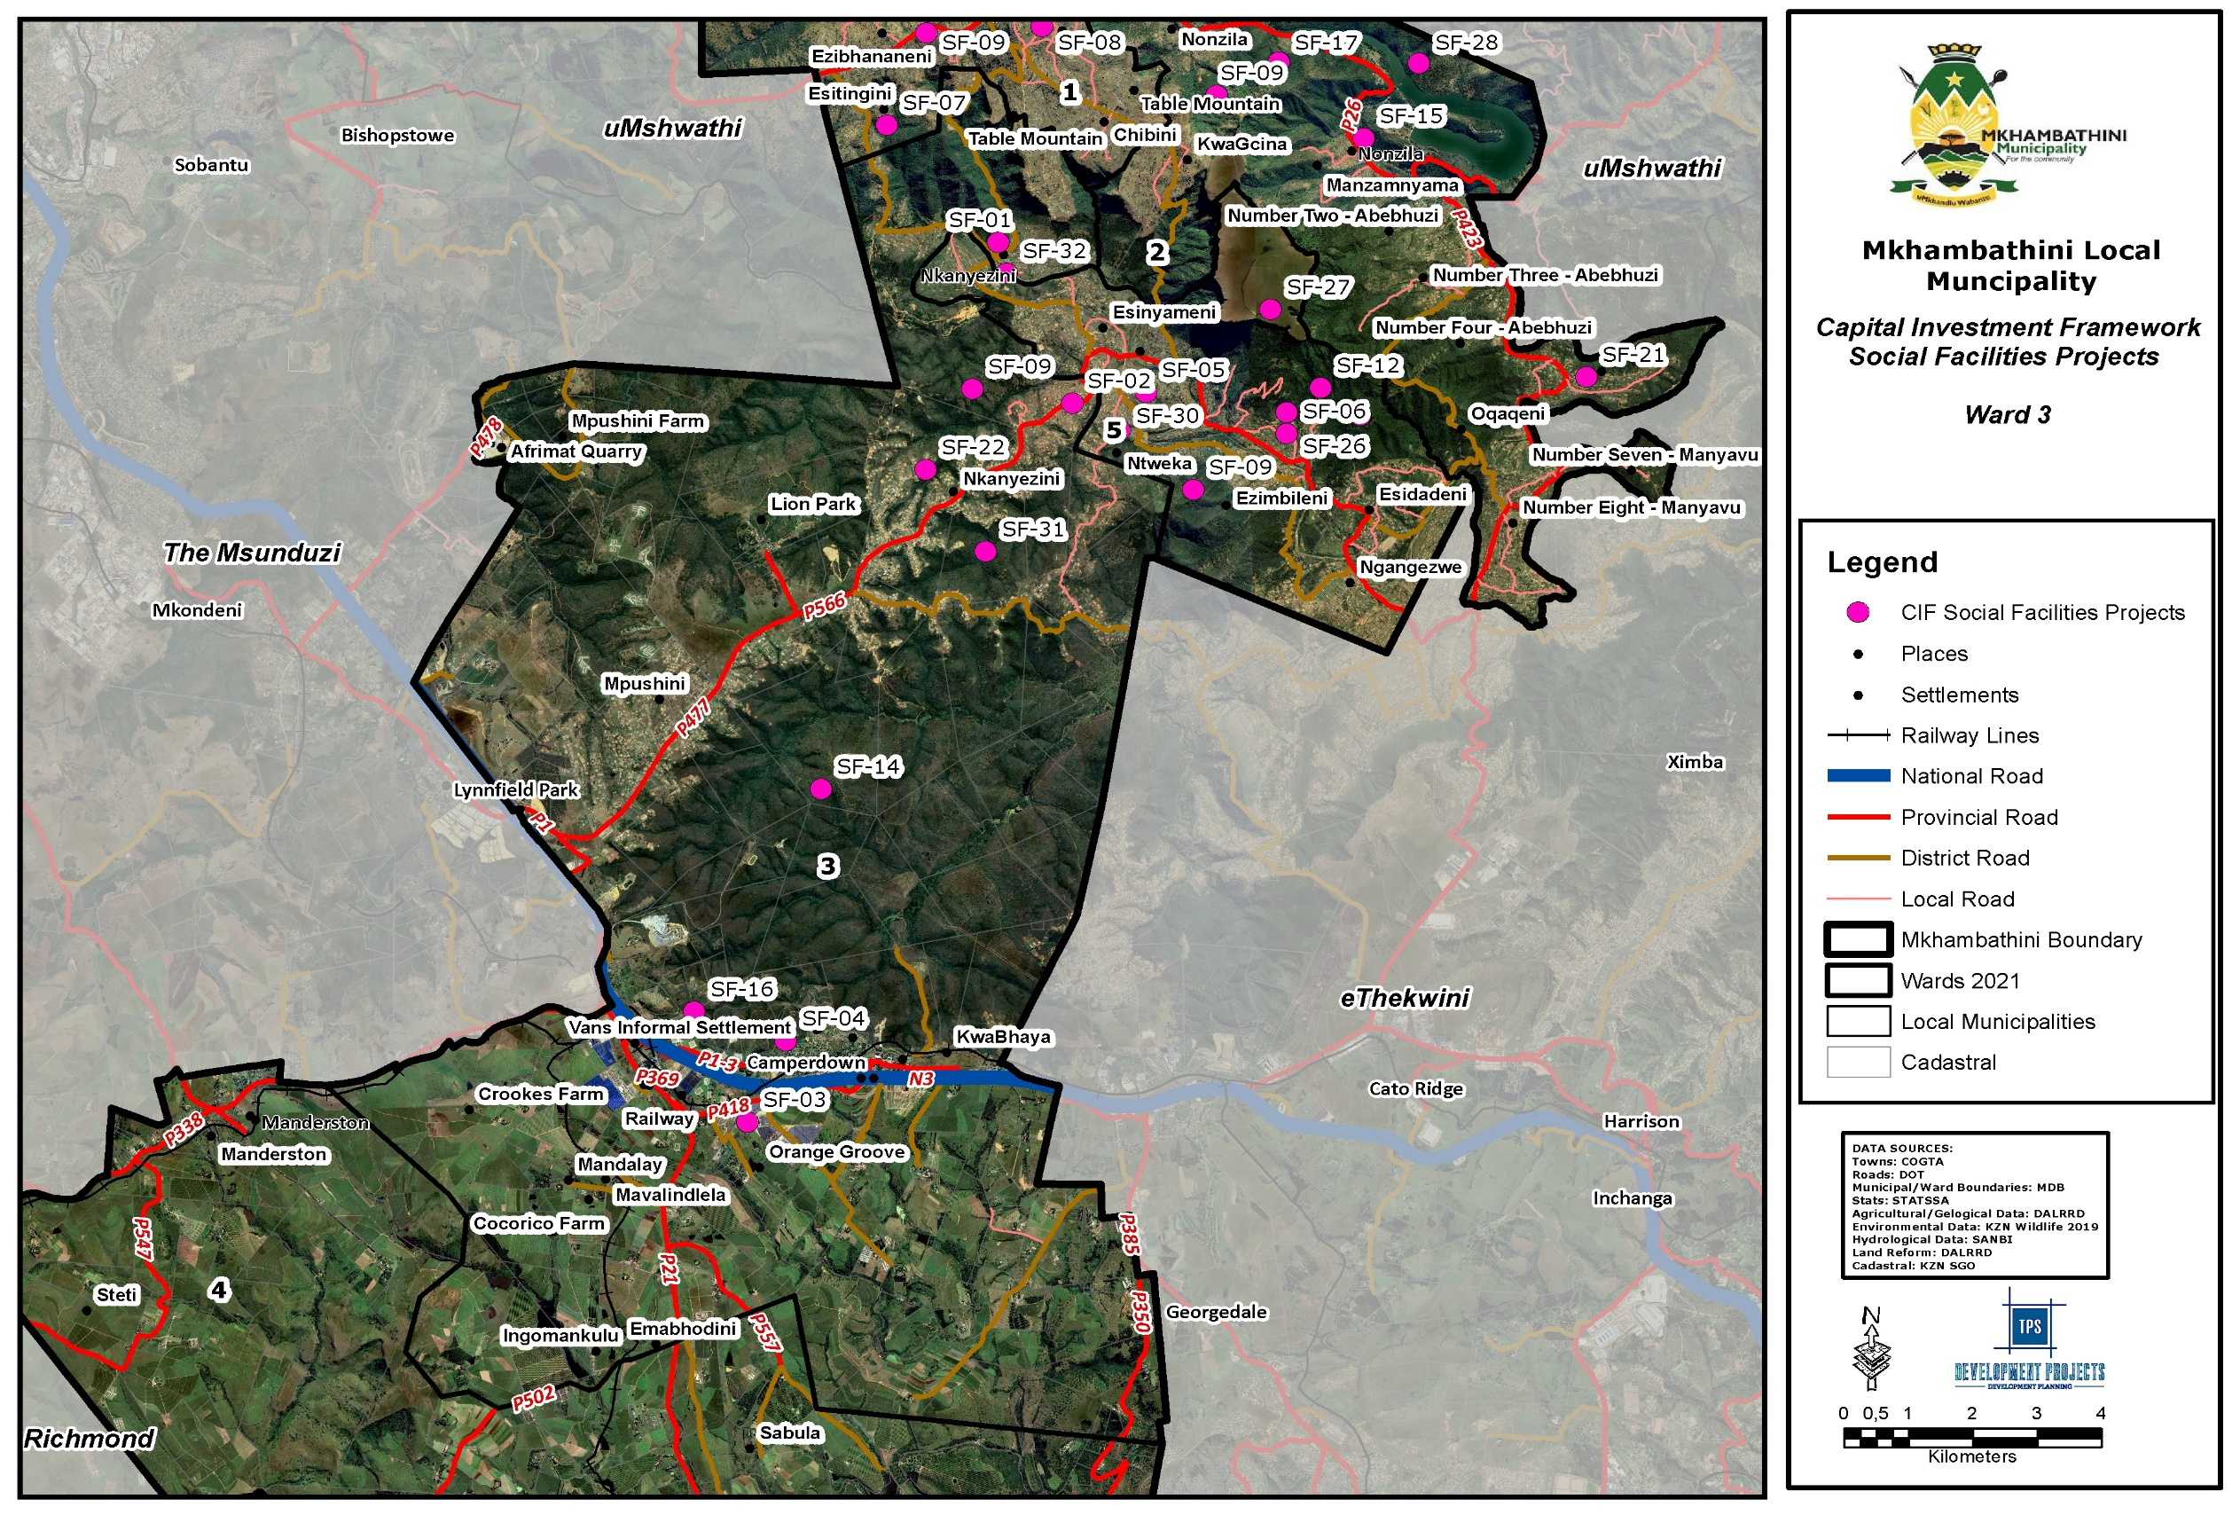
Map 15: CIF Social Facilities Ward 3
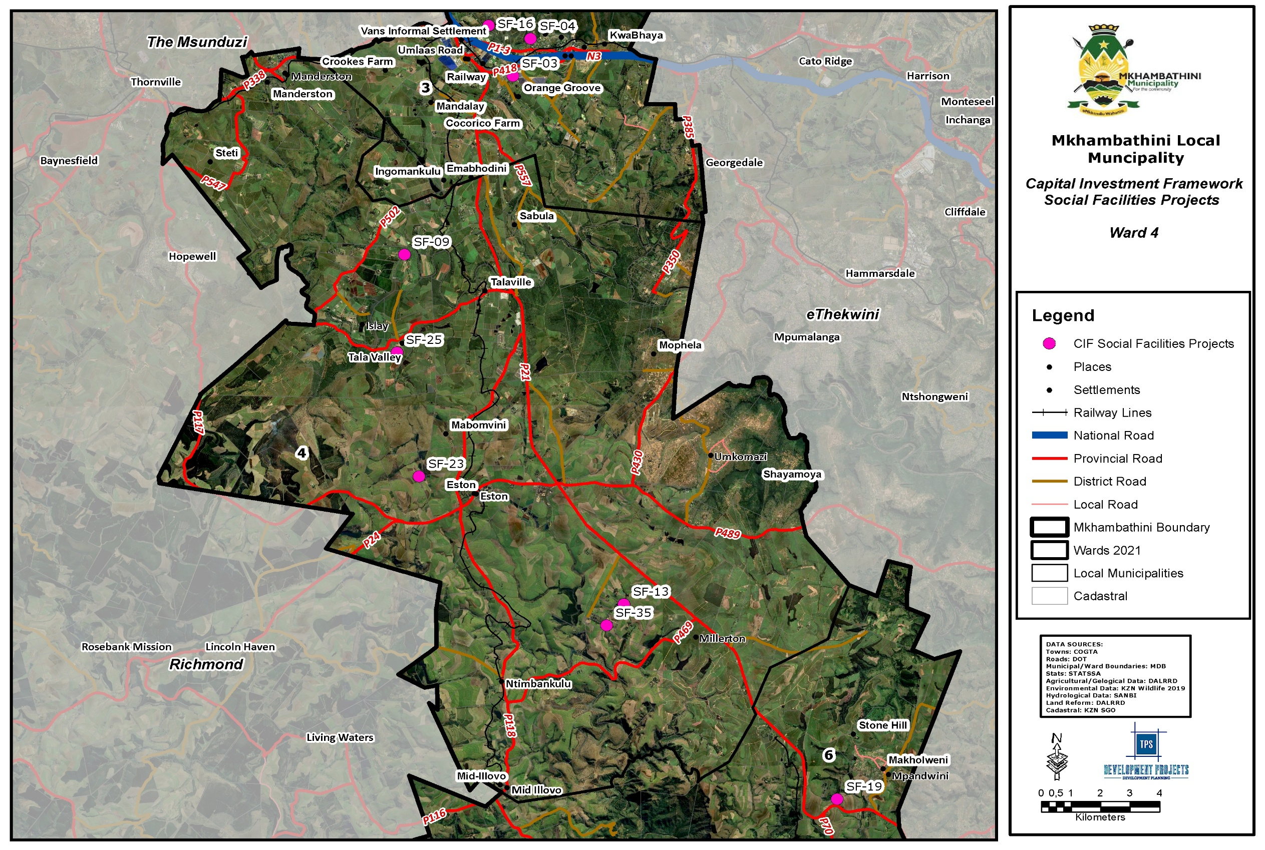
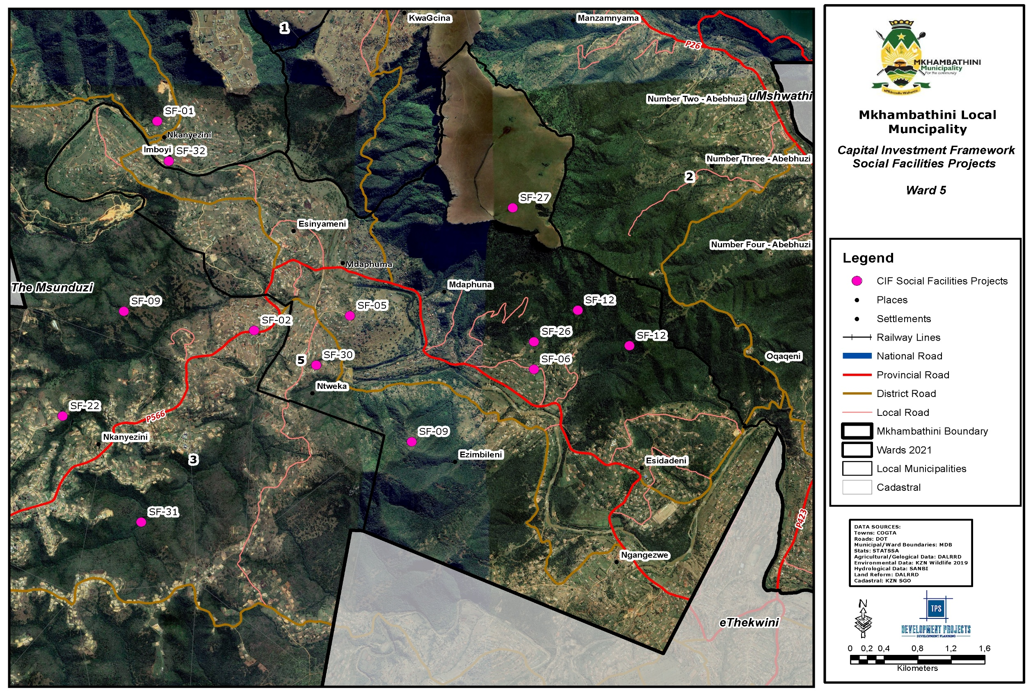
Map 16: CIF Social Facilities Ward 4
Map 17: CIF Social Facilities Ward 5
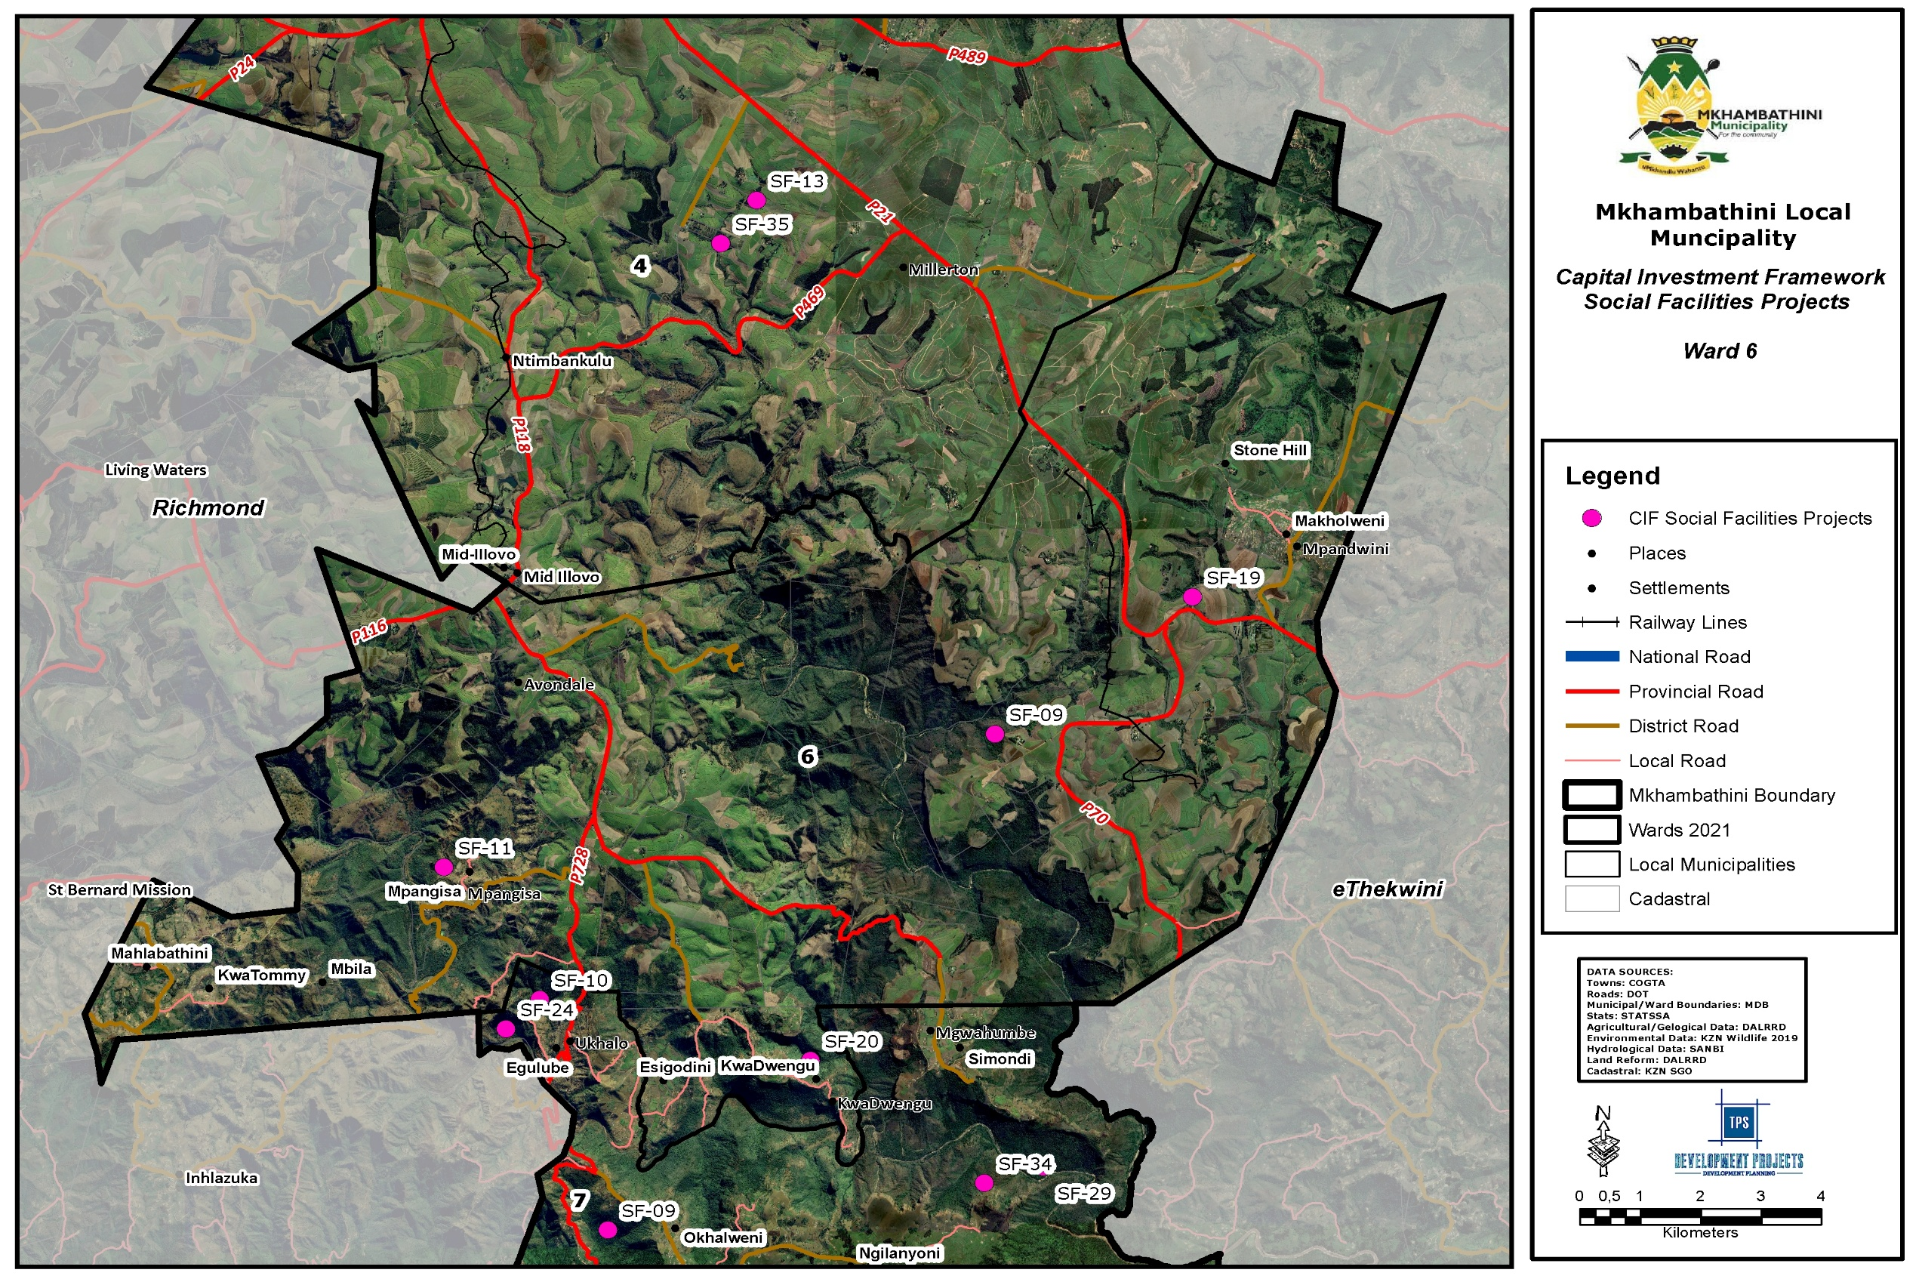
Map 18: CIF Social Facilities Ward 6
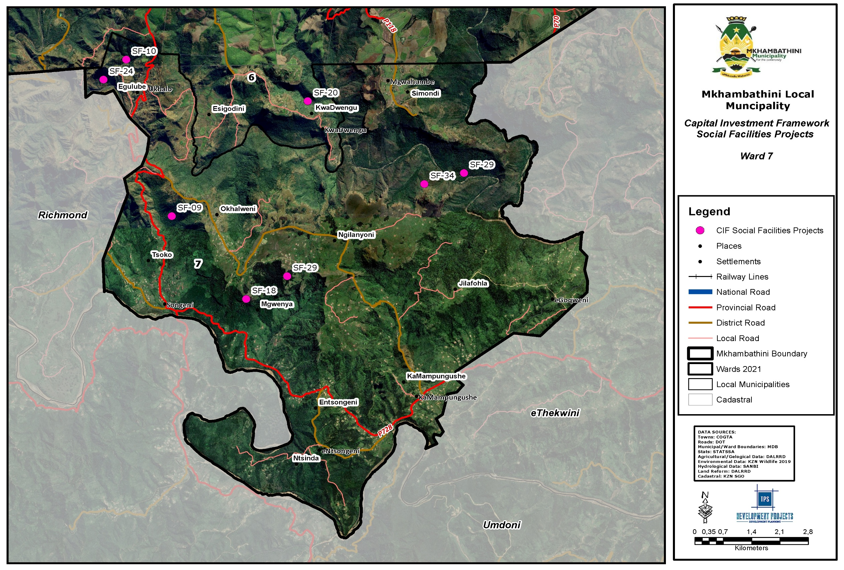
Map 19: CIF Social Facilities Ward 7
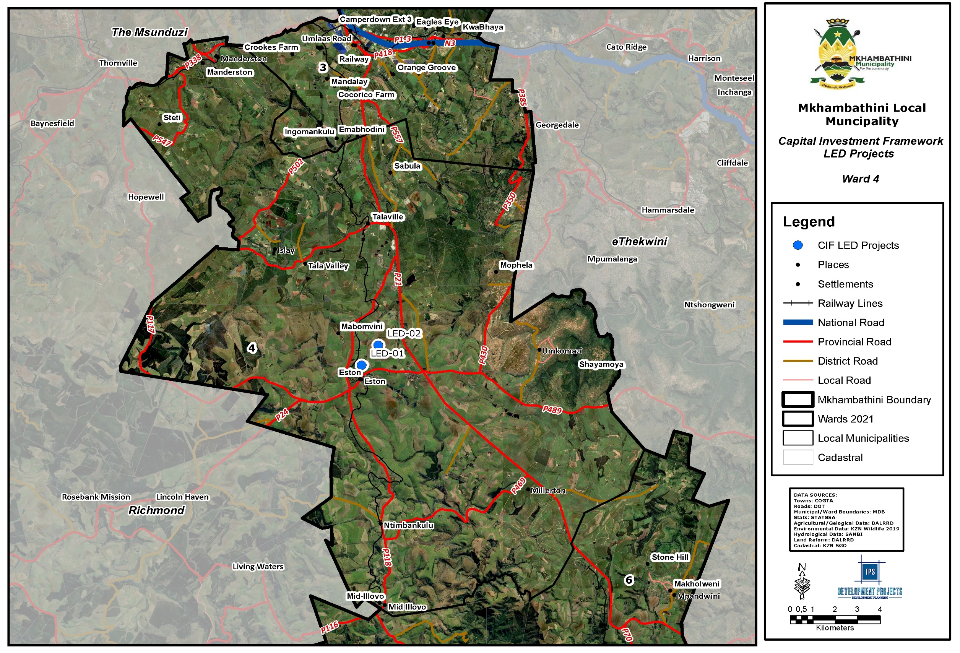
Map 20: CIF LED Ward 4
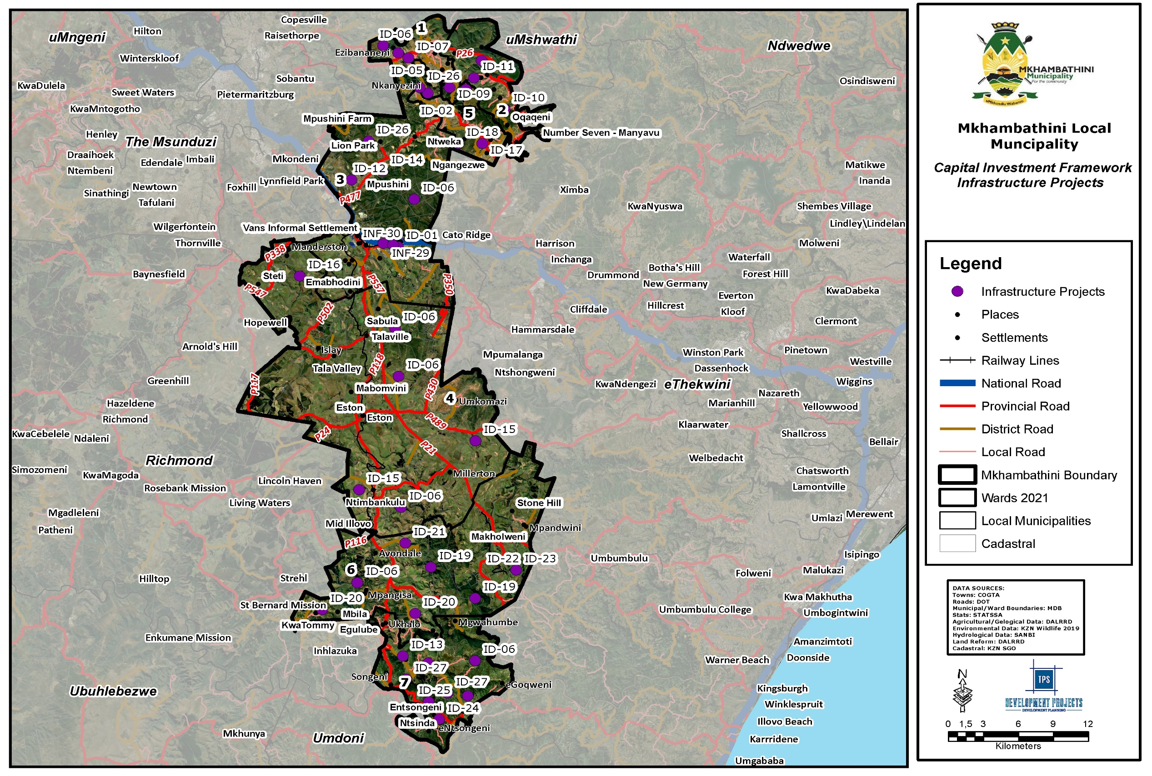
Map 21: CIF Infrastructure
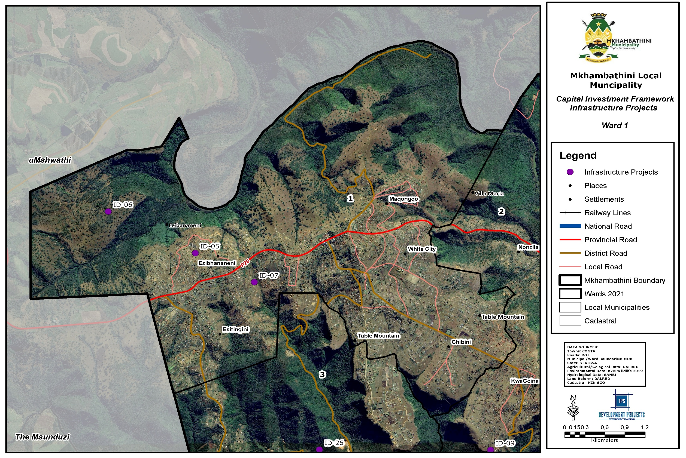
Map 22: CIF Infrastructure Ward 1
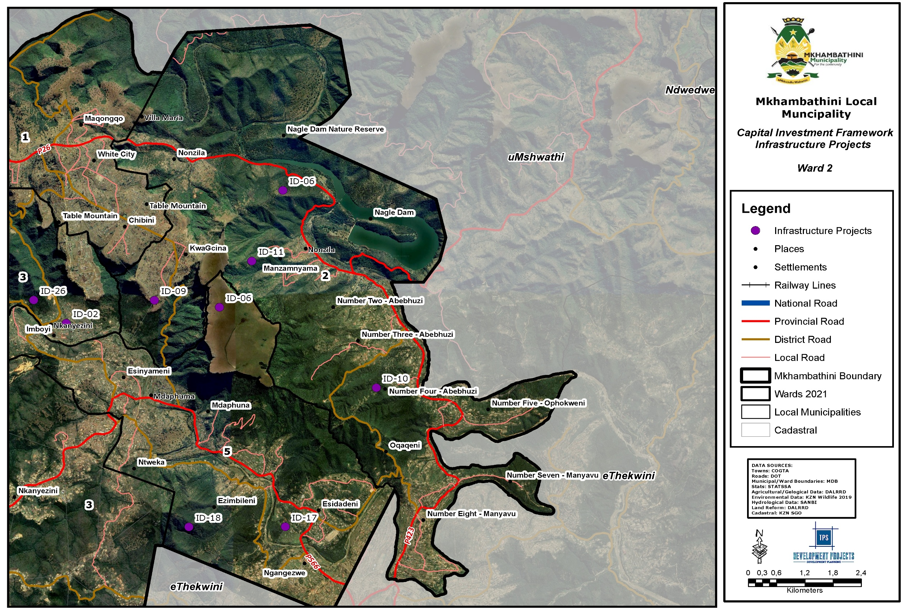
Map 23: CIF Infrastructure Ward 2
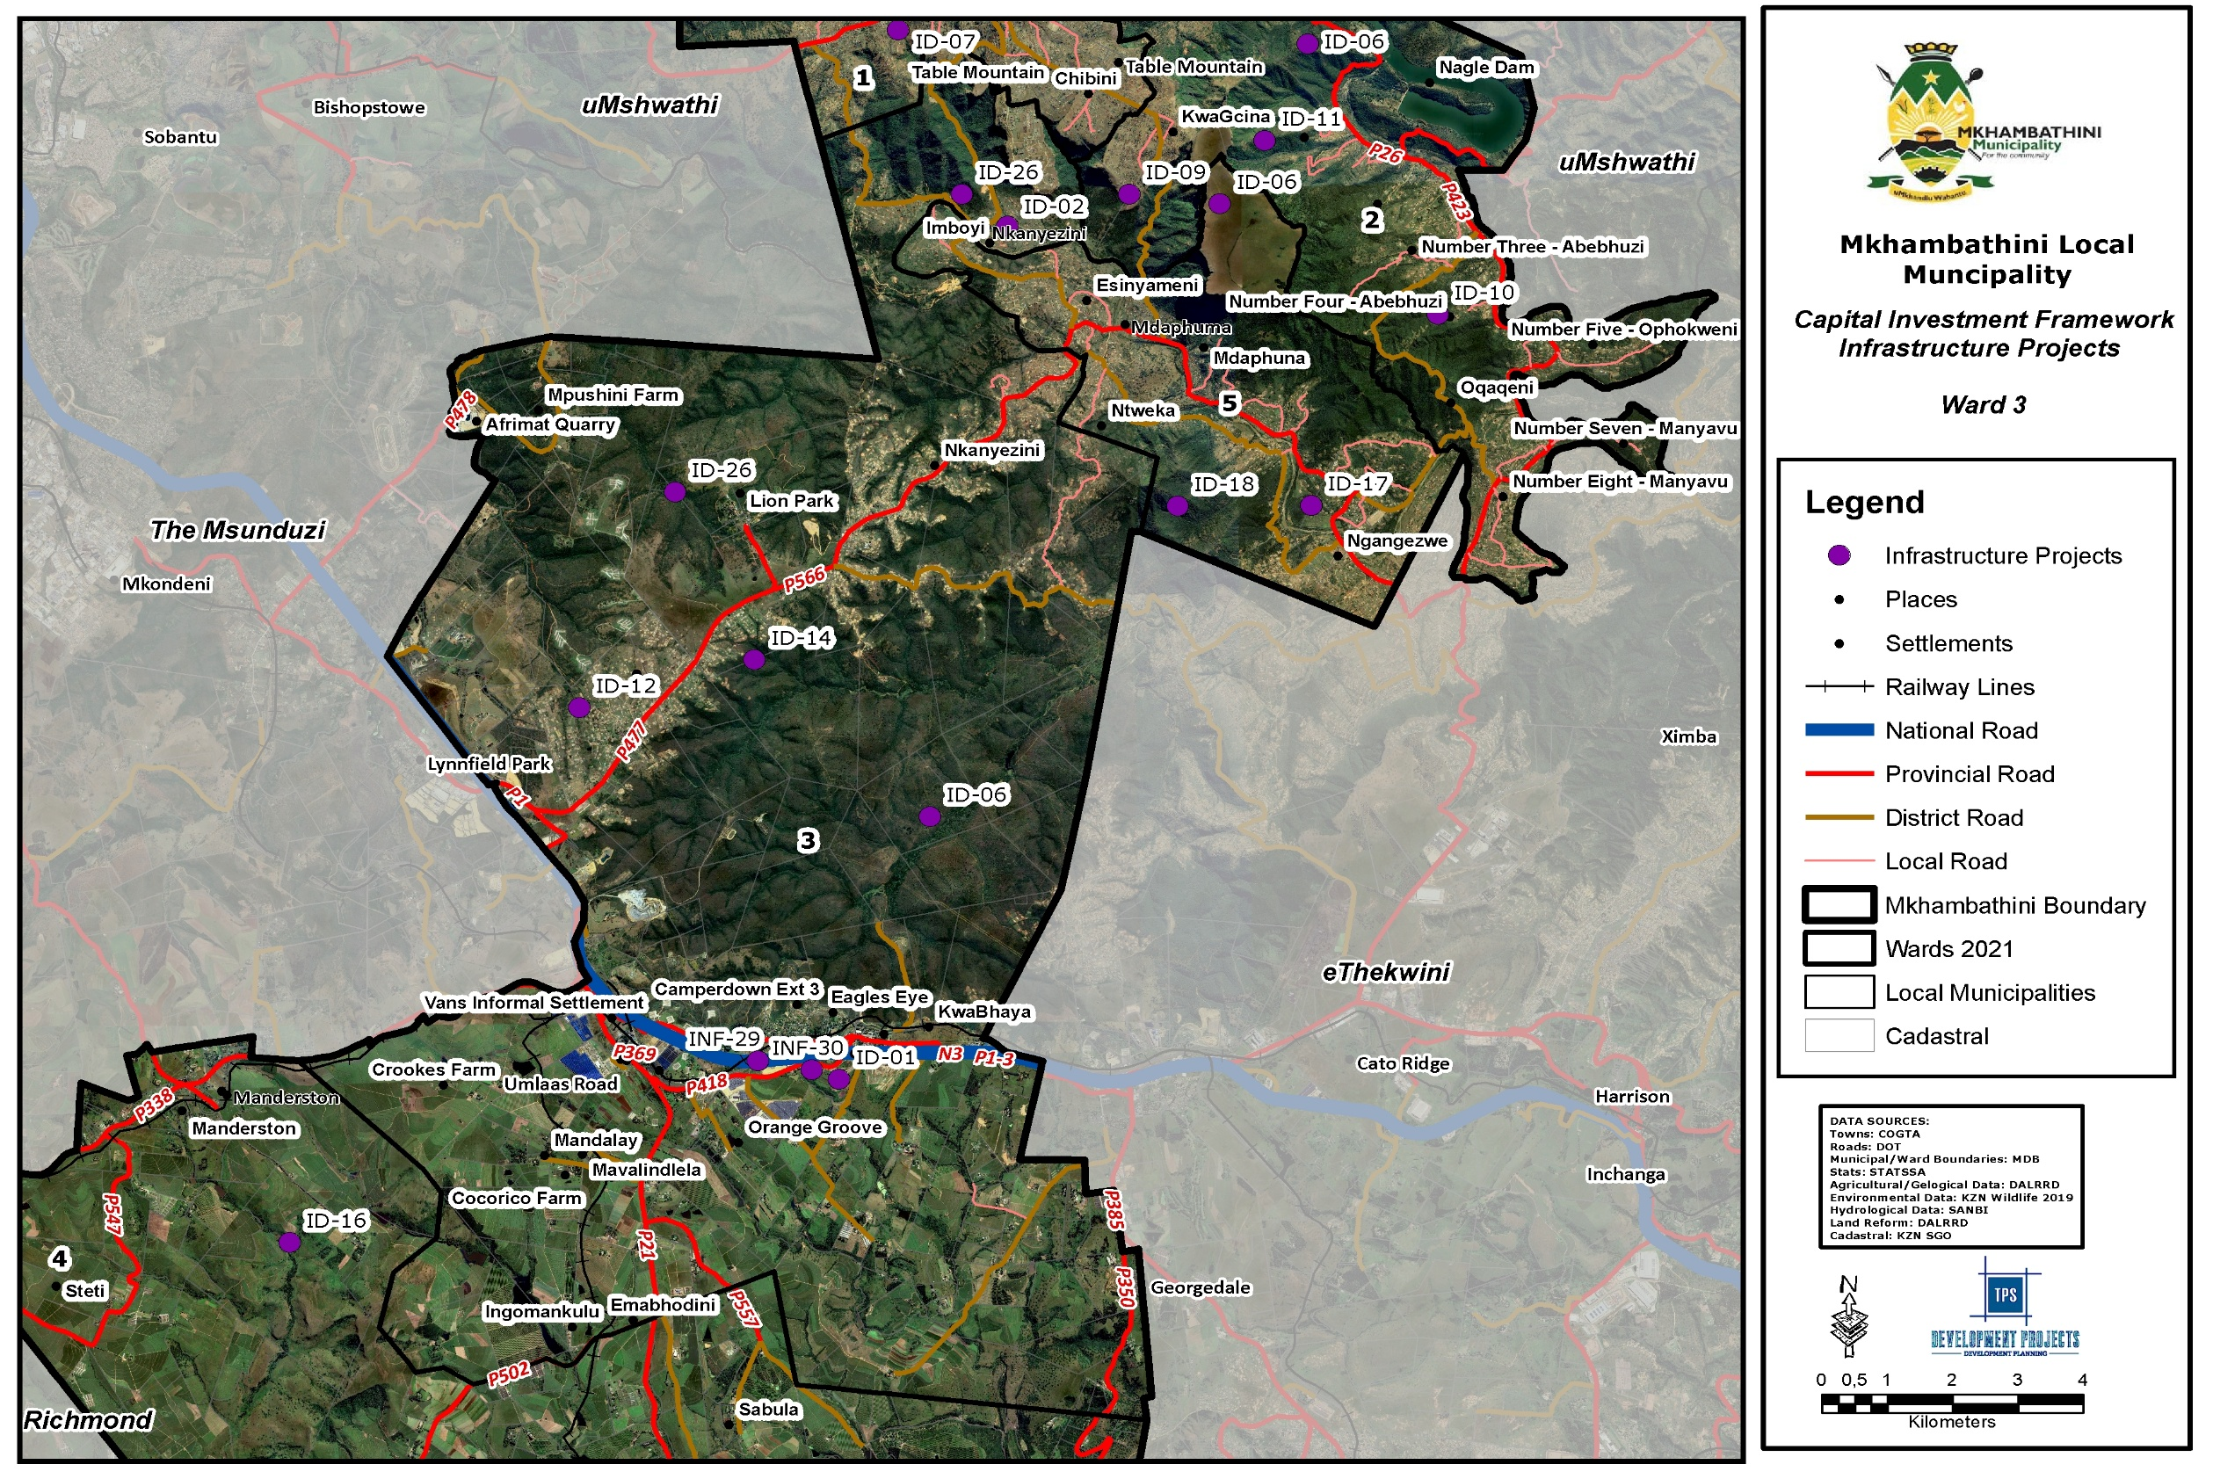
Map 24: CIF Infrastructure Ward 3
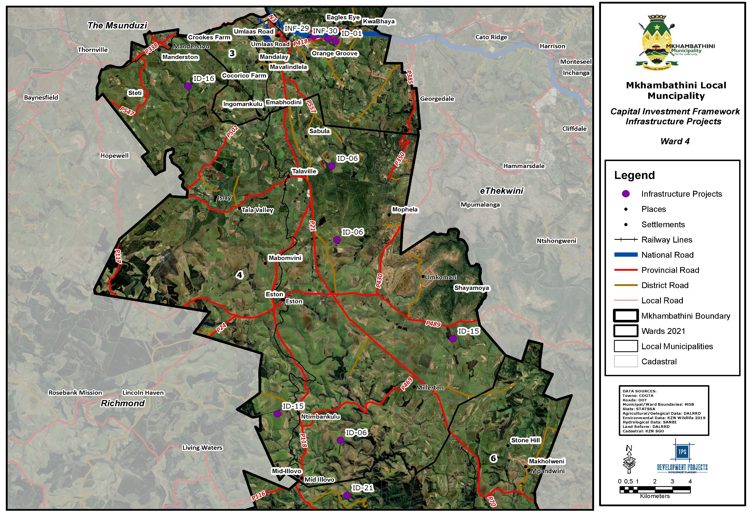
Map 25: CIF Infrastructure Ward 4
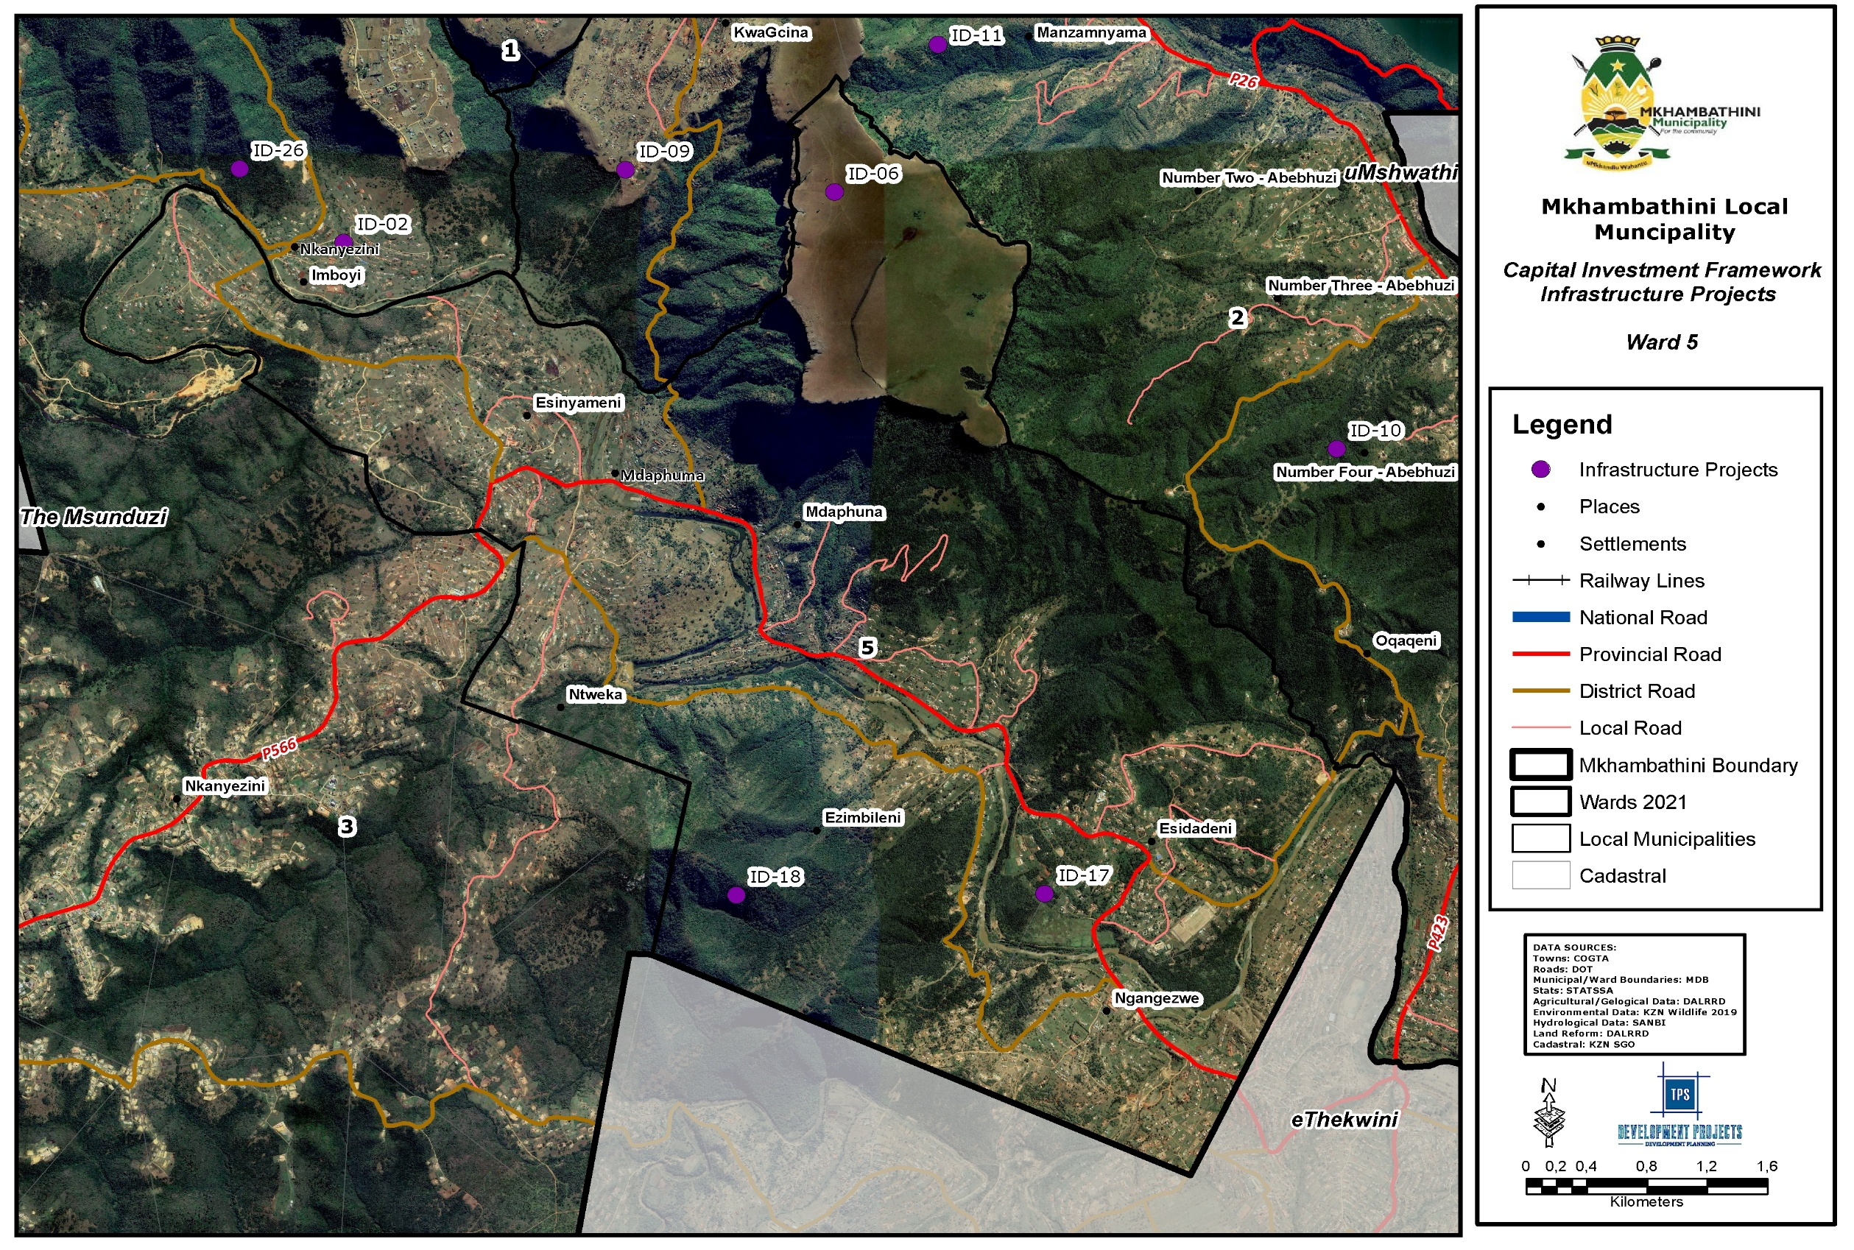
Map 26: CIF Infrastructure Ward 5
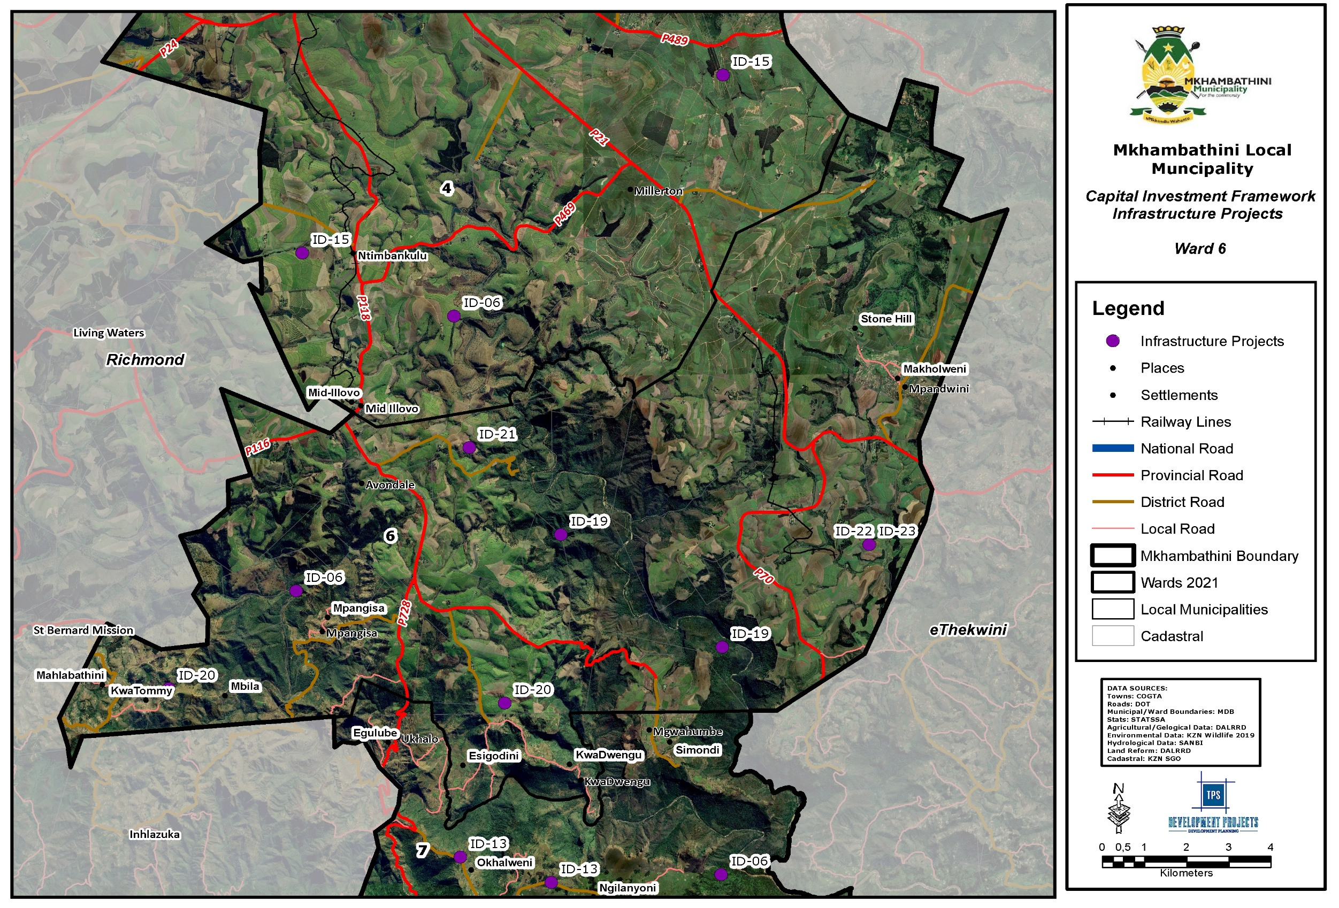
Map 27: CIF Infrastructure Ward 4
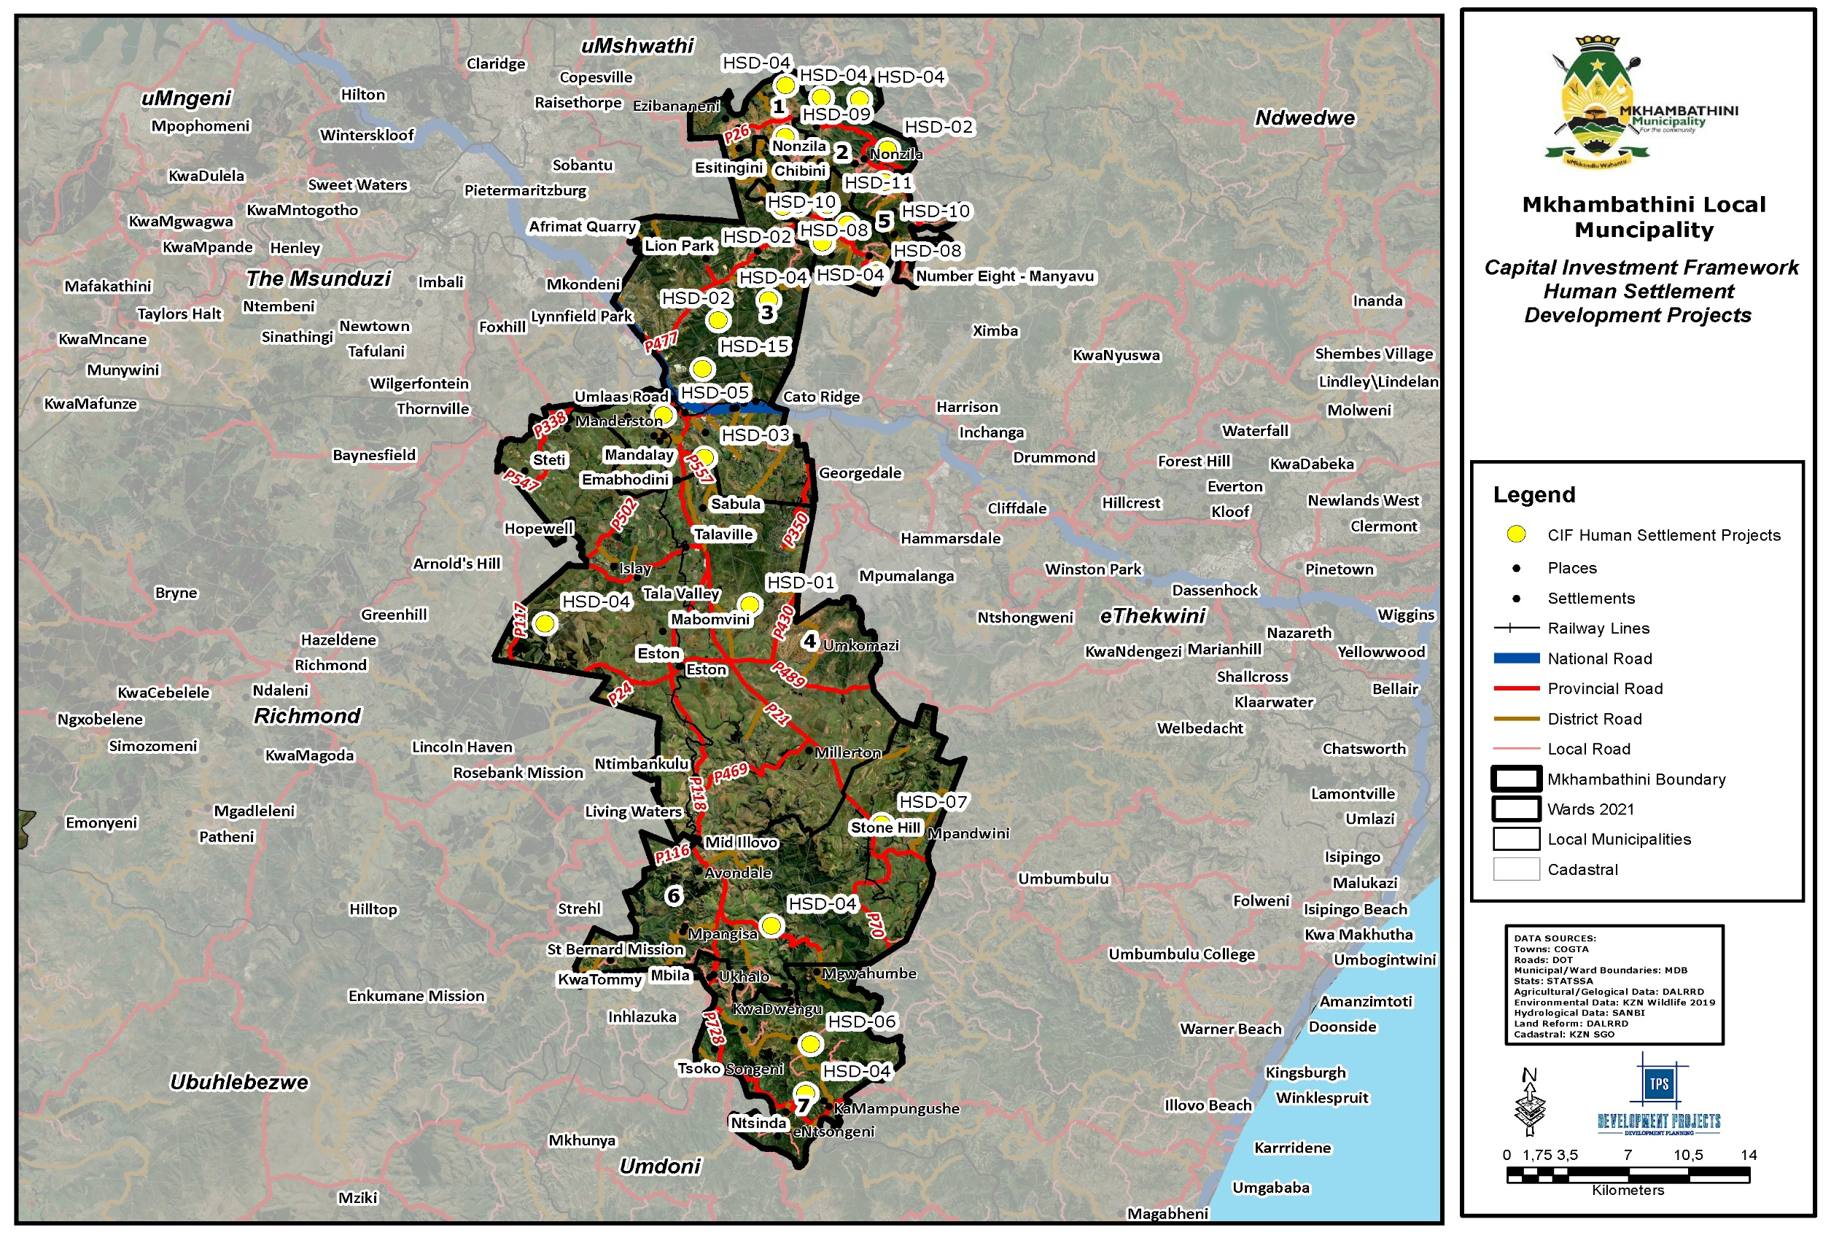
Map 28: CIF Human Settlements
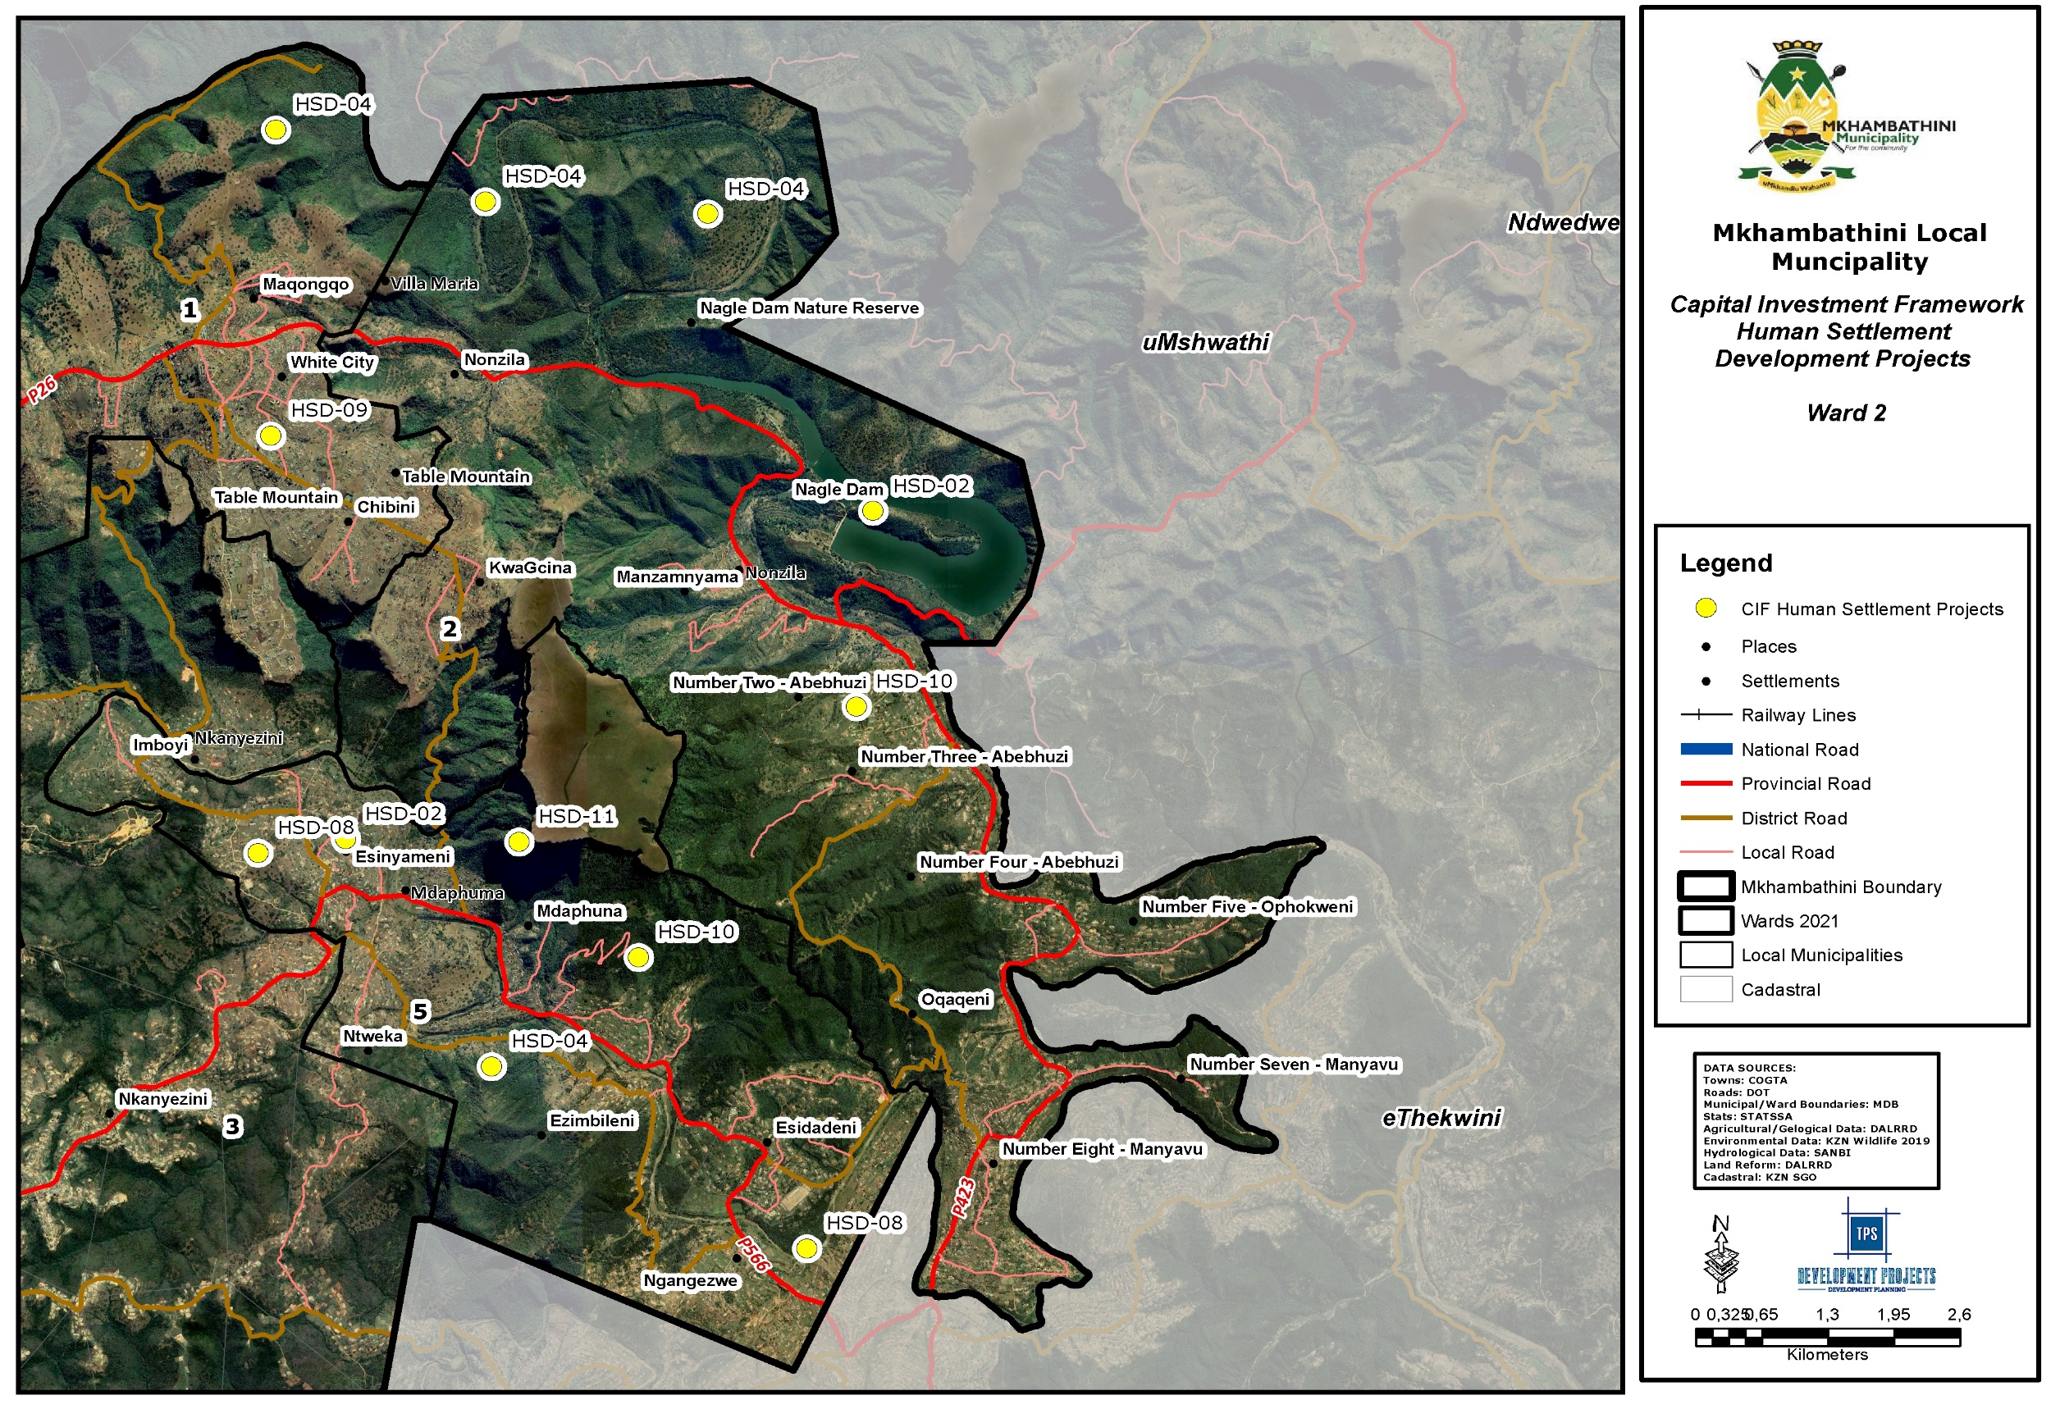
Map 29: CIF Human Settlements Ward 2
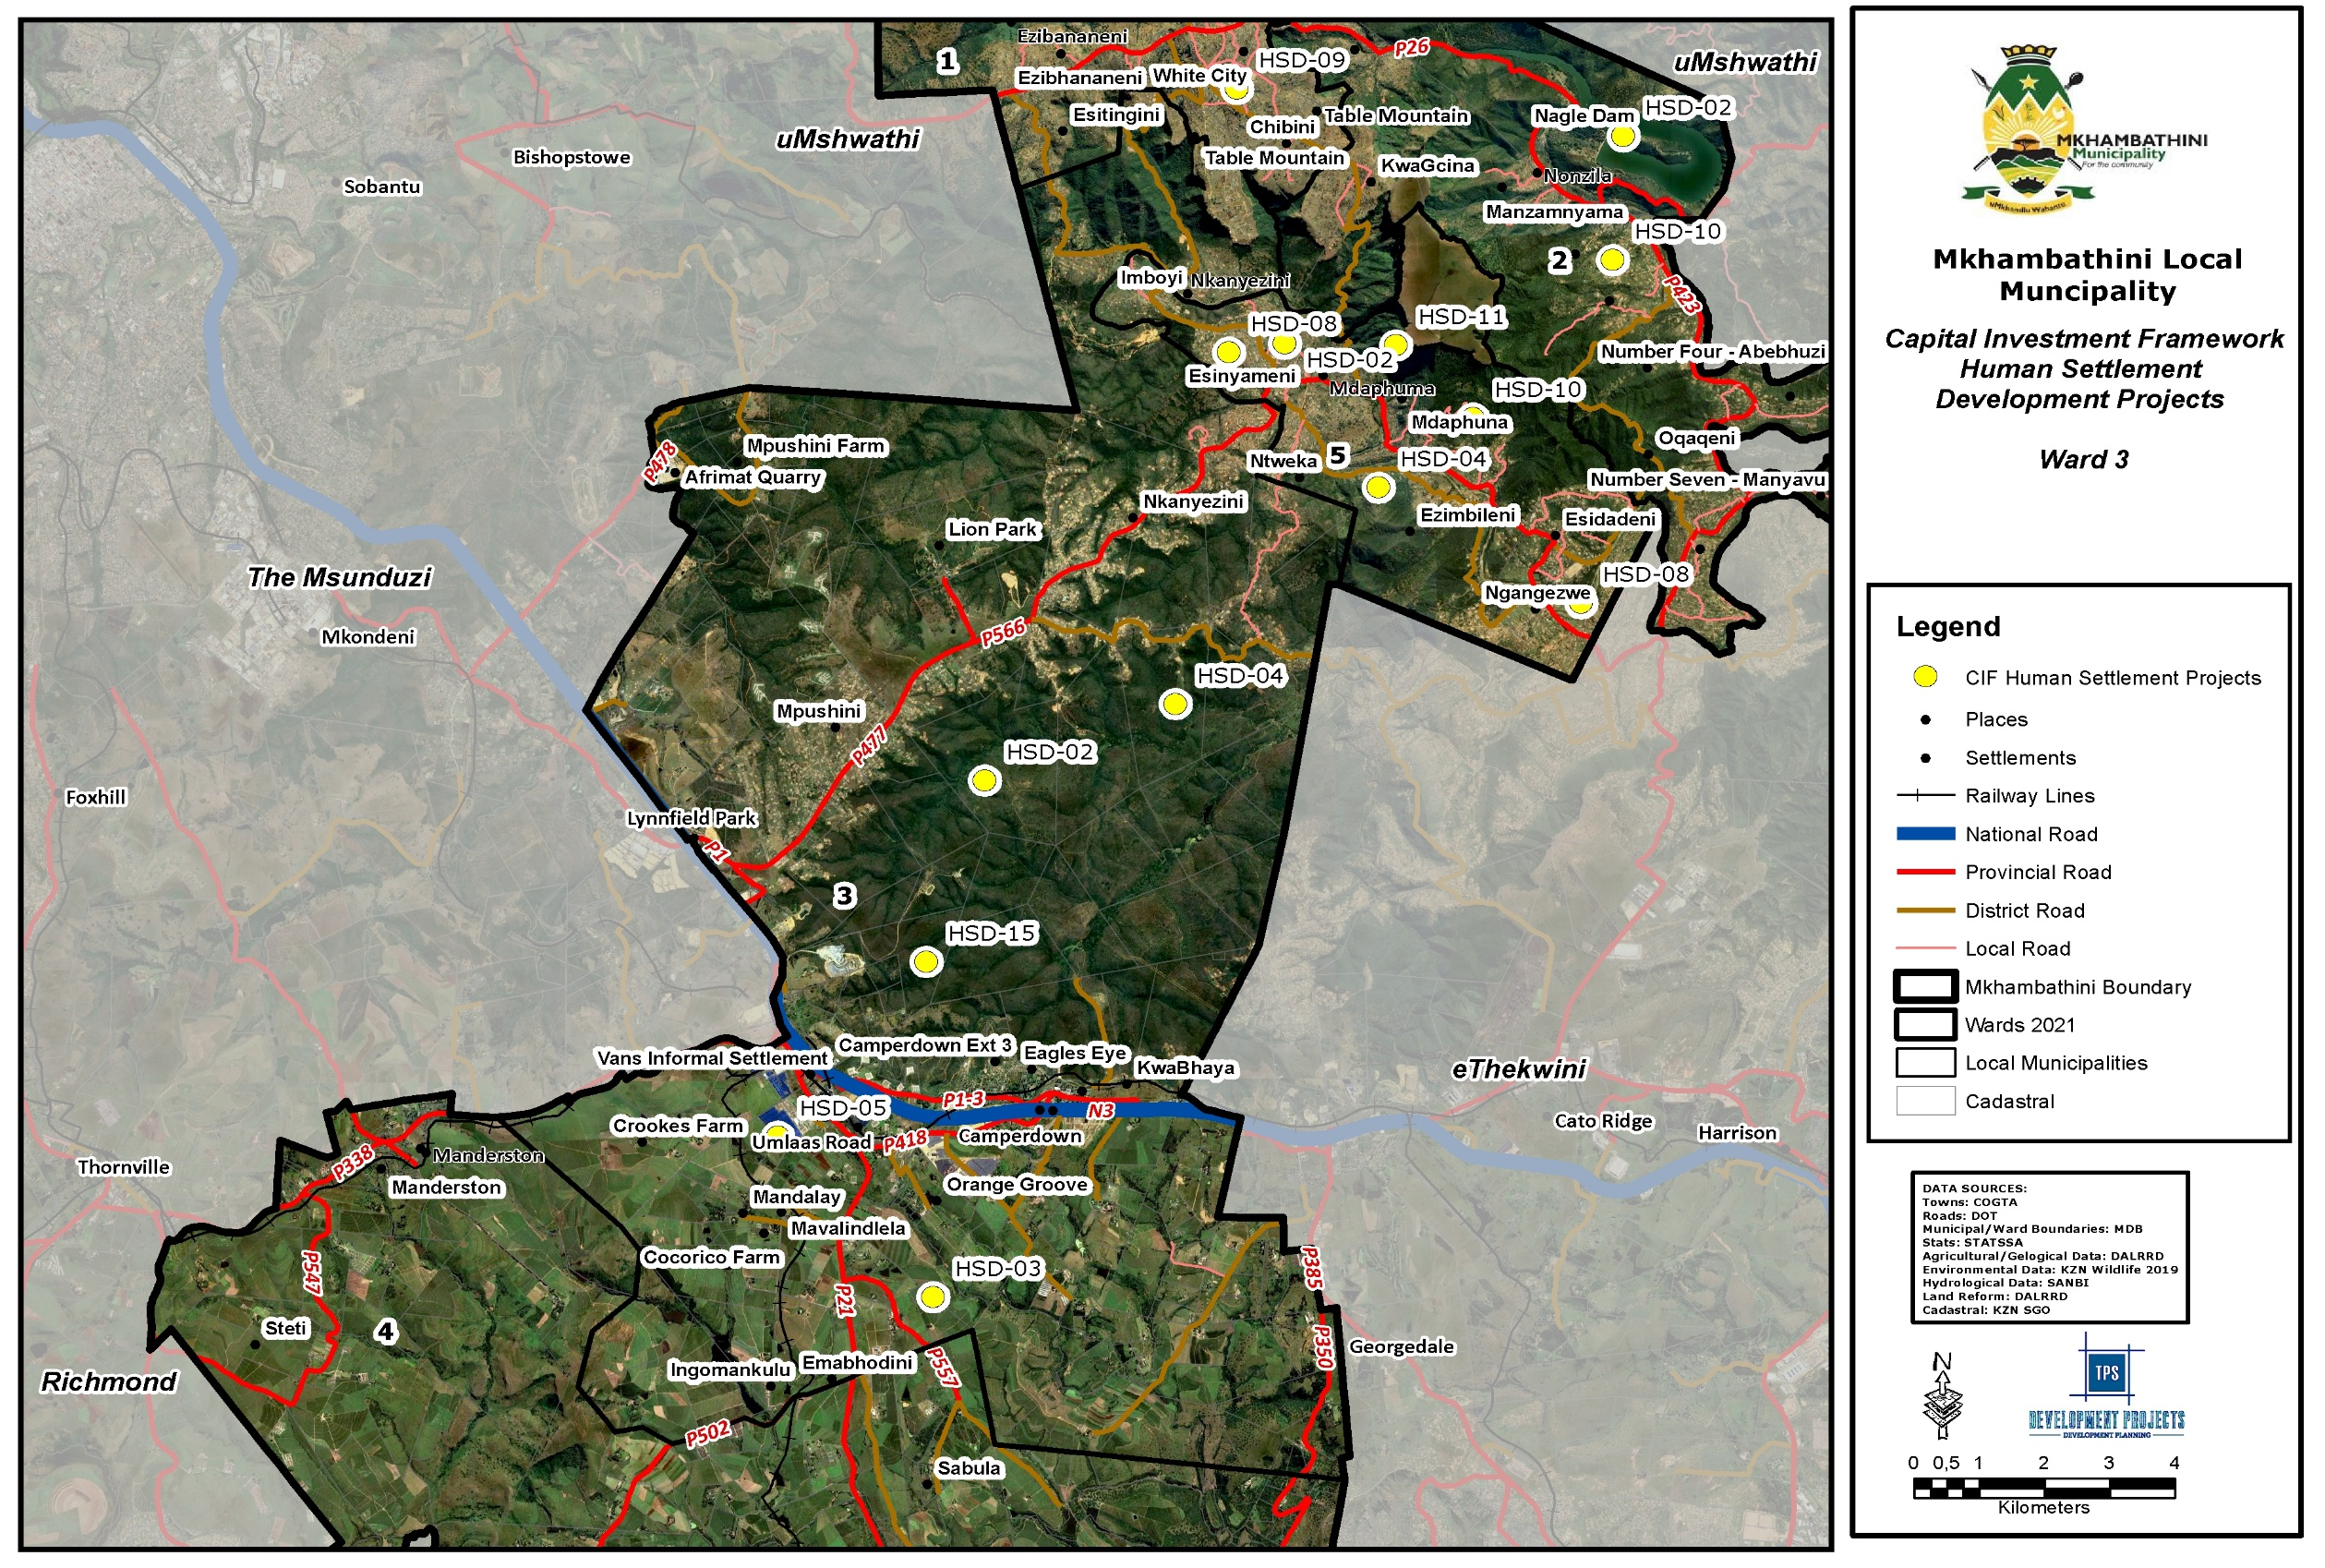
Map 30: CIF Human Settlements Ward 3
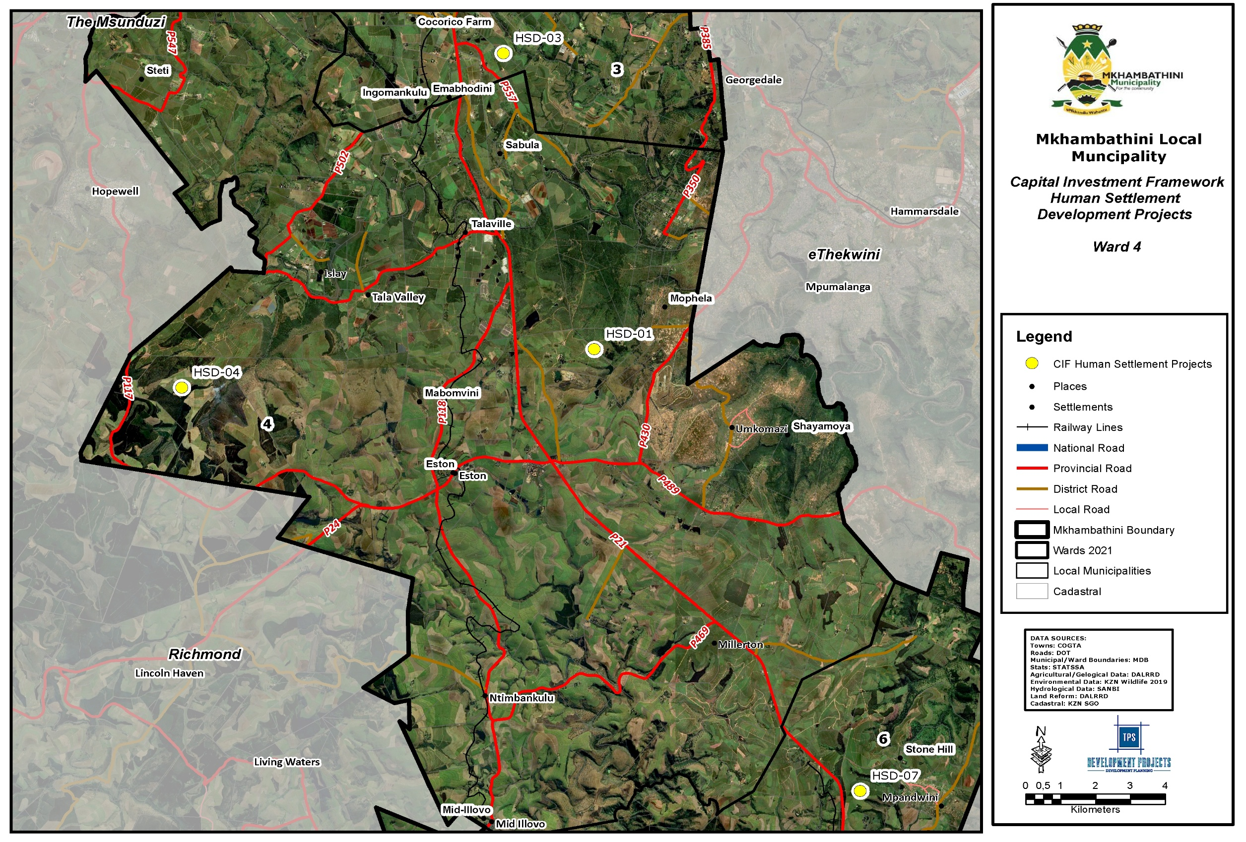
Map 31: CIF Human Settlements Ward 4
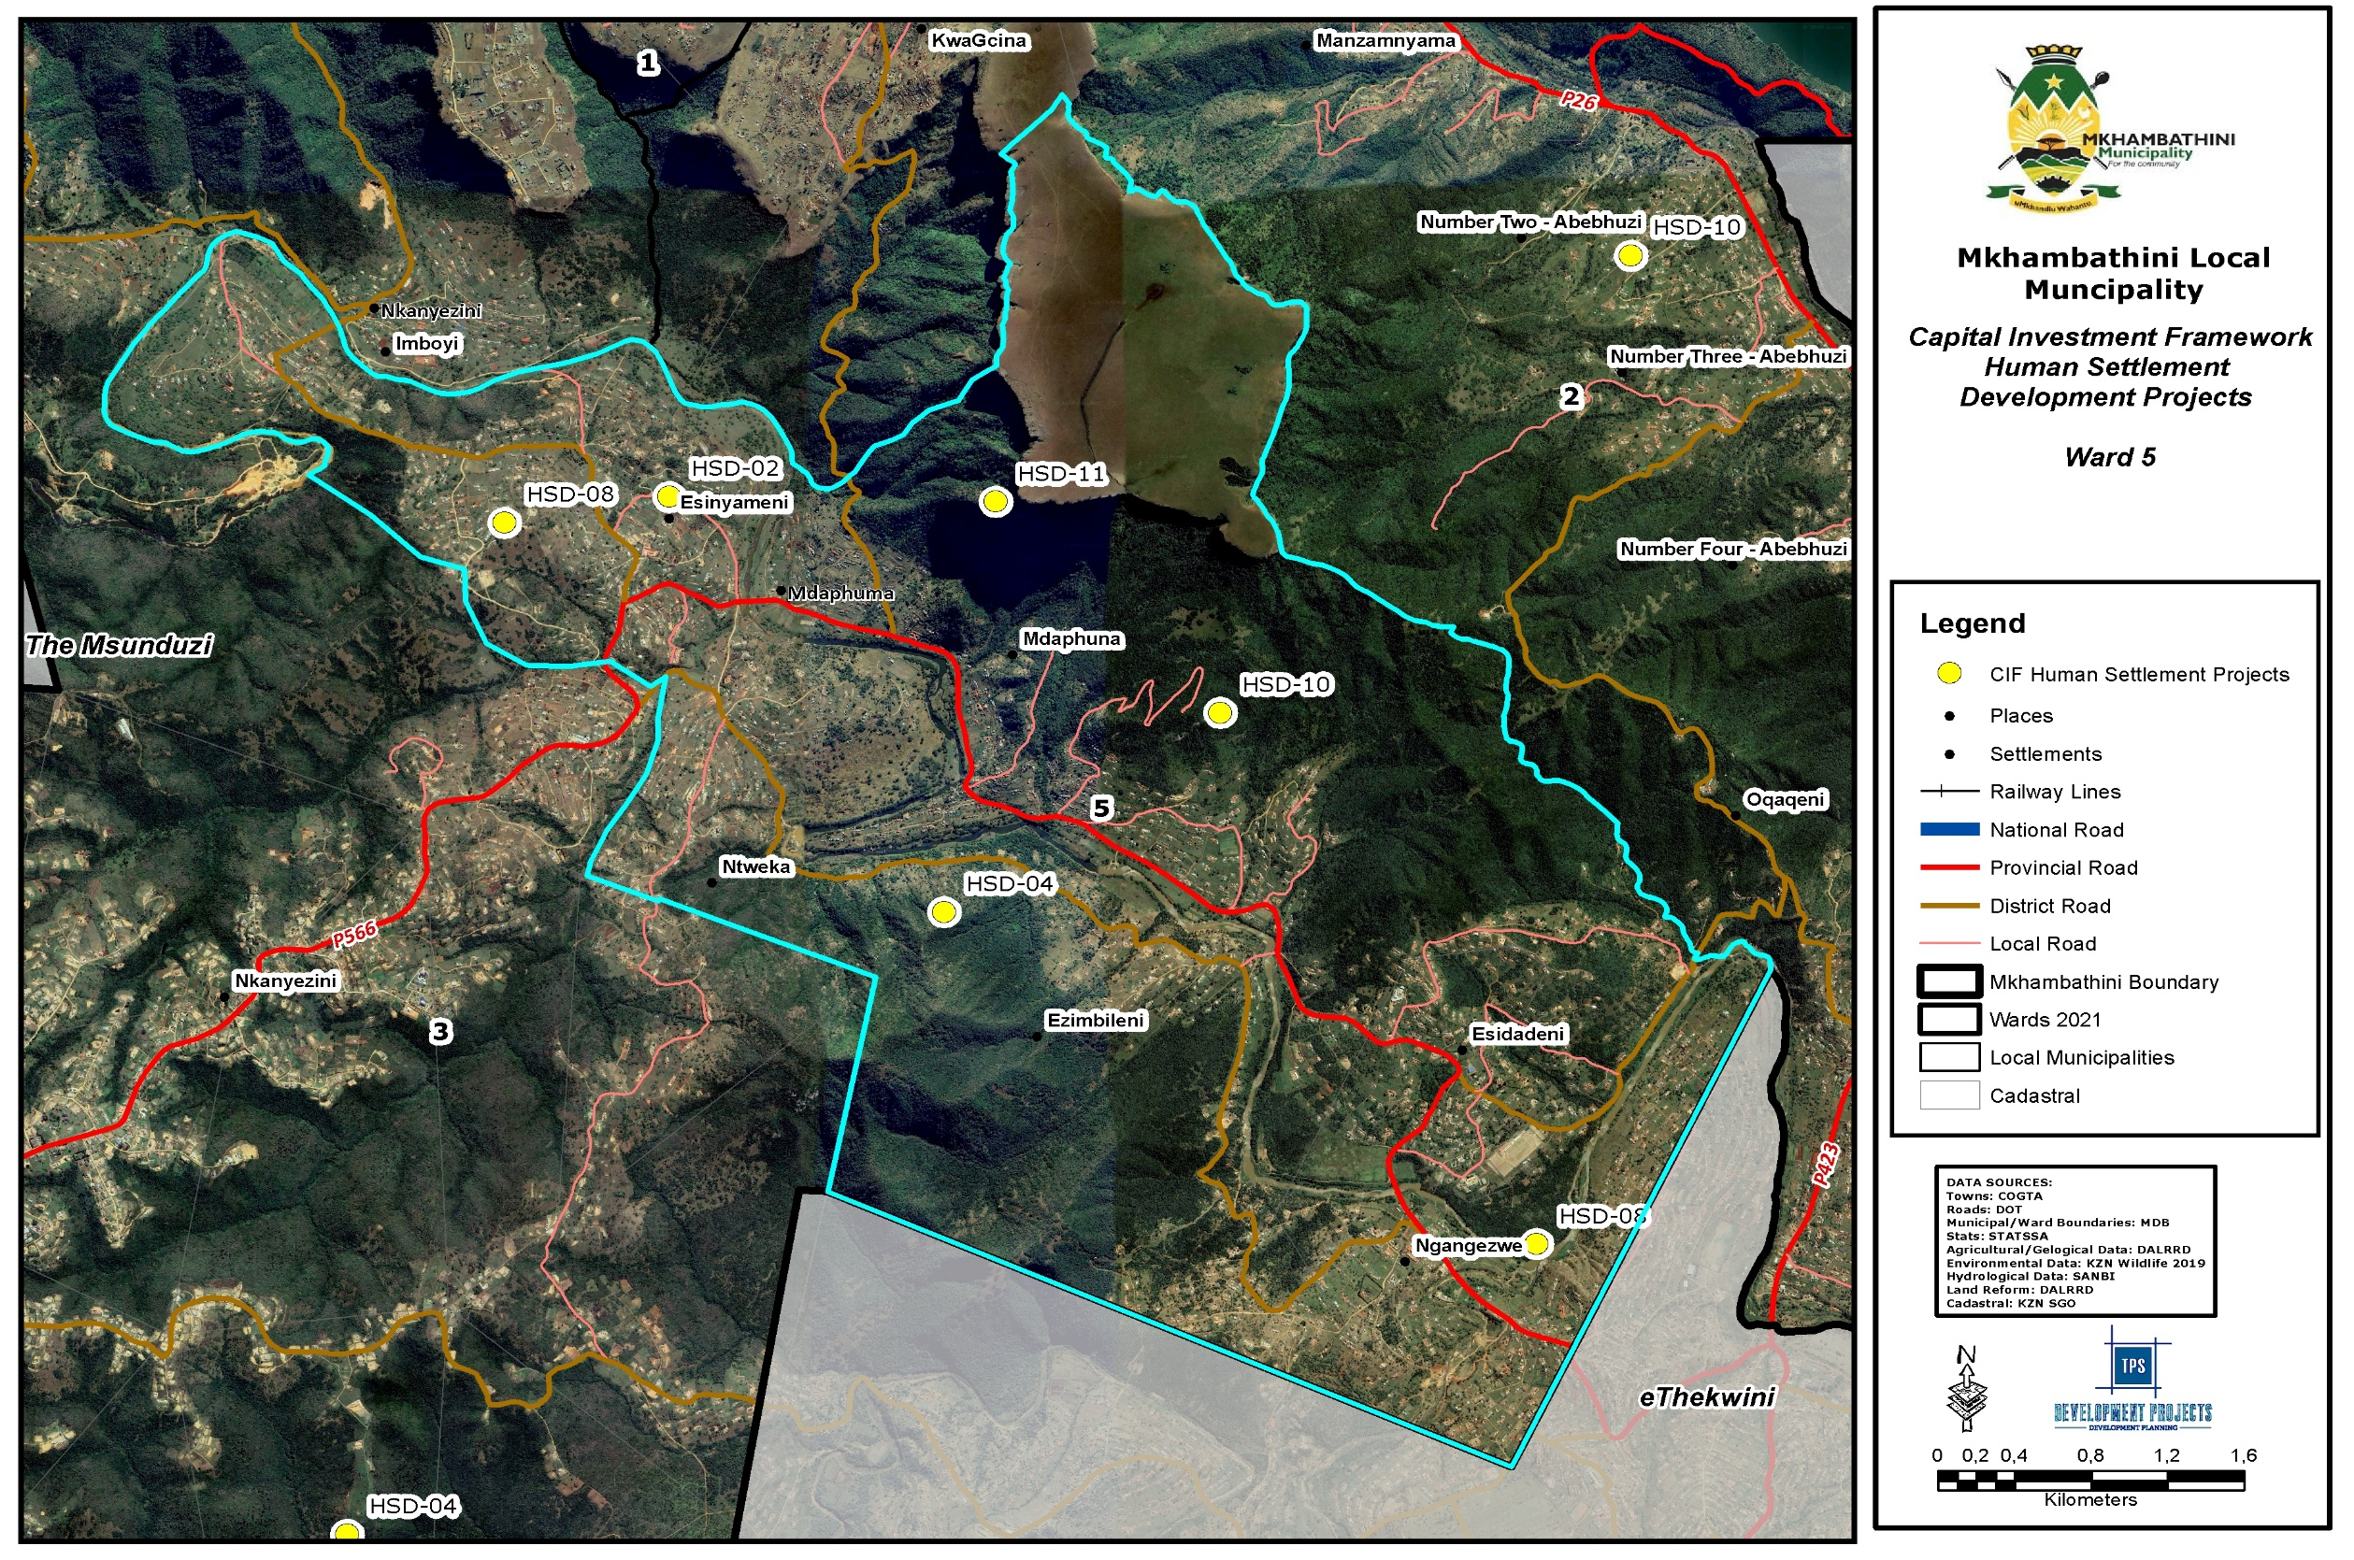
Map 32: CIF Human Settlements Ward 5
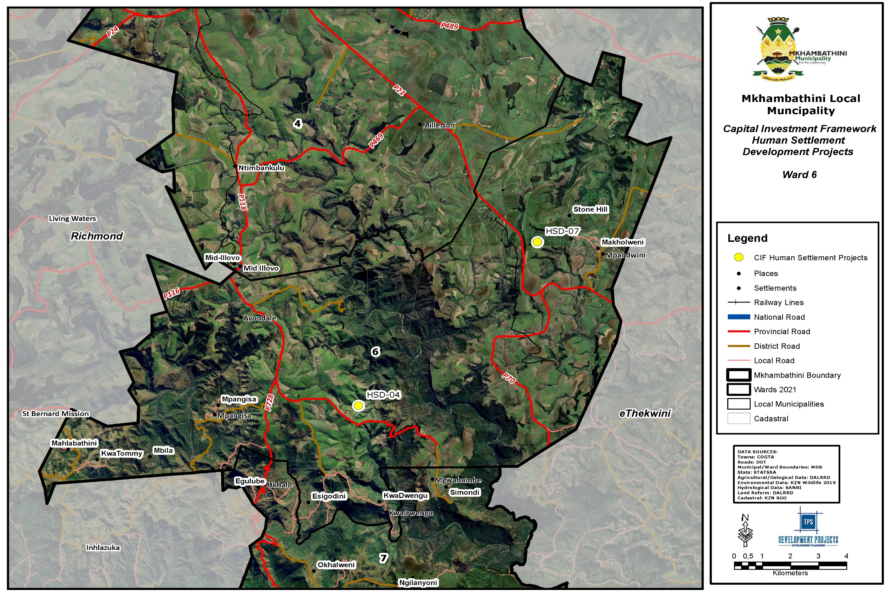
Map 33: CIF Human Settlements Ward 6
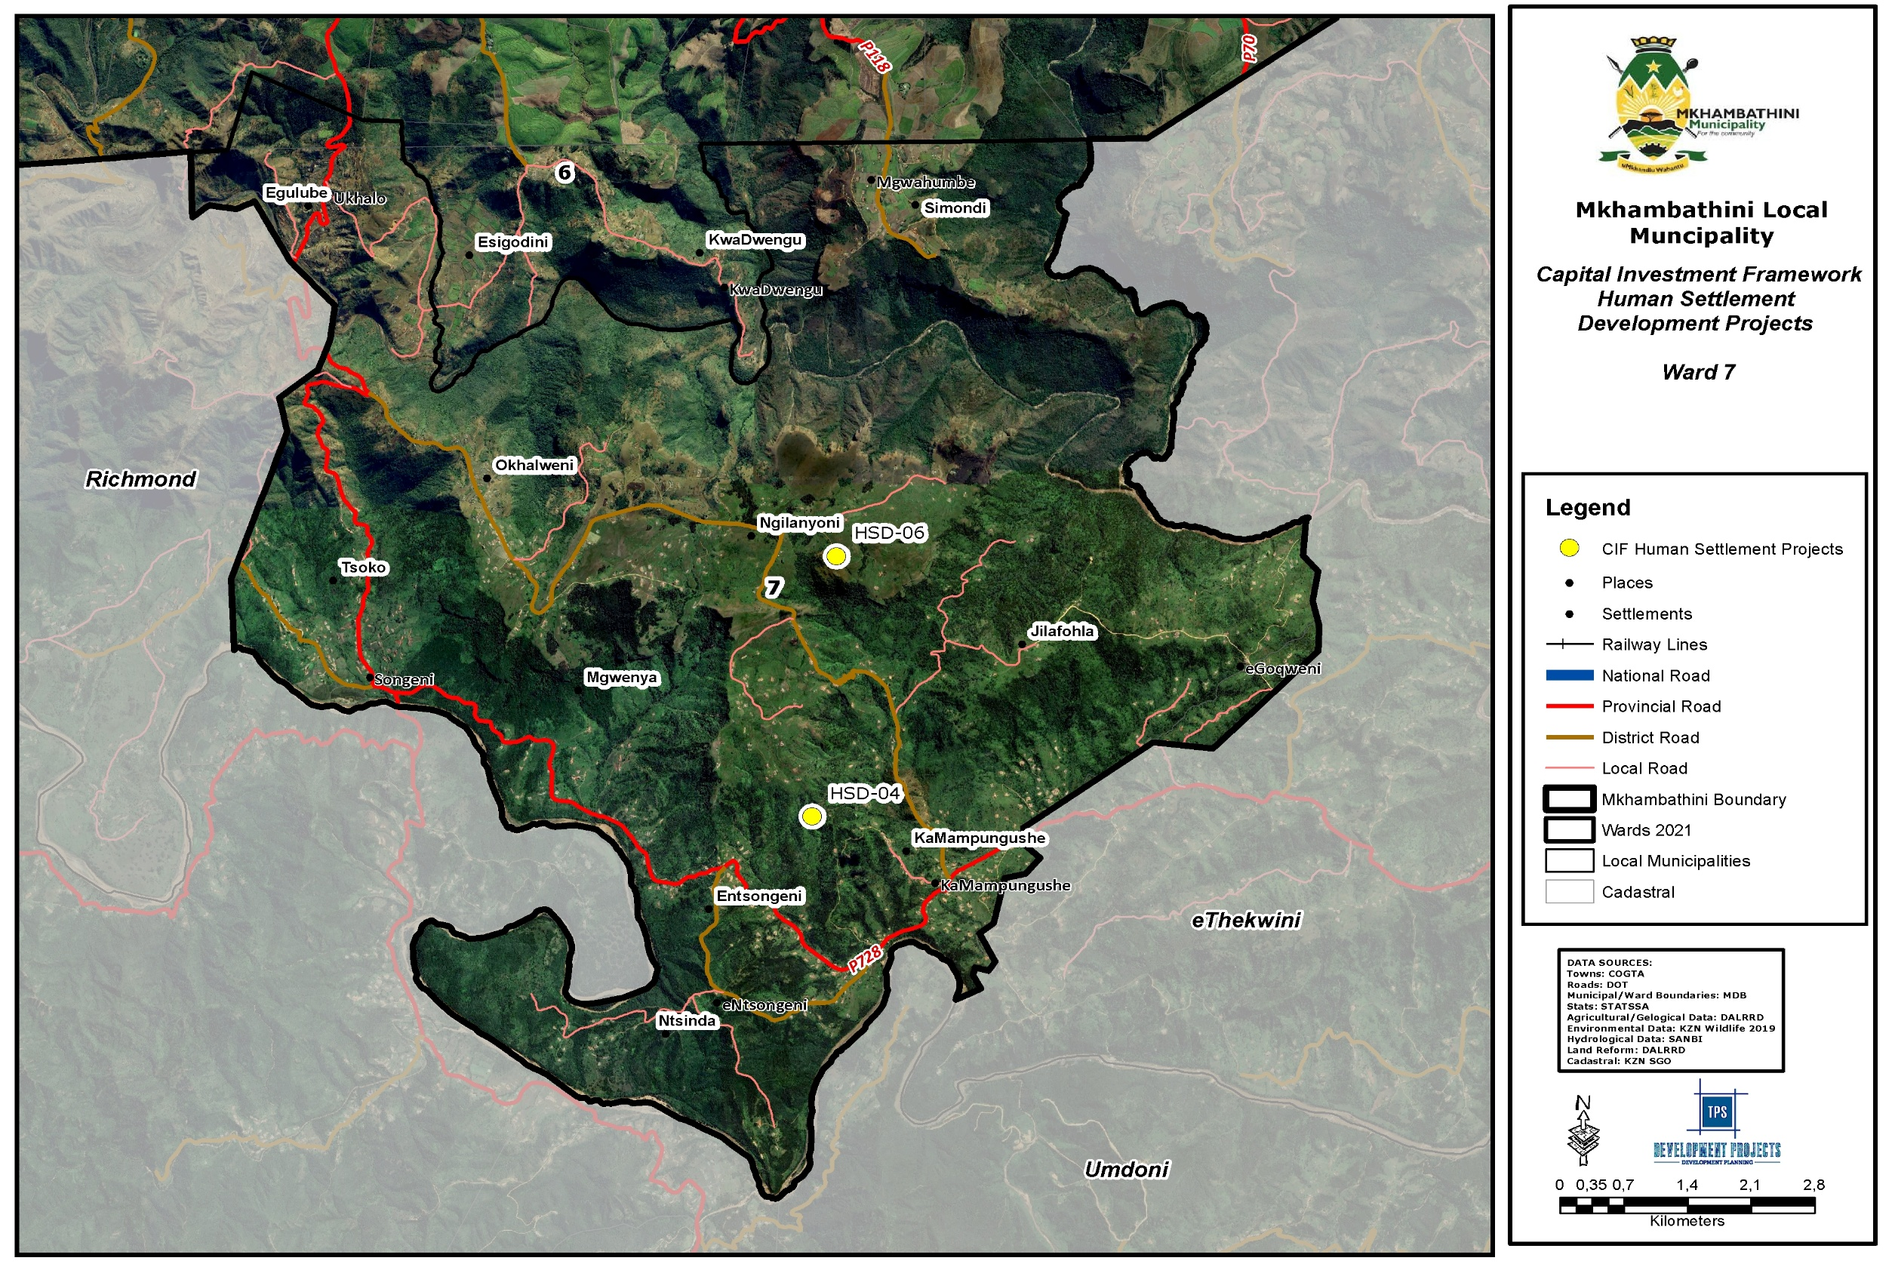
Map 34: CIF Human Settlements Ward 7
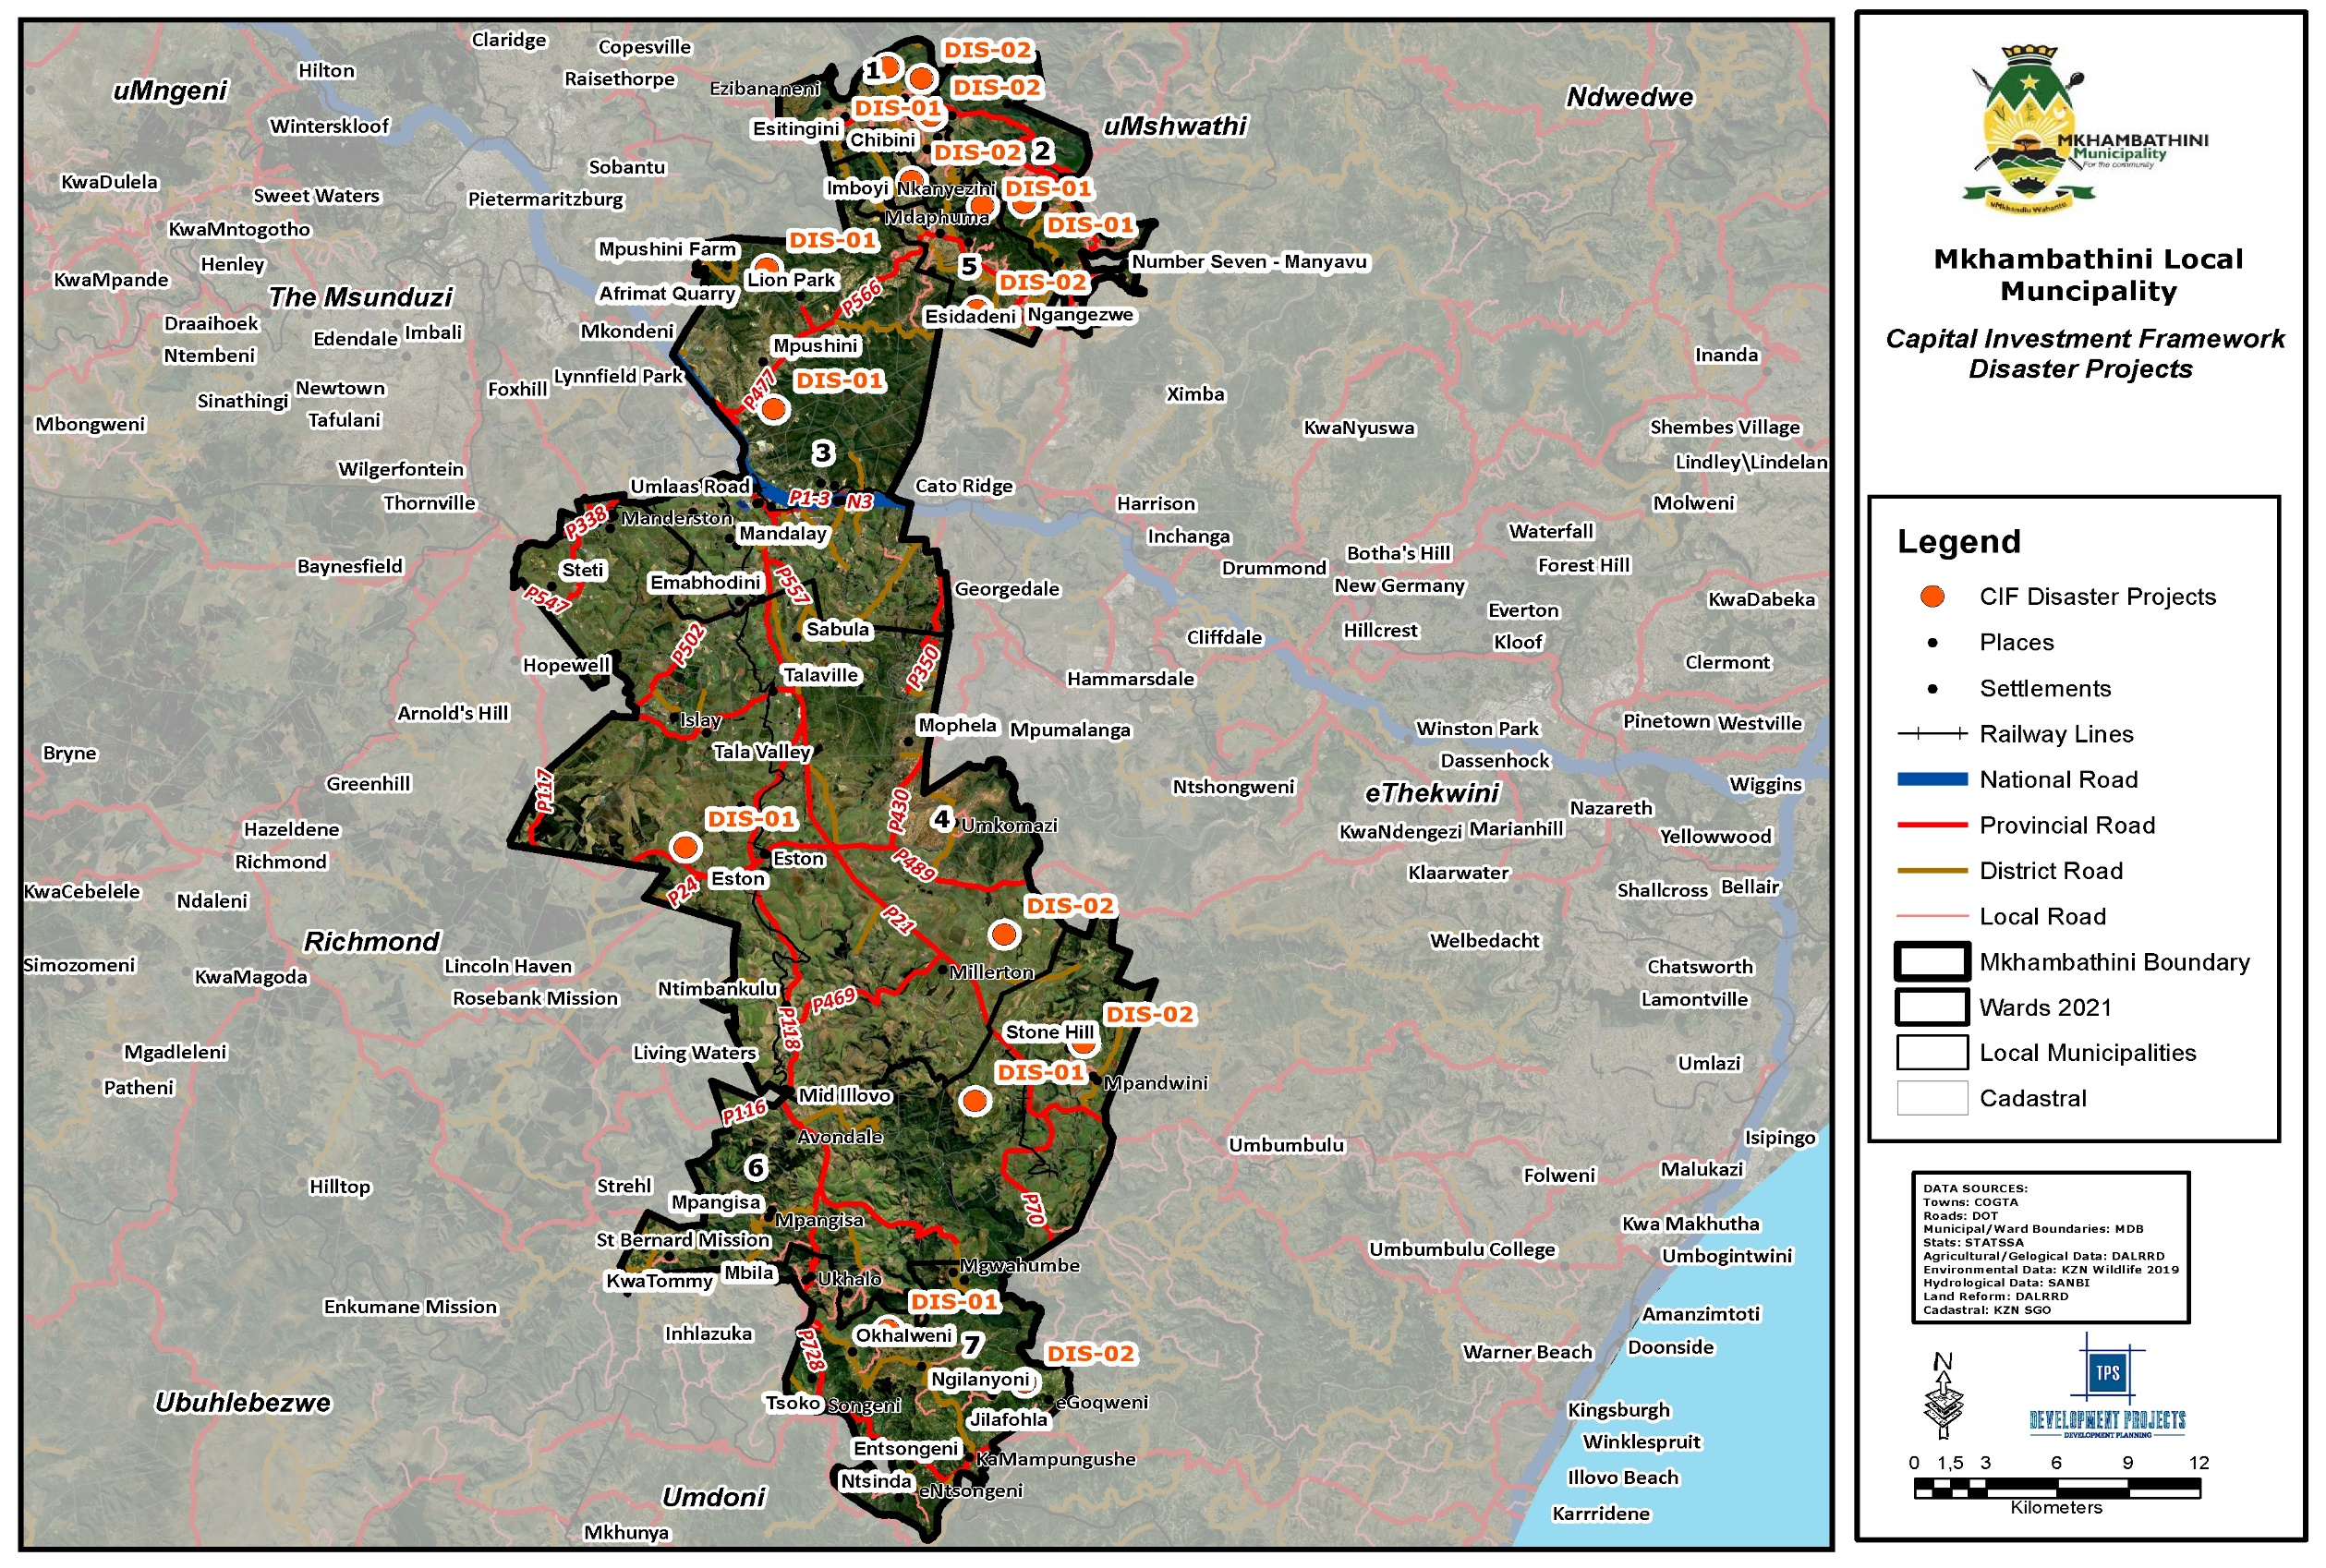
Map 35: CIF Disaster Risk Management
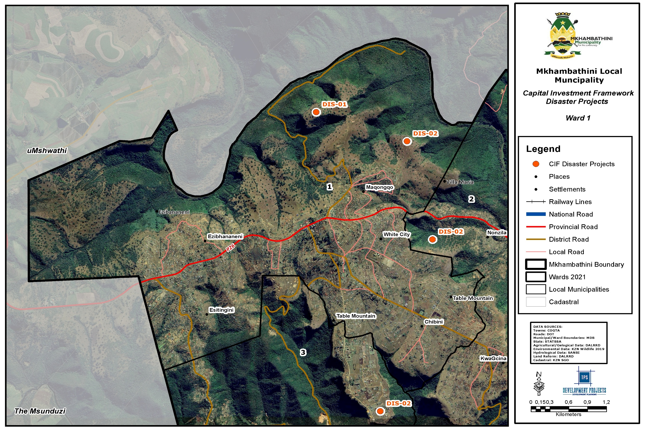
Map 36: CIF Disaster Risk Management Ward 1
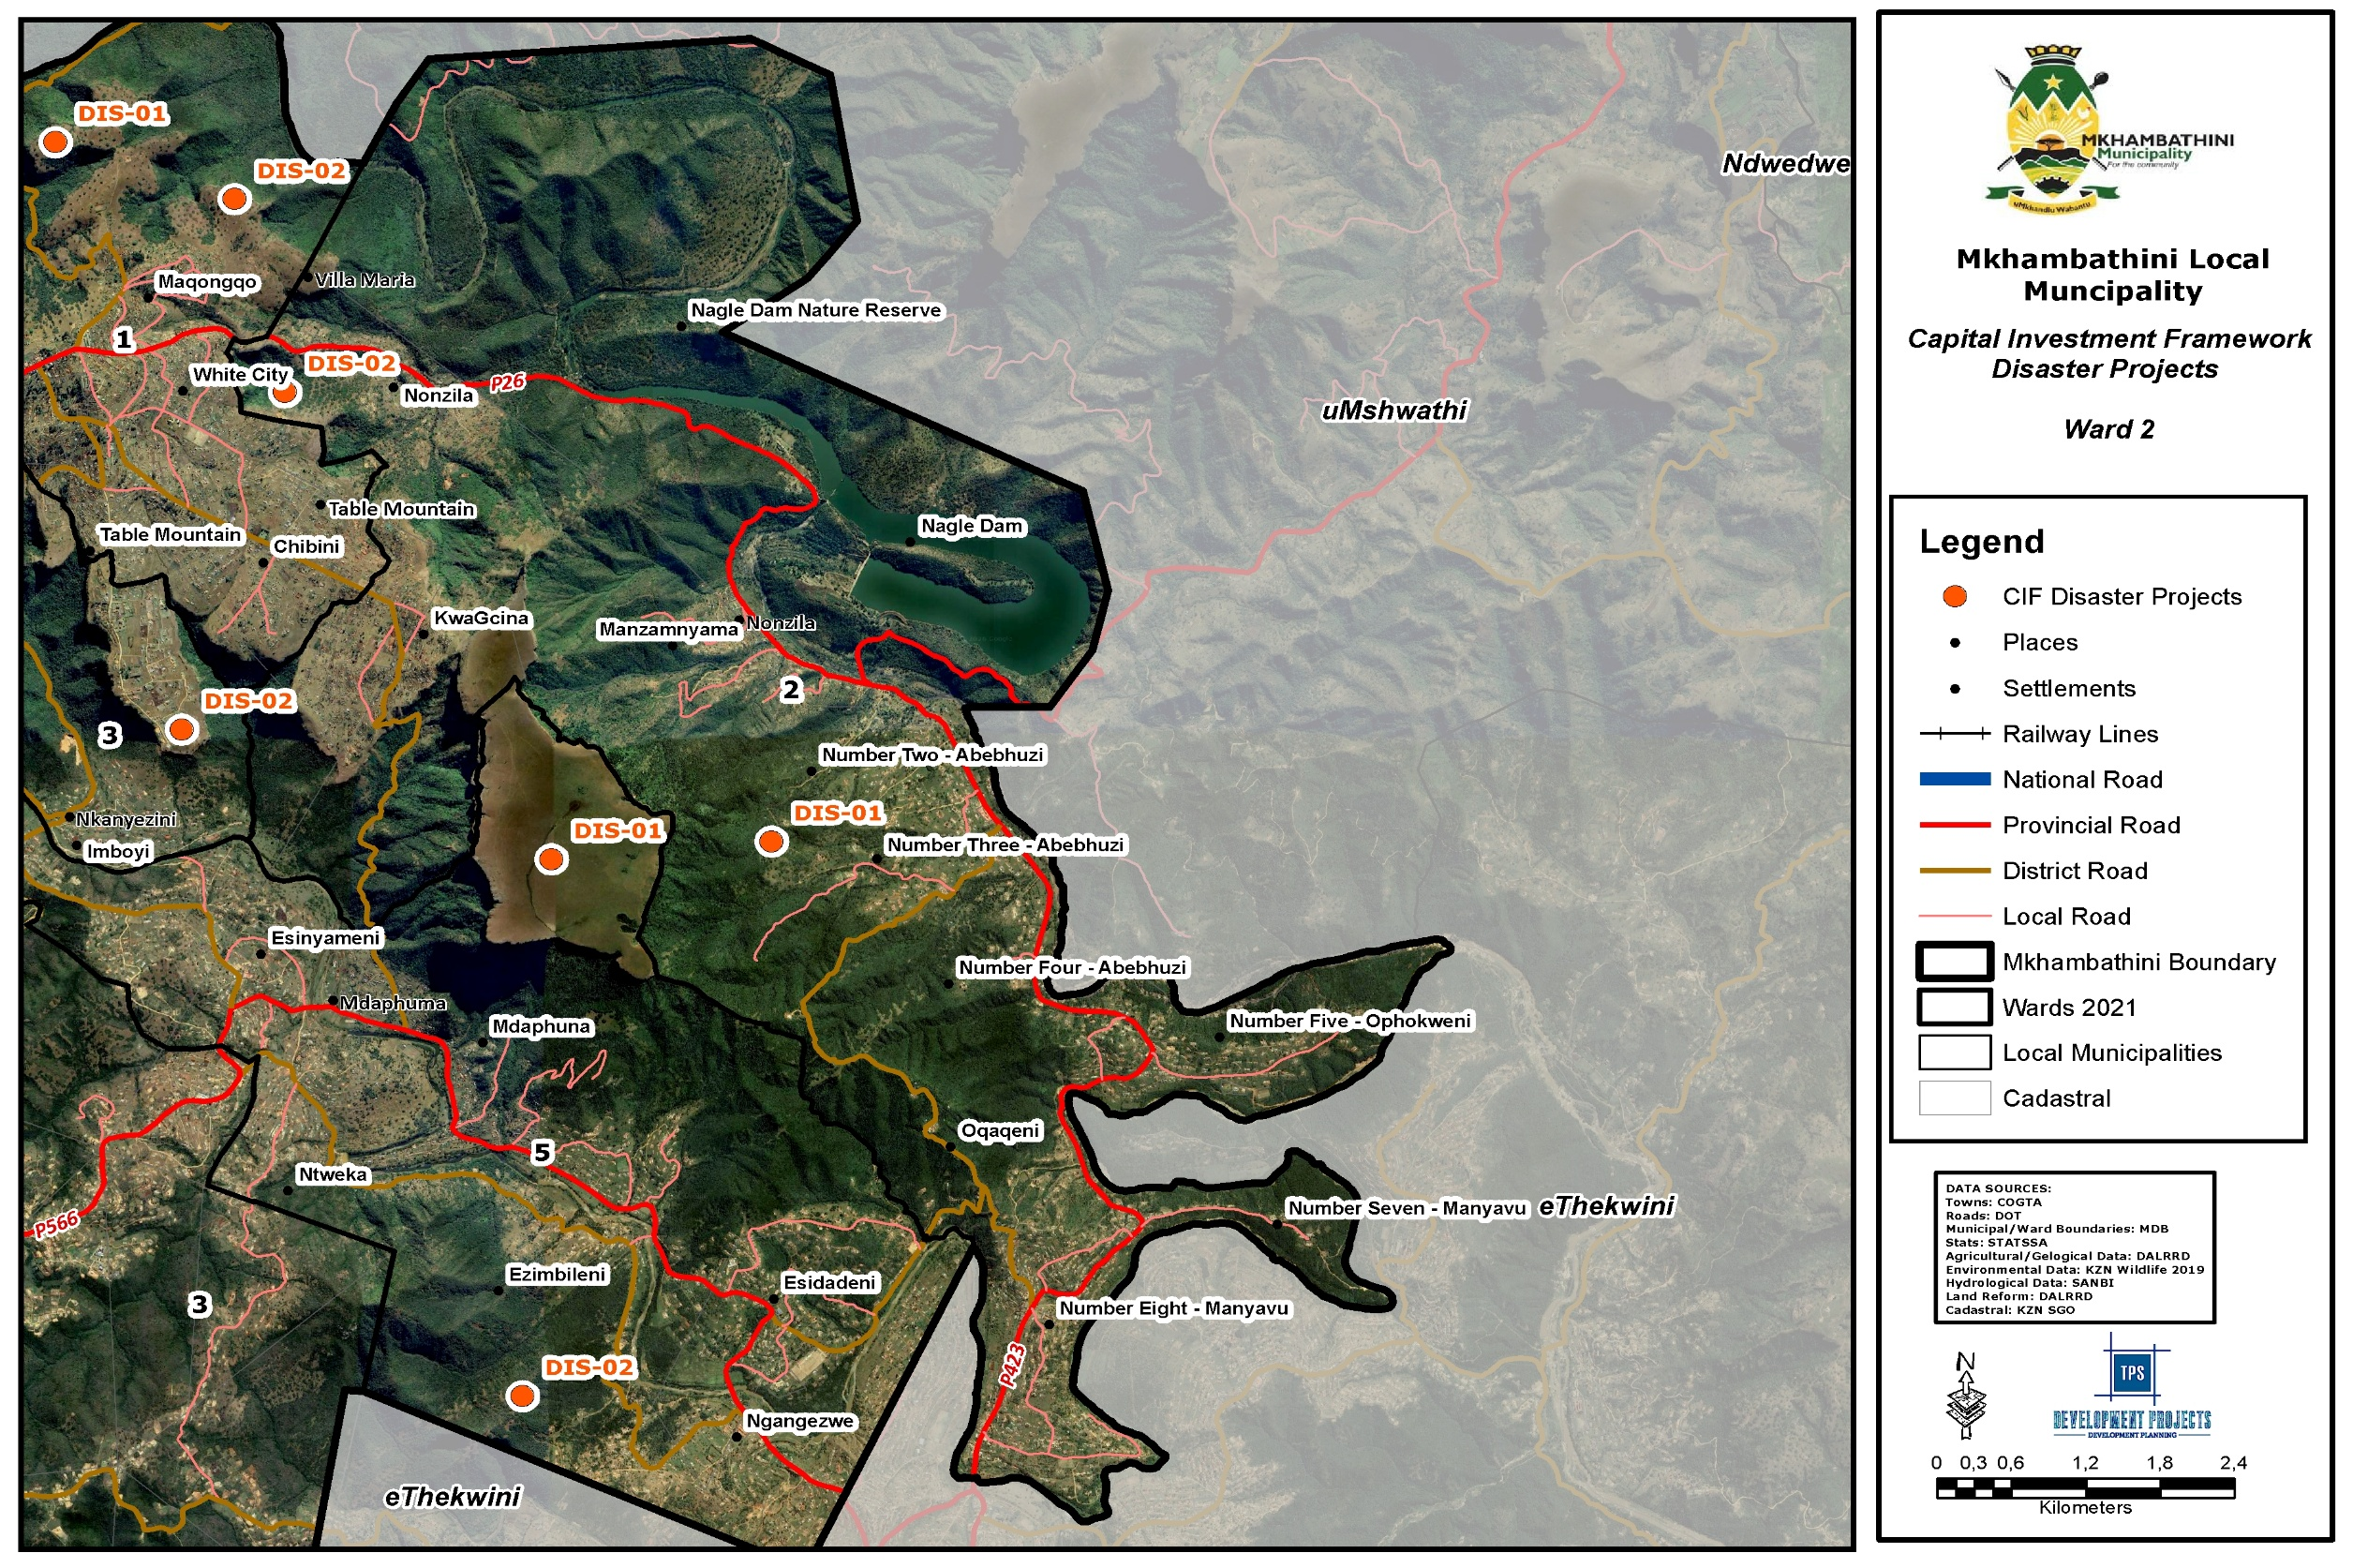
Map 37: CIF Disaster Risk Management Ward 1
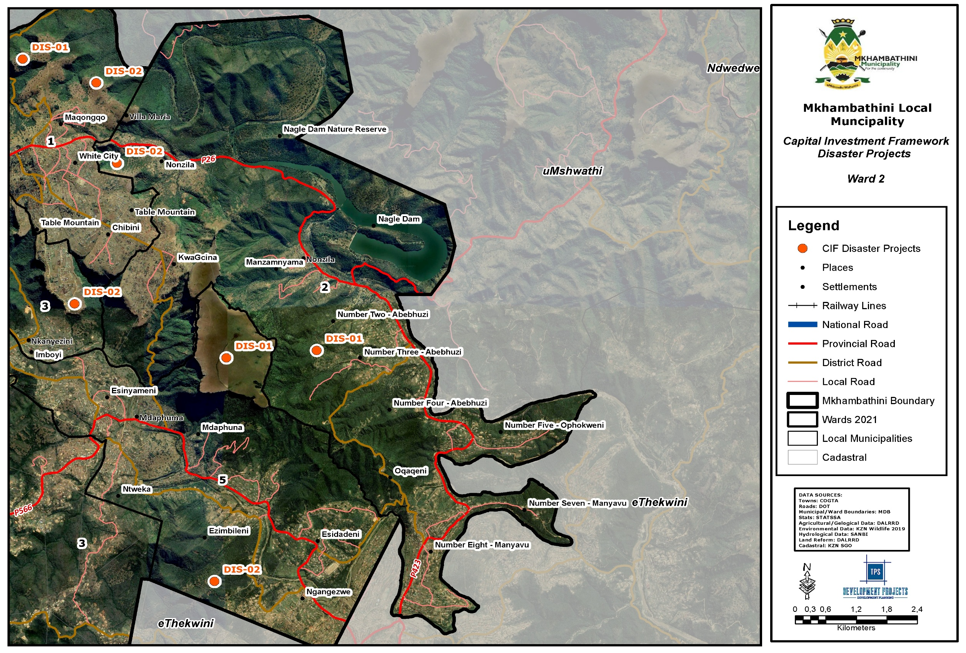
Map 38: CIF Disaster Risk Management Ward 2
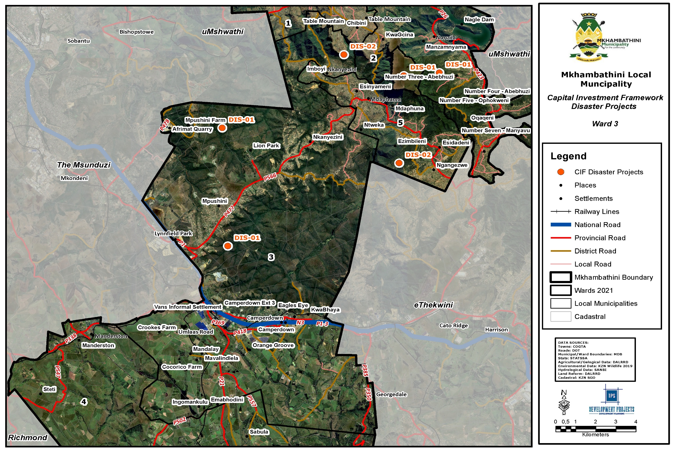
Map 39: CIF Disaster Risk Management Ward 3
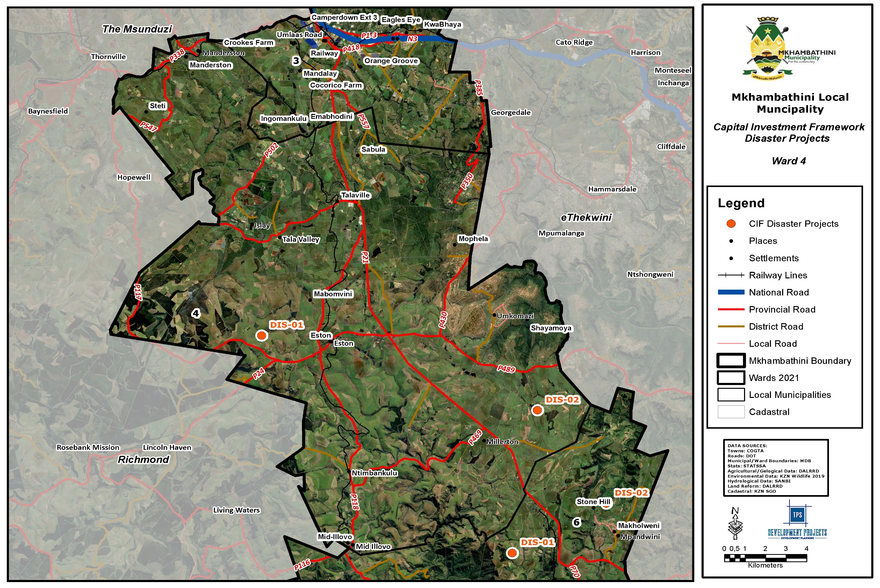
Map 40: CIF Disaster Risk Management Ward 4
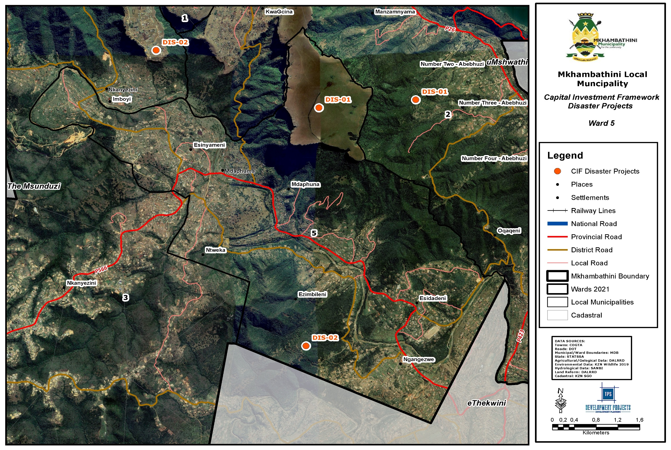
Map 41: CIF Disaster Risk Management Ward 5
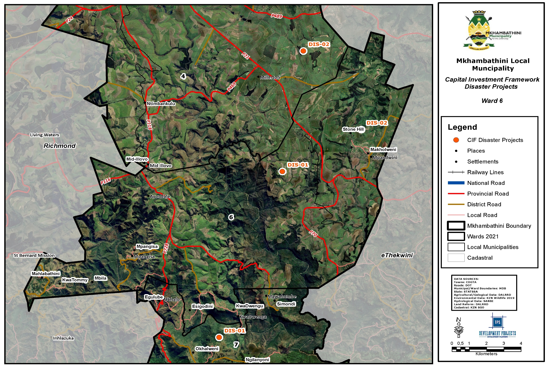
Map 42: CIF Disaster Risk Management Ward 6
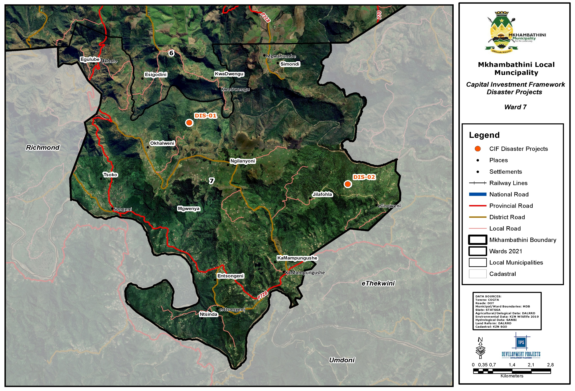
Map 43: CIF Disaster Risk Management Ward 7
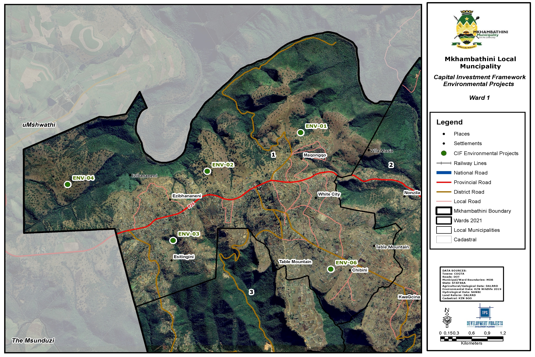
Map 44: CIF Environmental Management Ward 1
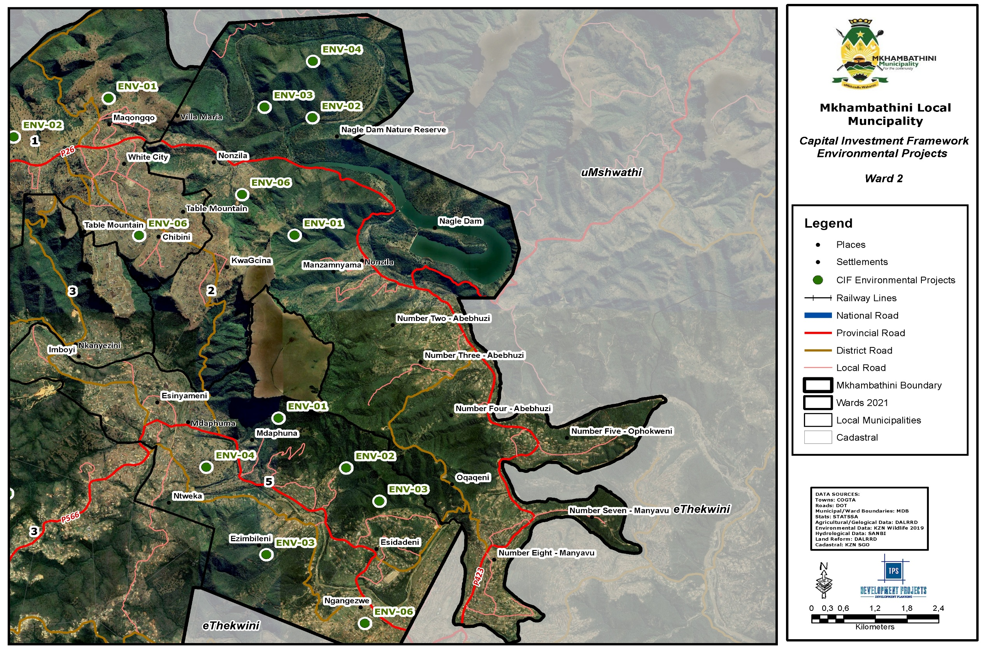
Map 45: CIF Environmental Management Ward 2
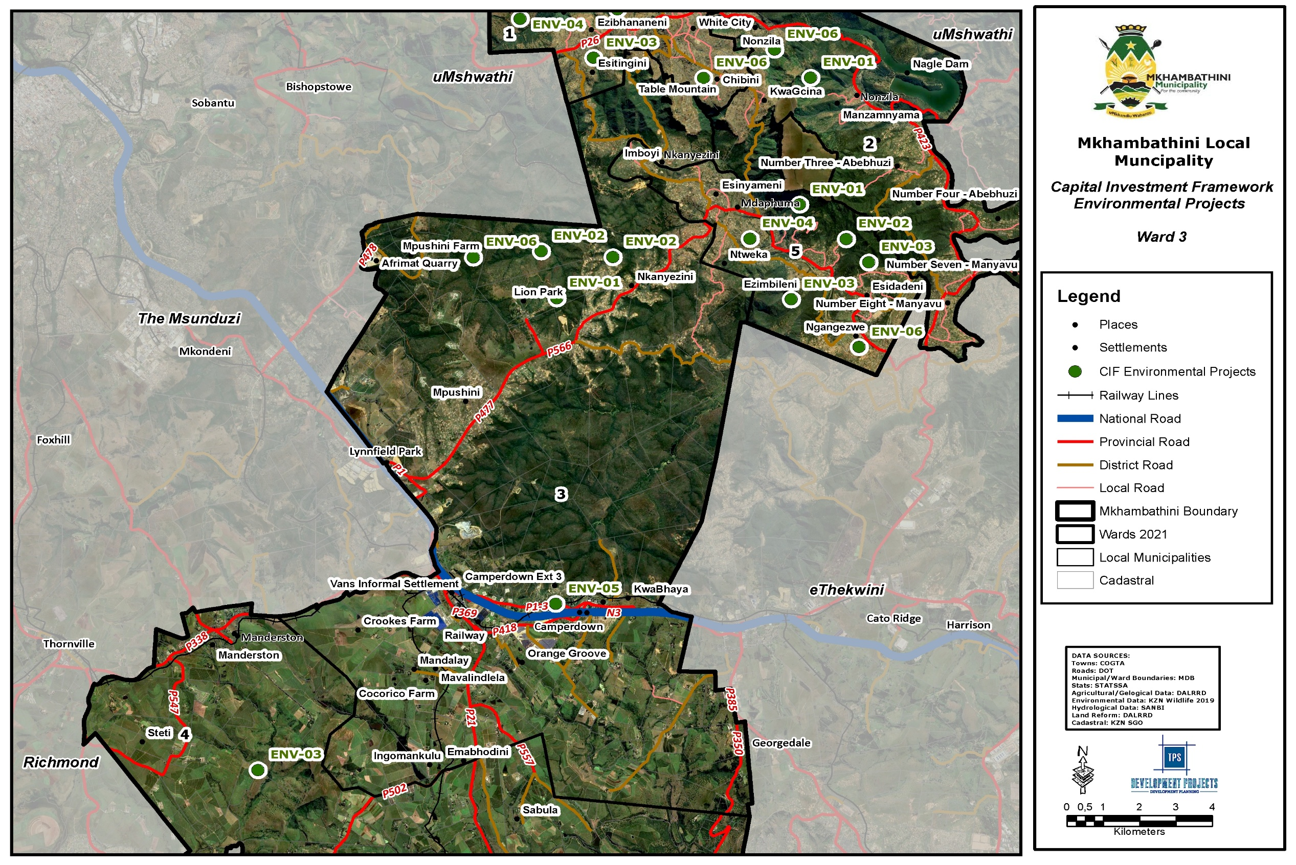
Map 46: CIF Environmental Management Ward 3
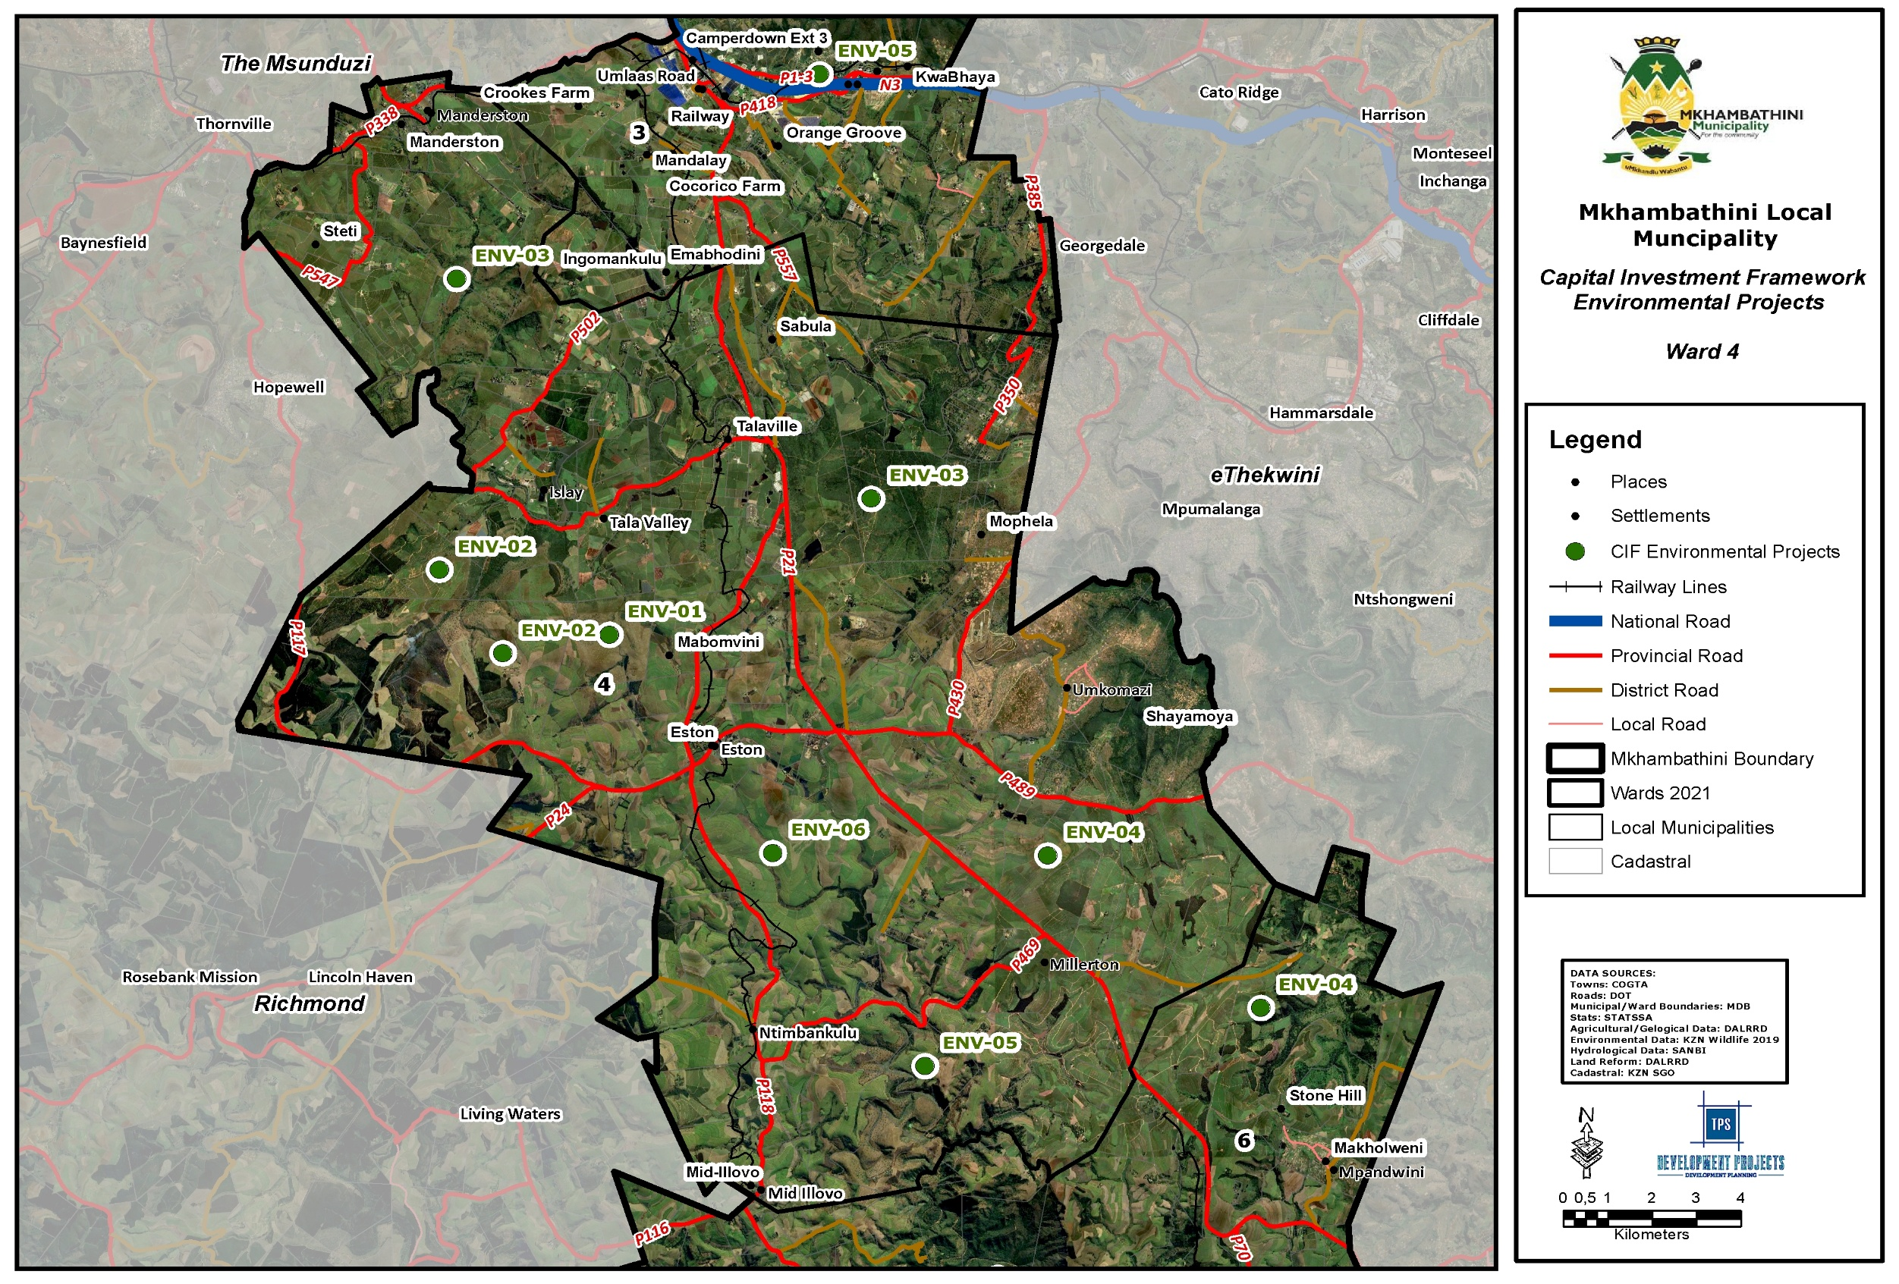
Map 47: CIF Environmental Management Ward 4
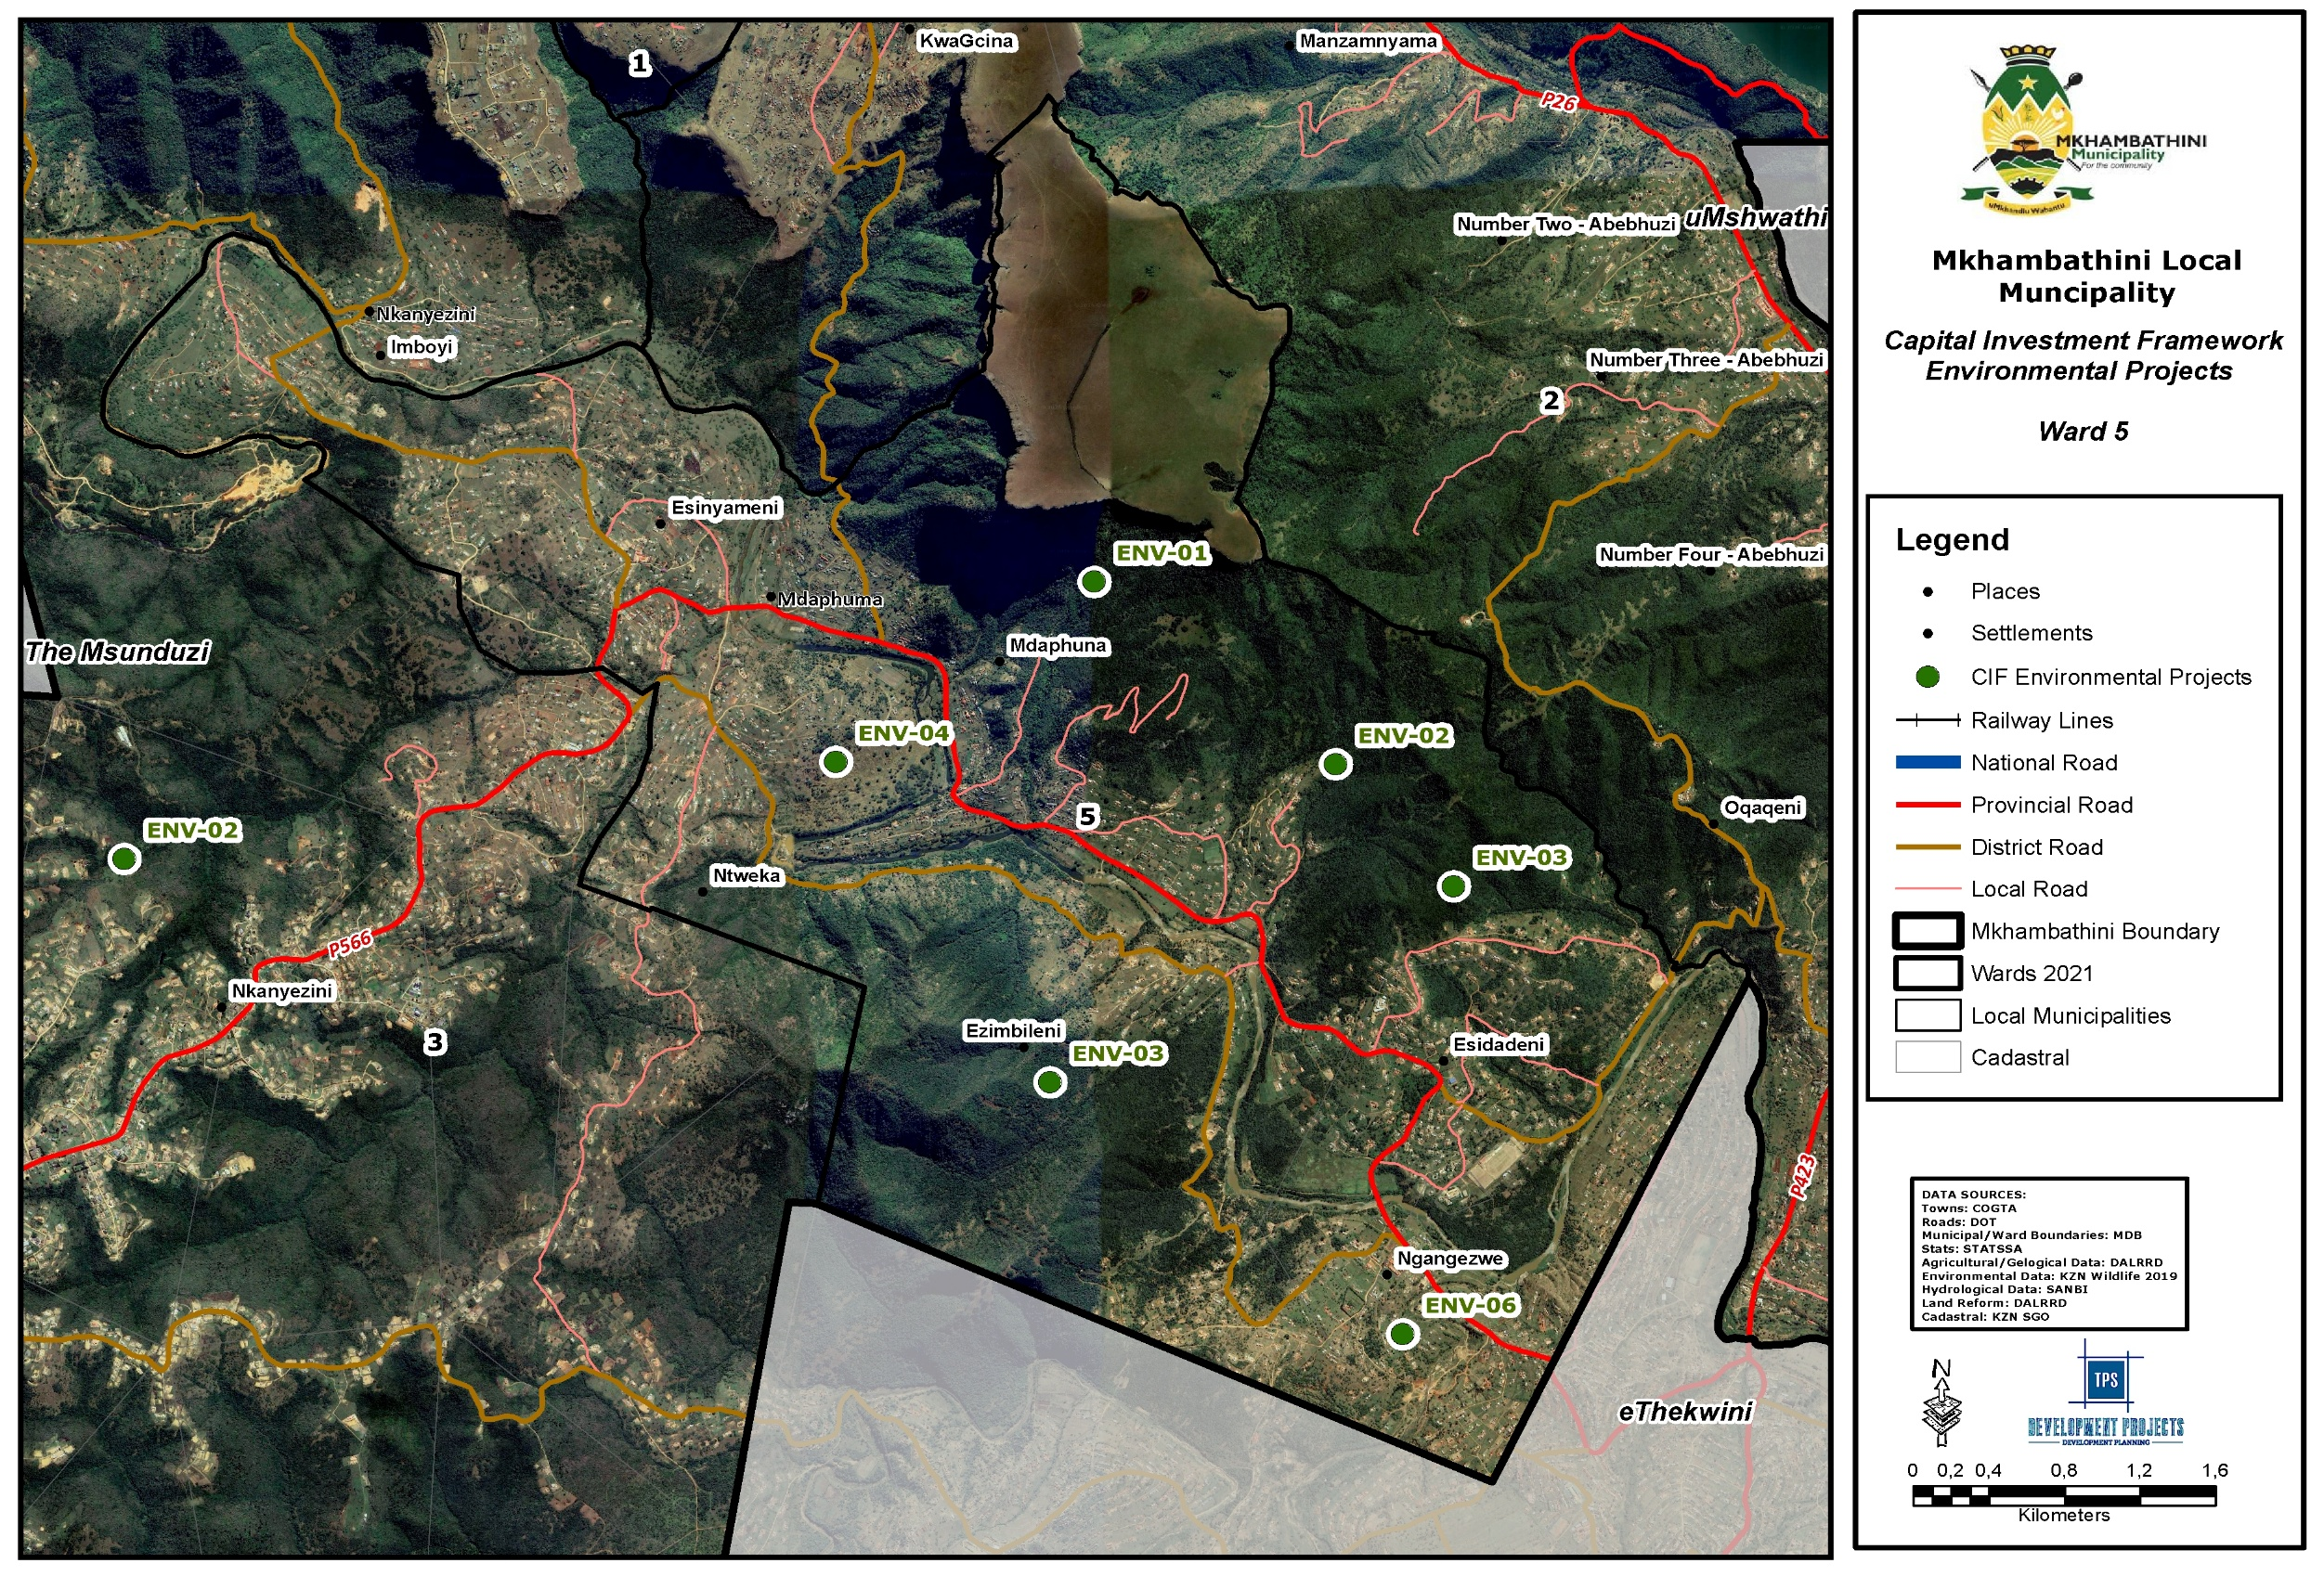
Map 48: CIF Environmental Management Ward 5
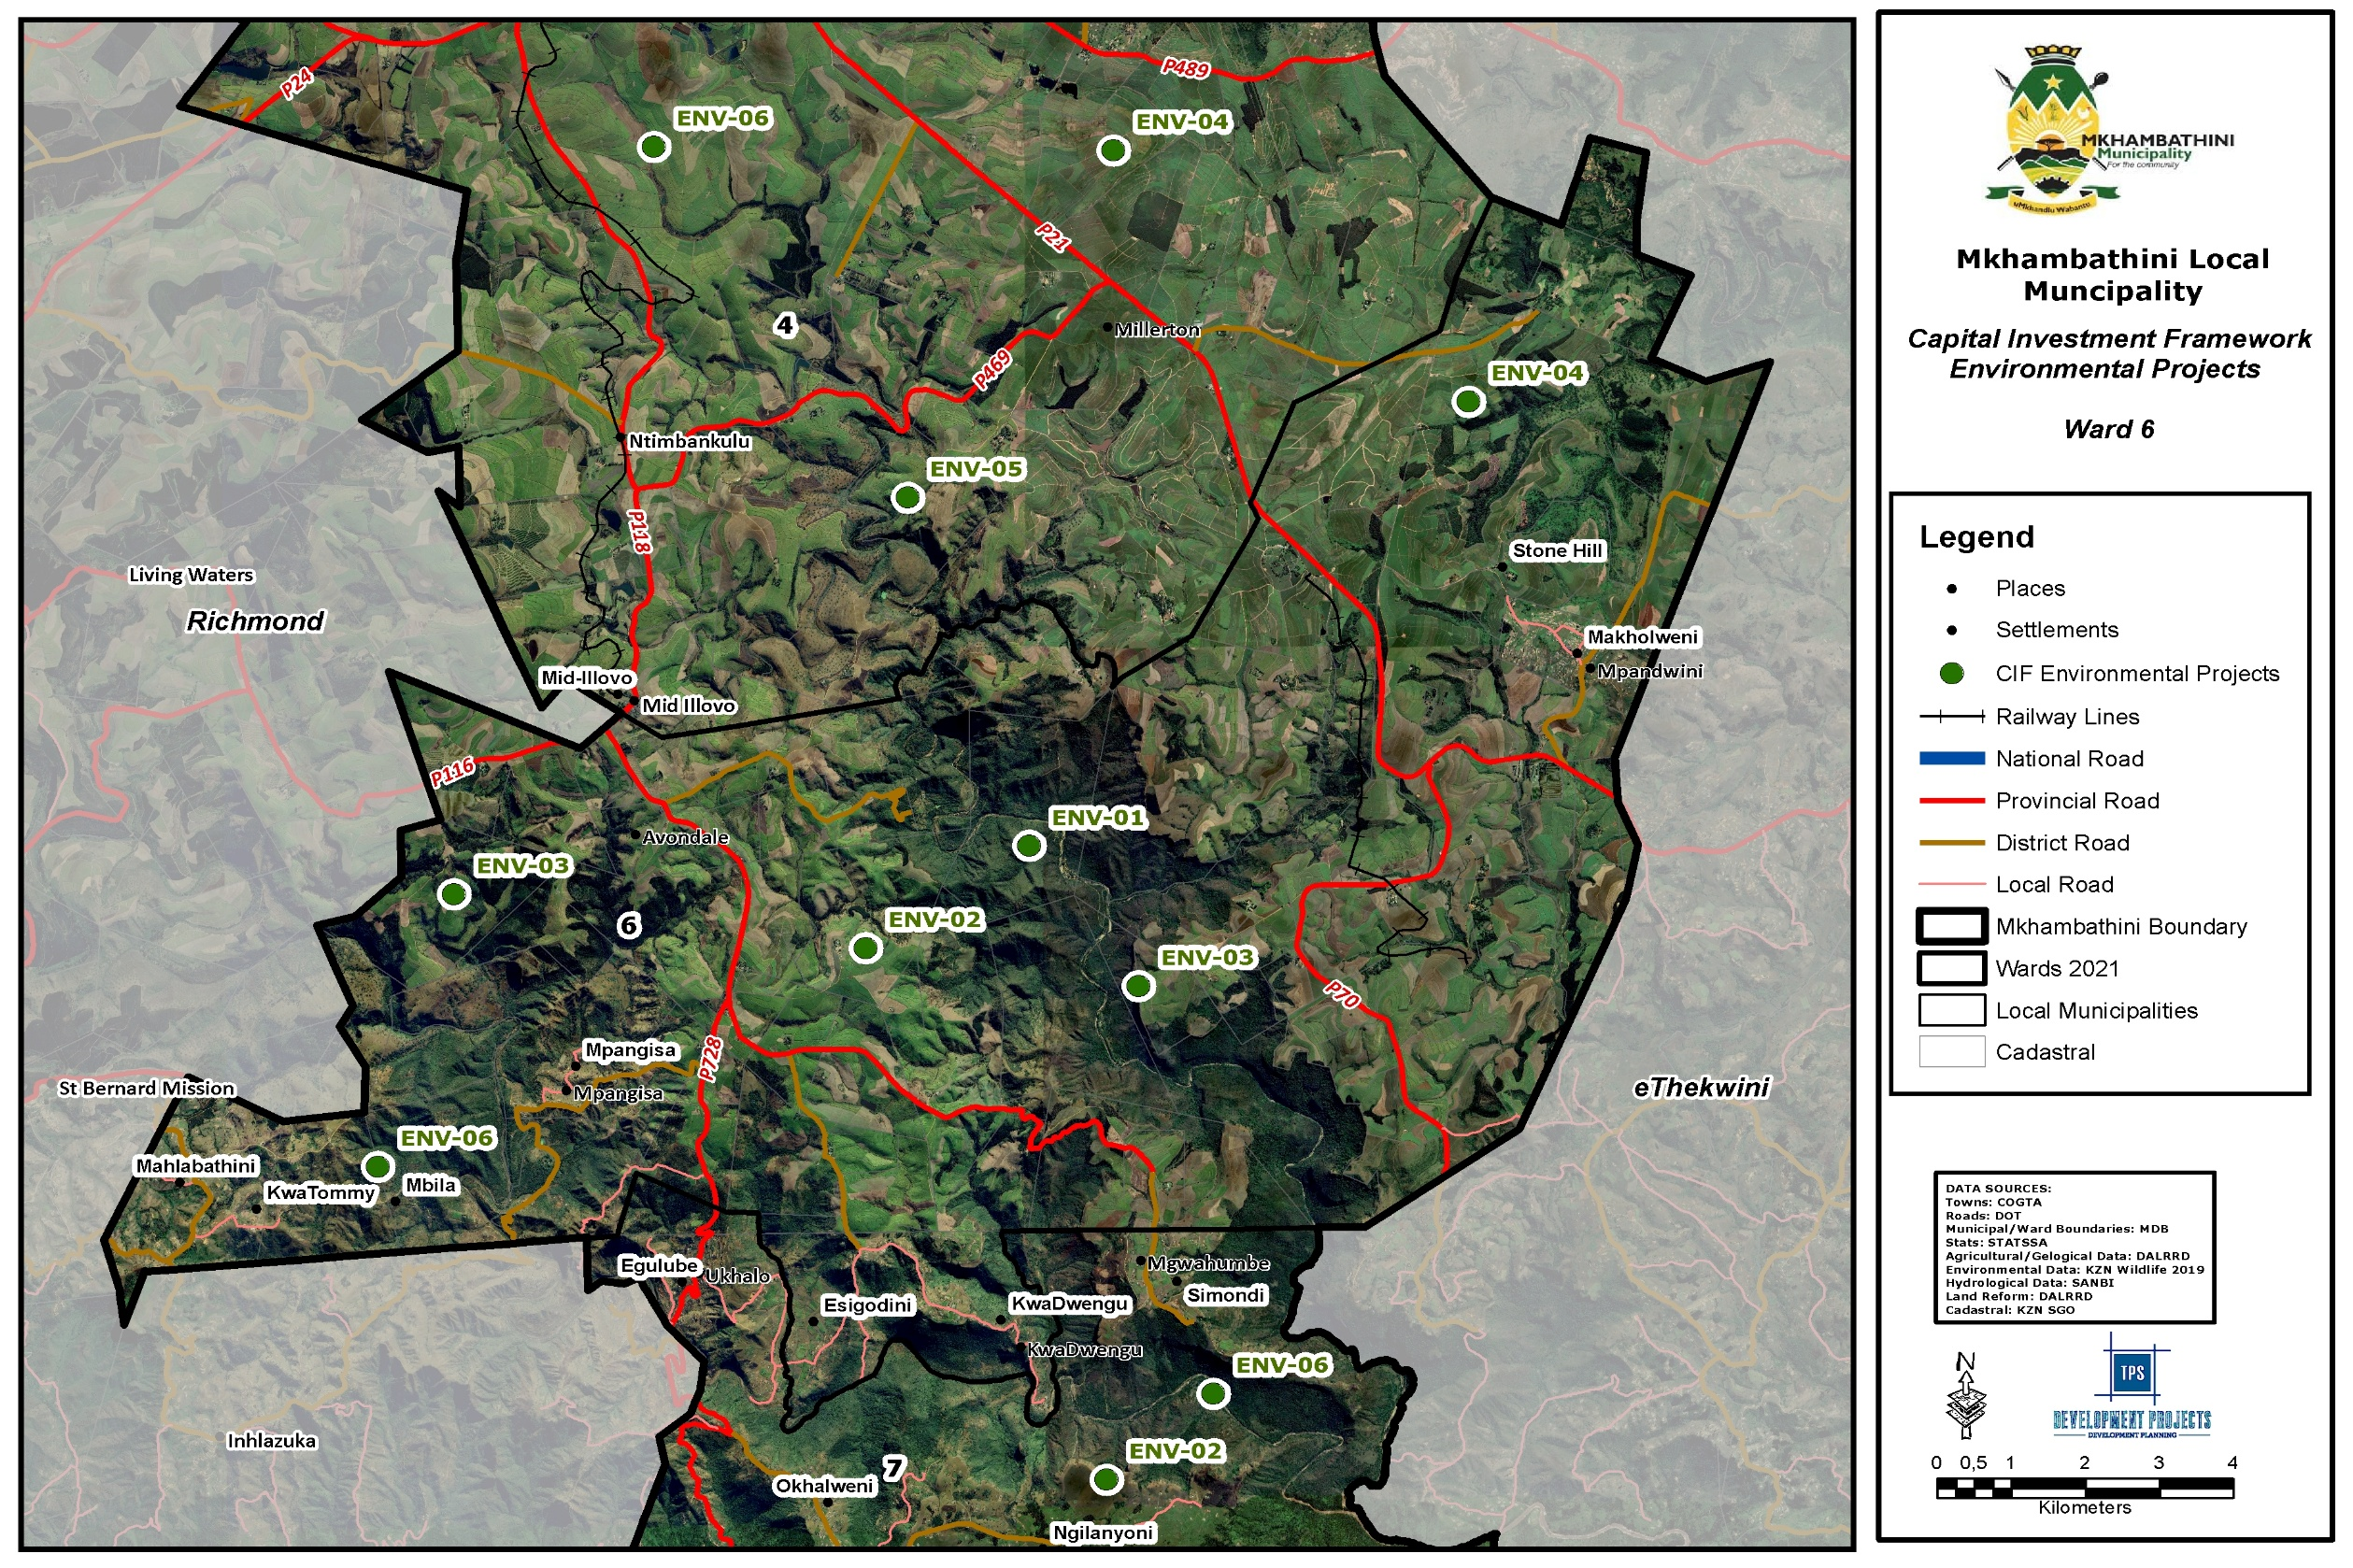
Map 49: CIF Environmental Management Ward 6
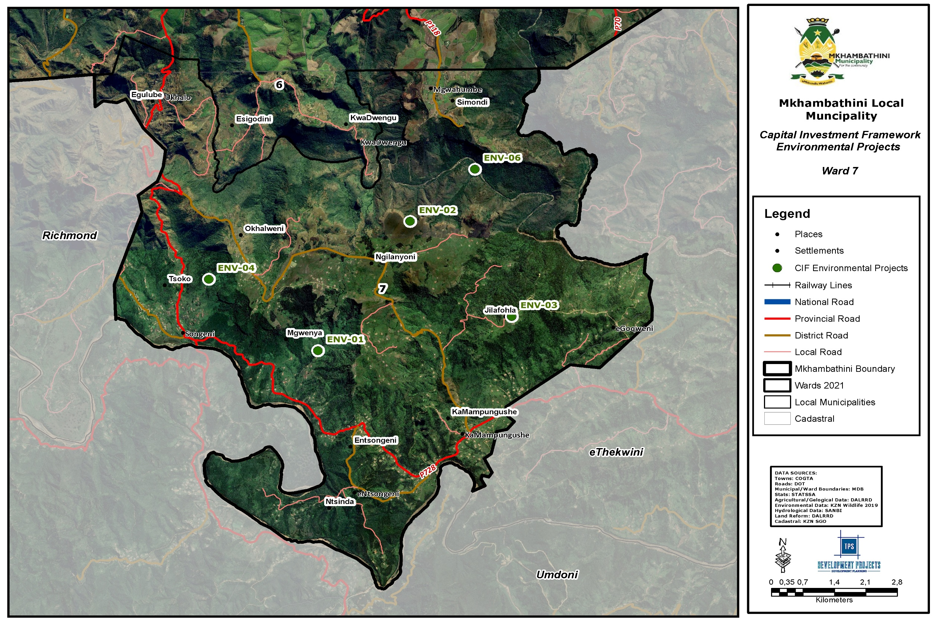
Map 50: CIF Environmental Management Ward 1

monitoring and evaluation plan
Monitoring and evaluation is critical to the successful implementation of the Mkhambathini LM SDF. As a longer term strategic plan it will be necessary to update and review the SDF on a regular basis and M&E is the basic tool through which this will be achieved. Monitoring and evaluation is a process that helps improving performance and achieving results. Its goal is to improve current and future management of outputs, outcomes and impact. It is mainly used to assess the performance of the SDF, specific projects featuring as part of the SDF and the institutions involved in implementing the SDF. M&E then also establishes the links between the past, present and future actions.

Table 4: Monitoring and Evaluation Framework
OBJECTIVE | PERFORMANCE INDICATORS | MEANS OF VERIFICATION | ASSUMPTIONS
ENVIRONMENTAL  MANAGEMENT | - Established programmes for clearing of invasive aliens through Working for Water, or other forms of rehabilitation e.g. through Working for Wetlands, Land Care.  - Established environmental management programs.  - Effective Water Resource Management  - Delineation of flood risk areas  - Establishment of protected areas  - Catchment management  - Alien plant management  - Protected area development  - Wetland management  - Biodiversity zones | - 1:50 years and 1:100-year flood lines.  - People removed from flood risk areas.  - Developed Water Resource Management Strategy  - Improved sanitation and waste management infrastructure and services in primary nodal areas.  - Rehabilitated wetlands and riparian zones.  - Catchment management programme.  - Participation in national catchment management initiatives.  - Application of carrying capacity standards to grazing land management.  - Amount of land cleared of alien plants.  - Programme to remove alien plants.  - Initiatives to rehabilitated land affected by soil erosion.  - Protection of indigenous forestry.  - Proclamation of environmentally sensitive areas that are not currently protected.  - Delineation of all major wetlands.  - Observation of a 32m buffer from each wetland.  - Management of bio-diversity corridors.  - Environmental overlays. | The municipality must work with all stakeholders towards an environmentally sustainable development
REGIONAL ACCESS  AND ROAD  NETWORK | - Upgrading of major access and arterial/link roads.  - Improving access to the existing and growing settlements.  - Creating new linkages.  - Location of development nodes along and at the intersection of key roads.  - Focusing development projects on settlements located along strategic roads. | - Number and location of roads upgraded.  - KMs of roads upgraded.  - New roads.  - Number of high impact and catalytic projects located along development corridors.  - Type and level of services provided to settlements located along development corridors.
CLUSTERING  PUBLIC FACILITIES  AND ECONOMIC  ACTIVITIES IN  DEVELOPMENT  NODES | - Development of service centres.  - Focusing strategic and high impact projects within development nodes.  - Promoting clusters of public facilities as a means to encourage nodal development. | - Number, nature and budgets for municipal projects in each of these nodes.  - Level of access and location of public facilities serving different communities in these nodes.  - Availability of infrastructure in nodes to enable these to perform their role.  - Number of public facilities locating in identified service | Development nodes have potential to improve access to basic and public services.
PROTECTION OF  AGRICULTURAL  LAND | - High potential agricultural land  - Agricultural protection plans  - Agricultural development support | - Identification and mapping of agricultural land with high potential.  - Size and use of high potential agricultural land Scheme clauses designed to protect high potential agricultural land.  - Introduction of land use controls for agricultural land.  - Initiatives to promote agriculture.  - Direct support to land reform projects. | Agricultural land is under threat from non-agricultural  uses such as settlement
UNLOCKING  ECONOMIC  DEVELOPMENT | - Tourism development  - Commercial & industrial development in nodal areas  - Number of Public Private  - Partnership Agreements signed | - Increased investment in terms of tourism, leisure and commercial within Mkhambathini  - Branded Tourism Route.  - Introduction of new tourism products.  - Number of new tourism facilities and products located in Mkhambathini Local Municipality.  - Commercial & industrial development applications received by the municipality.  - Percentage increase in commercial land.  - Uptake of commercial land in dense rural settlements
DEVELOPMENT  OF SOCIAL AND  SERVICE  INFRASTRUCTURE | - Improved sanitation services and infrastructure  - Improved access to water  - Improved access to electricity  - Improved access to social facilities | - All households access a health facility within a 5km radius.  - Number and location of new health facilities.  - Weakly mobile clinics  - Number of VIP’s in rural areas  - Waterborne sanitation system in areas inside urban edge  - Piped water within the house in urban settlements  - Water on site or at least within a 200m from  - each household in dense rural settlements  - Eradication of electricity backlogs  - Number of new health facilities  - Number of new schools | The municipality must work  together with government  departments to improve the quality of life of residents through the development and improvement of social and service infrastructure.
SUSTAINABLE  SPATIAL PLANNING  SYSTEM | - The sustainable Spatial Planning  - System must be able to map out all the strategically located land parcels for packaging for commercial and tourism investments | - Council approved land use management system.  - Cooperation between traditional leaders and the municipality on land use management issues.  - Continuum of settlements from urban high density to remote low-density settlements.  - Number of functional tertiary nodes.  - Availability of infrastructure in Mkhambathini LM to enable the area to perform its role.  - Upgrading and renewal | The municipality must refine the SDF and develop it further through the formulation of a series of plans with varying degrees of detail and flexibility.
DEVELOPING  SUSTAINABLE  HUMAN  SETTLEMENTS | - Upgrading of informal settlements.  - Consolidation of settlements located along primary and secondary corridors.  - Level and type of infrastructure in each settlement  - Implementation different types of housing projects. | - Number of housing units constructed;  - Number of households on waiting list for housing;  - Number of approved general plans for housing projects.  - Number of consolidated settlements. | There is a need to improve the structure and form of settlements

conclusion

The Mkhambathini Local Municipality's Spatial Development Plan (SDP) stands as a testament to the municipality's commitment to sustainable growth, equitable development, and an improved quality of life for its residents. Developed in adherence to the comprehensive guidelines set forth by the Department of Cooperative Governance and Traditional Affairs (CoGTA), this plan serves as a visionary framework that aligns seamlessly with the municipality's strategic objectives.
The purpose of the SDP is clearly defined, presenting itself as a proactive and strategically informed planning tool within the broader context of the Mkhambathini Municipality. Operating in conjunction with the long-term Spatial Development Framework (SDF), the SDP functions as a concise instrument for short-term planning. By centering on essential objectives, strategies, and outcomes, it provides a trajectory for projects and programs identified within the Capital Investment Framework (CIF) for a specified 5-year period. The plan also allows for flexibility, recognizing the need for adjustments in alignment with evolving priorities.
The SDP included a Capital Investment Framework (CIF) which is a mechanism for implementation that intricately merges financial allocations and temporal boundaries. This commitment to enhancing infrastructure and spatial dimensions is not only aligned with the priorities set by the CIF but also integrated into the consolidated budgets of both the Municipality and Sector Departments.

