PUBLIC NOTICE

2021/22 DRAFT INTEGRATED DEVELOPMENT PLAN
In terms of Section 25(1) of the Municipal Systems Act 32 of 2000 ,The Mkhambathini Local Municipality 2021/22 that is open for comments by the Public and other Stakeholders at the Municipal Offices, Reception Area No.18 Old Main Road Camperdown, Maqongqo Modula Library and all Traditional Councils during weekdays from 08:00 to 15:30 from 6th of April 2021 to 5th May 2021
All comments on the Draft IDP Document must be submitted in writing to the IDP Officer by no later than 5th May 2021 at 12h00
For all enquiries please contact Miss Z Magini , IDP Officer at : Idp@mkhambathini.gov.za Tel: 031 785 9370/07

ISAZISO NGOHLELO LWENTUTHUKO OLUDIDIYELWE LOKUBUYEKEZWA LWEMINYAKA 2021/22
Ukwamukelwa kwezincomo ngokubuyekweza kweIDP yomkhandlu wase Mkhambathini ngokwesahluko 25 (1) somthetho weMunicipal Systems Act wonyaka ka 2021/22
Umkhandlu wase Mkhambathini wazisa umphakathi nabanye ababambe iqhaza ekuthuthukisweni kwezentuthuko ukuthi kusukela ngomhlaka 6 ku Mbasa 2021 kuya kumhlaka 5 ku Nhlaba 2021 kusukela ngo 08:00 kuya ku 15:30 kuzobe kunohlelo lwentuthuko olubuyekeziwe,izobe itholakala kulendawo elandelayo amahhovisi kamasipala(reception), No.18 Old Main Road, Camperdown 3720, Camperdown Library, imikhandlu yamakhosi akhele umasipala, Maqongqo Modula Library.
Umphakathi uyacelwa ukuba ulethe izincomo zawo kulezndawo ezingenhla ezibhaliwe ngaphambi komhlaka 5 ku Nhlaba 2021 ngo 12h00 noma uxhumane no Nkosikazane Z Magini, IDP Officer ku Idp@mkhambthini.gov.za ucingo :031 785 9370/07
NOTICE NO.11/2021 DATED :31/03/2021
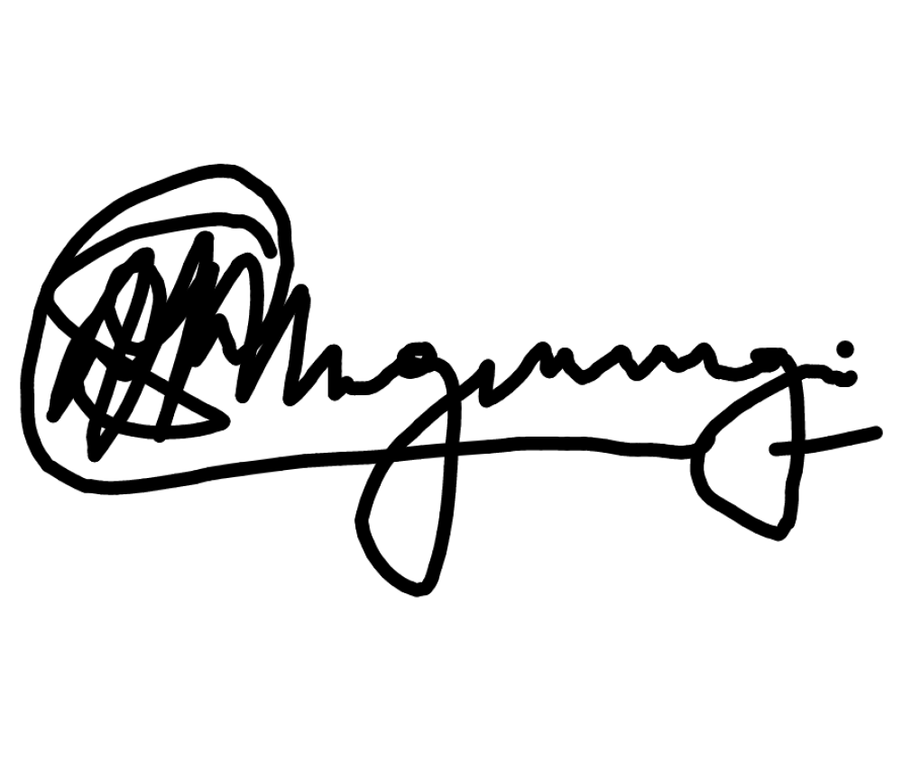

MR SANELE MNGWENGWE
MUNICIPAL MANAGER

