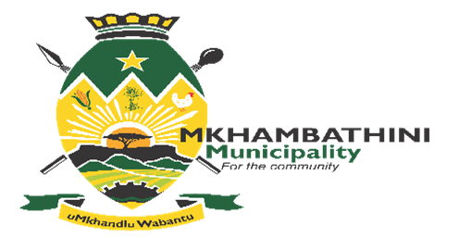
PUBLIC NOTICE

DRAFT ANNUAL REPORT 2021/2022
In terms of the Municipal Systems Act (MSA) Section 46 and the Municipal Finance Management Act (MFMA) Section 121, the adoption of the Draft Annual Report 2021/2022 is opened that is open for comments by the Public and other Stakeholders at the Municipal Offices, Reception Area No.18 Old Main Road Camperdown, Maqongqo Modula Library, all Traditional Councils and municipal website (www.mkhambathini.gov.za) during weekdays from 08:00 to 15:30 from 25th of January 2023 to 25th February 2023.

All comments on the Draft Annual Report must be submitted in writing to the Communications Office by no later than 25th May 2023 at 12h00

For all enquiries, please contact Communications Office at : communications@mkhambathini.gov.za Tel: 031 785 9344

NOTICE NO.12/2023 DATED : 25/01/2023
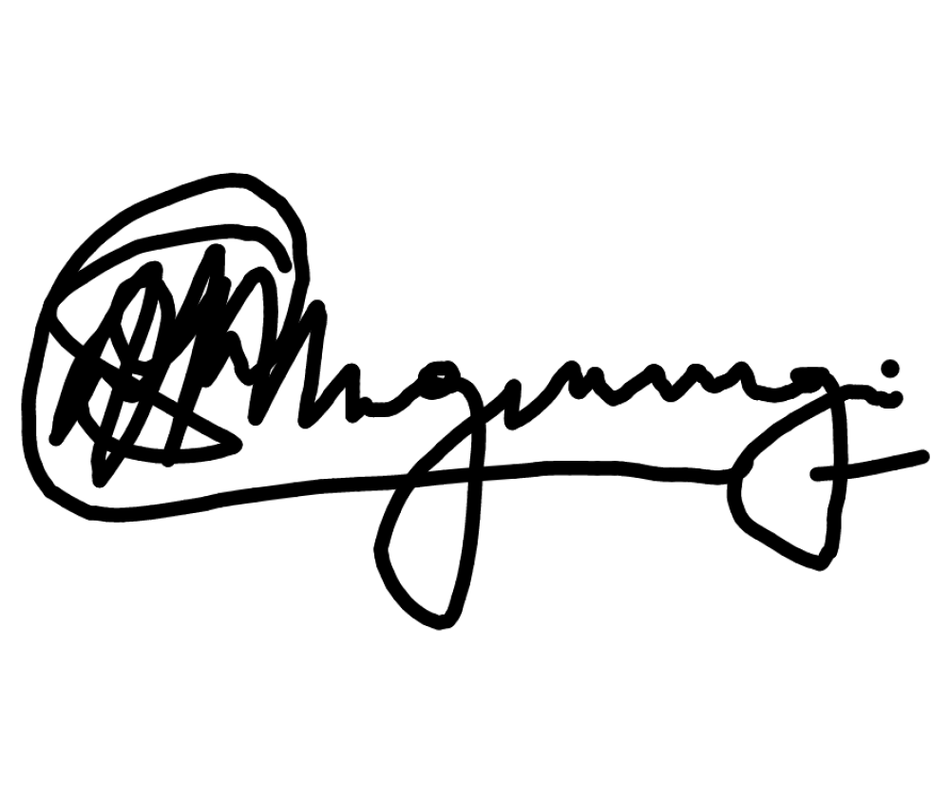

MR SANELE MNGWENGWE
MUNICIPAL MANAGER

