**Mid-year Budget and Performance Assessment**

2020/2021 FINANCIAL YEAR



**MKHAMBATHINI MUNICIPALITY**

**Contents**

**Part 1** 2

**1.** **Introduction**

**2.** **Executive Summary**

**3.** **In-Year Budget Tables** 6

**Part 2 – Supporting Documentation** 15

**1.** **Debtors Analysis**

**2.** **Investment Portfolio Analysis** 16

**3.** **Allocation and grant receipts and expenditure** 16

**4.** **Councillor and employee benefits**

**5.** **Financial Performance** 21

**6.** **Capital Programme Performance**

**7.**  **Financial Ratios** ……………………………………………………………………………………………………………………… 17

**8. Municipal Manager’s Quality Certificate** 26

Figure 1: Operating income for the first quarter 4

Figure 2: Summary of Expenditure for the Mid Year 4

Table 1: Summary of operating revenue for the period ended 31 December 2020 4

Table 2: Summary of Operating Expenditure for the period ended 31 December 2020

Table 3: C1 Monthly Budget Statement Summary 6

Table 4: C2 Monthly Budget Statement – Financial Performance (Standard Classification) 7

Table 5: C3 Monthly Budget Statement – Financial Performance (Revenue and Expenditure by Vote) 9

Table 6: C4 Monthly Budget Statement – Financial Performance (Revenue and Expenditure) 9

Table 7: C5 Monthly Budget Statement Capital Expenditure

Table 8: C6 Monthly Budget Statement Financial Position 10

Table 9: C7 Monthly Budget Statement Cash Flow 15

Table 10: Outstanding debt as at 31 December 2020 **Error! Bookmark not defined.**

Table 11: Investments as at 31 December 2020 16

Table 12: Outstanding conditional grants 17

Table 13: Capital Grants Unspent 14

Table 14: Employee Benefits and Councilors remuneration 15

Table 15: Summary of Financial Performance 16

**INTRODUCTION**

**REPORT OF THE MAYOR**

In my capacity as the Mayor, it is an honor to present this Mid-Year Budget and Performance Assessment for the six months ended 31 December 2020. Primarily let me take this opportunity to thank the community of Mkhambathini Municipality for the unstinting support they have given to the Councilors and Administration of our municipality under different political and economic situations.

**Purpose**

The purpose of this report is to comply with Sections 72 (1) (a) and 52 (d) of the Municipal Finance Management Act (MFMA) and the requirements as promulgated in the Government Gazette No. 32141 of 17 April 2009 regarding Municipal Budget and Reporting Regulations, which requires that specific financial particulars be reported on and in the formats prescribed. Therefore, this report is presented to the Council to obtain approval for adjustments to the approved 2020/2021 Medium Term and Expenditure Framework (MTREF) in terms of the MFMA.

**Background**

In terms of Section 72(1)(a) and 52(d) of the Local Government Municipal Finance Management Act, 2003 (Act 56 of 2003) (hereinafter referred to as the MFMA), the Accounting Officer of a municipality must by 25 January of each year assess the performance of the municipality during the first half of the financial year. A report on such assessment must then be submitted to the Mayor, Provincial Treasury and National Treasury each year in terms of Section 72(1)(b) of the Act.

Section 52 (d) of the Municipal Finance Management Act (MFMA) states that:

“The Mayor of a municipality must within 30 days of the end of each quarter, submit a report to Council on the implementation of the budget and the financial state of the municipality”. Section 54 of the Municipal Finance Management Act (MFMA) says one the Mayor has considered the report he must submit the report to Council by the 31 January of each year.

The mid-year reports and supporting tables of Mkhambathini Municipality prepared in accordance with the Municipal Budget and Reporting Regulations.

**Impact of the National and Provincial Adjustments Budgets**

Regulation 23 of the Municipal Budget and Reporting Regulations provides, inter alia for the following:

*“An adjustment budget may be tabled in the Municipal Council at any time after the* *Mid-year Budget and Performance Assessment has been tabled in the Council but not later than 28 February of each year”*.

Furthermore, except under certain circumstances only one adjustment budget may be tabled in the Municipal Council during a financial year.

Accordingly, Council will submit a report on adjustments to the budget for consideration at its meeting to be held on or before 28 February 2021.

Due to the 2020/21 Adjusted Estimates of National Expenditure and its proposed adjustments to the allocations made to the Provinces, the municipality anticipates a similar effect on its budget taking also into account adjustments due to unforeseen circumstances as well virement and shifting of funds amongst votes.

There are **no** changes to the annual budget arising from the National and Provincial Adjusted Estimates to be made according to the gazettes.

**Recommendation by the Mayor**

* **THAT** this report which is submitted in compliance with Section 72 (1) (a) and 52 (d) of the MFMA and in terms of Government Gazette 32141 dated 17 April 2009, relating to the “Local Government: Municipal Finance Management Act, Municipal Budget and Reporting Regulations”, and the financial results and supporting documentation (Schedule C) as at 31 December 20 be considered by the Council.
* **THAT** in the light of the financial assessment and forecasting of figures on the annual budget based on the first six months of the financial year an adjustment budget for the 2020/2021 financial year is required.

I place on record my appreciation to all Councilors, Senior Management, the entire staff of the municipality and all stakeholders in the community of Mkhambathini for their tireless dedication, co-operation and participation in the programs of the municipality.

Their contributions will always be cherished.

I thank you

# **Part 1**

Table 1: Summary of operating revenue for the period ended 31December 2020



The table above summarizes the income for the mid- year. This income excludes income from the transfer of capital grants. As it can be seen above we are sitting at R81 442 million.

The figure below diagrammatically presents the income for the Mid-Year:

Figure 1: Operating income for the First quarter

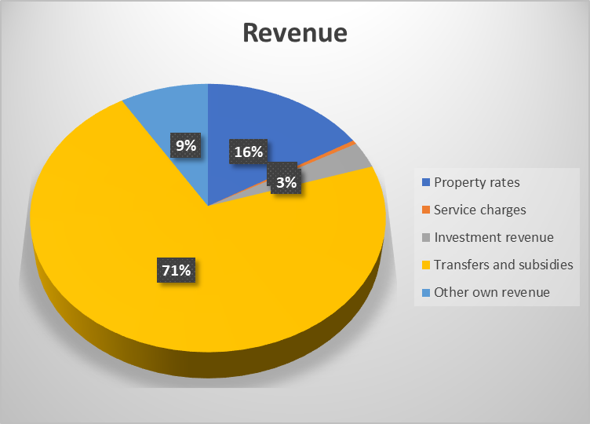

Transfers and Subsidies shows 71% contribution to total income, while Property Rates income comprises 16% of the total income of municipality. Own Revenue contributed 9% while service charges shows 3% and Investment contributed

**2.2 Expenditure:**

**Table below represent operational expenditure as at 31 December 2020**



Diagrammatically, the expenditure for the quarter is shown below:

Figure 2: Summary of Expenditure for the Mid-Year/second quarter

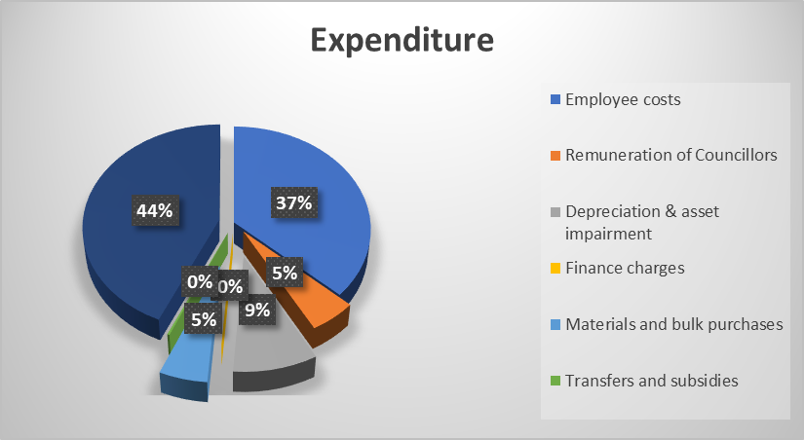

The actual expenditure as at 31 December 2020 as stated on the above shows that the salaries represent 44%. Actual Remuneration of Councilors is 5%. Depreciation and asset impairment is 9%. Material and bulk purchases is 5% and General Expenditure 37%.

**Conclusion**

The financial performance of the municipality for the Mid year has been stable and favorable. Revenue raised amounts to R 81 442 million compared to expenditure incurred of R 58 445 million.

1. **In-Year Budget Tables**

Table 2: C1 Monthly Budget Statement Summary



Table 3: C2 Monthly Budget Statement – Financial Performance (Standard Classification)



Table 4: C3 Monthly Budget Statement – Financial Performance (Revenue and Expenditure by Vote)



Table 5: C4 Monthly Budget Statement – Financial Performance (Revenue and Expenditure)



Table 6: C5 Monthly Budget Statement Capital Expenditure



Table 7: C6 Monthly Budget Statement Financial Position



Table 8: C7 Monthly Budget Statement Cash Flow



**Part 2 – Supporting Documents**

**1. Debtors Analysis**

The gross outstanding debt from consumers amounts to R 29 132 mil as at 31 December 2019. This is depicted as follows:

Figure 3: Outstanding Debtors as at 31 December 2020

The table above details the outstanding debt as at 31 December 2020.



|  |
| --- |
|  |

1. **Investment Portfolio Analysis**

The investments of the municipality as at 31 December 2020, were as follows:

Table 9: Investments as at 31 December 2020

|  |  |  |
| --- | --- | --- |
| **Investments** | | |
| **Institution** | **Account Number** | **Balance** |
|  | | |
| FNB | 62831920766 | 45 938 526 |
| Standard Bank | 358478994 | 30 000 000 |
|  |  |  |
|  |  | **75 938 526** |
|  |  |  |

Interest rates from other financial institutions are also being sourced to ensure that the maximum amount of interest is realized on these investments. All Municipal grants are cashed-back

**3Allocation and grant receipts and expenditure**

Grants for the period ended 31 December 2020 are as follows:

Table 10: Outstanding conditional grants

|  |  |  |  |  |  |  |
| --- | --- | --- | --- | --- | --- | --- |
| **Description** | **2019/20** | **Budget Year 2020/2021** | | | | |
| **Audited Outcome** | **Original Budget** | **Adjusted Budget** | **Monthly Actual** | **Year TD Actual** | **Full Year Forecast** |
|  |  |  |  |  |  |  |
| National Government | 73 789 000 | 90 495 000 |  | 32 604 000 | 73 319 000 | 90 495 000 |
|  |  |  |  |  |  |  |
| Municipal Infrastructure Grant | 16 076 000 | 15 996 000 |  | 3 0000 000 | 12 000 000 | 15 996 000 |
|  |  |  |  |  |  |  |
| **Total Capital Transfers and Grants** | **89 865 000** | **106 491 000** |  | **35 604 000** | **85 319 000** | **106 491 000** |

From the table above R12 millions of conditional Capital grant has been received from the anticipated annual grant of R 15 996 000. We have spent R11 107 million .The reconciliations expenditure is checked by the General Manager for Technical Services and General Manager for Finance department to ensure that amounts outstanding on projects are correct.

TABLE 13: table SC7(1) Monthly Budget Statement

Capital Grants Unspent



**4. Employee Benefits and Councilors remuneration**

TABLE 14: SC8 Monthly Budget Statement



**5. Financial Performance**

The financial performance for the first quarter is highlighted in the executive summary above and detailed in Table C4 above. It has been reported that the financial performance of the municipality has been favorable for the past six months. This is summarized in the table below. The table includes capital transfers.

Table 13: Summary of



6. FINANCIAL RATIOS

7.1 Personnel costs to total expenditure = employee related costs/ total expenditure x 100

= R 20 700 872/58 419 846 Rx 100

= 35%

This ratio measures the extent of Remuneration to Total Operating Expenditure. If the ratio exceeds the norm it could indicate inefficiencies, overstaffing or even the incorrect focus due to misdirected expenditure to non-service delivery related expenditure. The norm ranges between 25% and 40%.

7.2 Cost coverage ratio = Cash and Cash Equivalent – unspent grant / Current liabilities

= R85 628M – R9 581 m/ R18 544

= 6months

The ratio indicates the municipality’s ability to meet at least its monthly fixed operating commitments from cash and short-term investment without collecting any additional revenue, during that month. The norm ranges between 1 month to 3 months.

7.3 Creditors payment period = Trade creditors outstanding / Trade creditors Purchases X 365

= R 1 176M / 25 000M X 365

= 18 days

Creditors Payment Period (Trade Creditors)

This ratio indicates the average number of days taken for trade creditors to be paid and the norm is 30 days.

A period of longer than 30 days to settle creditors is normally an indication that the municipality may be experiencing cash flow problems, however in certain instances this may be as a result of disputes, processing of payments, etc.

7.4 Net Debtors Days = ((Gross Debtors- Bad Debt Provision)/Billed Revenue)) X 365

= R29 132 - R2 795 /9 903 X 365

= 956 Days

This ratio reflects the collection period. Net Debtor Days refers to the average number of days required for a Municipality to receive payment from its consumers for bills issued to them for services rendered.

7.5 Collection Rate= Gross Debtors Opening Balance + Billed Revenue – Gross Debtors Closing Balance- Bad Debts Written Off)/Billed Revenue x 100

= 30 835 288+ 9 906 204 -29 132 006 /9 906 204 x 100

= 117%

The ratio indicates the collection rate; i.e. level of payments. It measures increases or decreases in debtors relative to annual billed revenue. In order to determine the real collection rate bad debts written-off is taken into consideration. The norm is 95%.

7.6 Current Ratio = Current Assets /Current Liabilities

= R122 934 / R18 544

= 1: 7

The ratio is used to assess the municipality’s ability to pay back its short-term liabilities (debt and payables) with its short-term assets (cash, inventory, receivables). The norm ranges between 1.5 to 2.1. The higher the current ratio, the more capable the municipality will be able to pay its current or short-term obligations and provide for a risk cover to enable it to continue operations at desired level.

7.7 Capital Expenditure to Total Expenditure = Total Capital Expenditure/Total Expenditure x 100

= R22 129/ R58 420 X 100

= 38%

The norm ranges between 10% and 20%. A ratio less than 10% reflects lower spending by the municipality in infrastructure and holds potential risks to service delivery. A ratio of more than 20% reflects higher spending on infrastructure and acceleration in service delivery, but could also hold financial sustainability risks if the infrastructure does not include both economic (revenue generating) and social type infrastructure.

7.8 Capital Expenditure Budget Implementation Indicator= Actual Capital Expenditure/Budget Capital Expenditure x 100

= R 22 129 / 33 421 X 100

= 66%

This ratio measures the extent to which Budgeted Capital Expenditure has been spent during the financial year, under review. Further, this ratio measures the municipality’s ability to implement capital projects and monitor the risks associated with non-implementation. The ratio also assesses whether the municipality has effective controls in place to ensure that expenditure is incurred in accordance with an approved budget.

7.11 Operating Expenditure Budget Implementation Indicator= Actual Operating Expenditure/Budgeted Operating Expenditure X 100

= R58 420/ R121 537 X 100

= 48%

This ratio measures the extent to which Budgeted Operating Expenditure has been spent during the financial year, under review. The ratio also assesses whether the municipality has effective controls in place to ensure that expenditure is incurred in accordance with an approved budget. The norm ranges between 95% and 100%.

7.12 Operating Revenue Budget Implementation Indicator= Actual Operating Revenue/Budgeted Operating Revenue x 100

= R81 650 / R120 631 X 100

= 68%

This ratio measures the extent of Actual Operating Revenue (excl. Capital Grant Revenue) received in relation to Budgeted Operating Revenue during the financial year, under review. The norm ranges between 95% and 100%.

The ratio measures the extent to which Total Capital Expenditure of the Municipality is funded through Internally Generated Funds. No norm at this stage. The funding mix for capital expenditure is dependent on the municipal policy and ability to raise revenue from different sources. Increased capacity for internally generated funding is required in some circumstances, which could also improve the balance in funding sources.

**7. Municipal Manager’s Quality Certificate**

I, Mr. S Mngwengwe, Municipal Manager of Mkhambathini Municipality, hereby certify that the Mid -Year Budget Performance Assessment report on the implementation of the budget and financial state of affairs of the municipality for the Six Months/Mid-Year Budget Performance assessment of the financial year ending 31 December 2020 has been prepared in accordance with the Municipal Finance Management Act and regulations made under that Act.

**Mr. S Mngwengwe**

**MUNICIPAL MANAGER: MKHAMBATHINI MUNICIPALITY, KZN226**

**SIGNATURE_____________________________**

**DATE__________________________________**